Troubleshooting your connection to Jefferson County’s Vendor Self Service Website

First, please make sure that you are using Internet Explorer version 10 or newer.
Second, if you are using the correct program and you get the below message, there are a few things that could possibly be causing the issue:
If you get the message below please try the following:
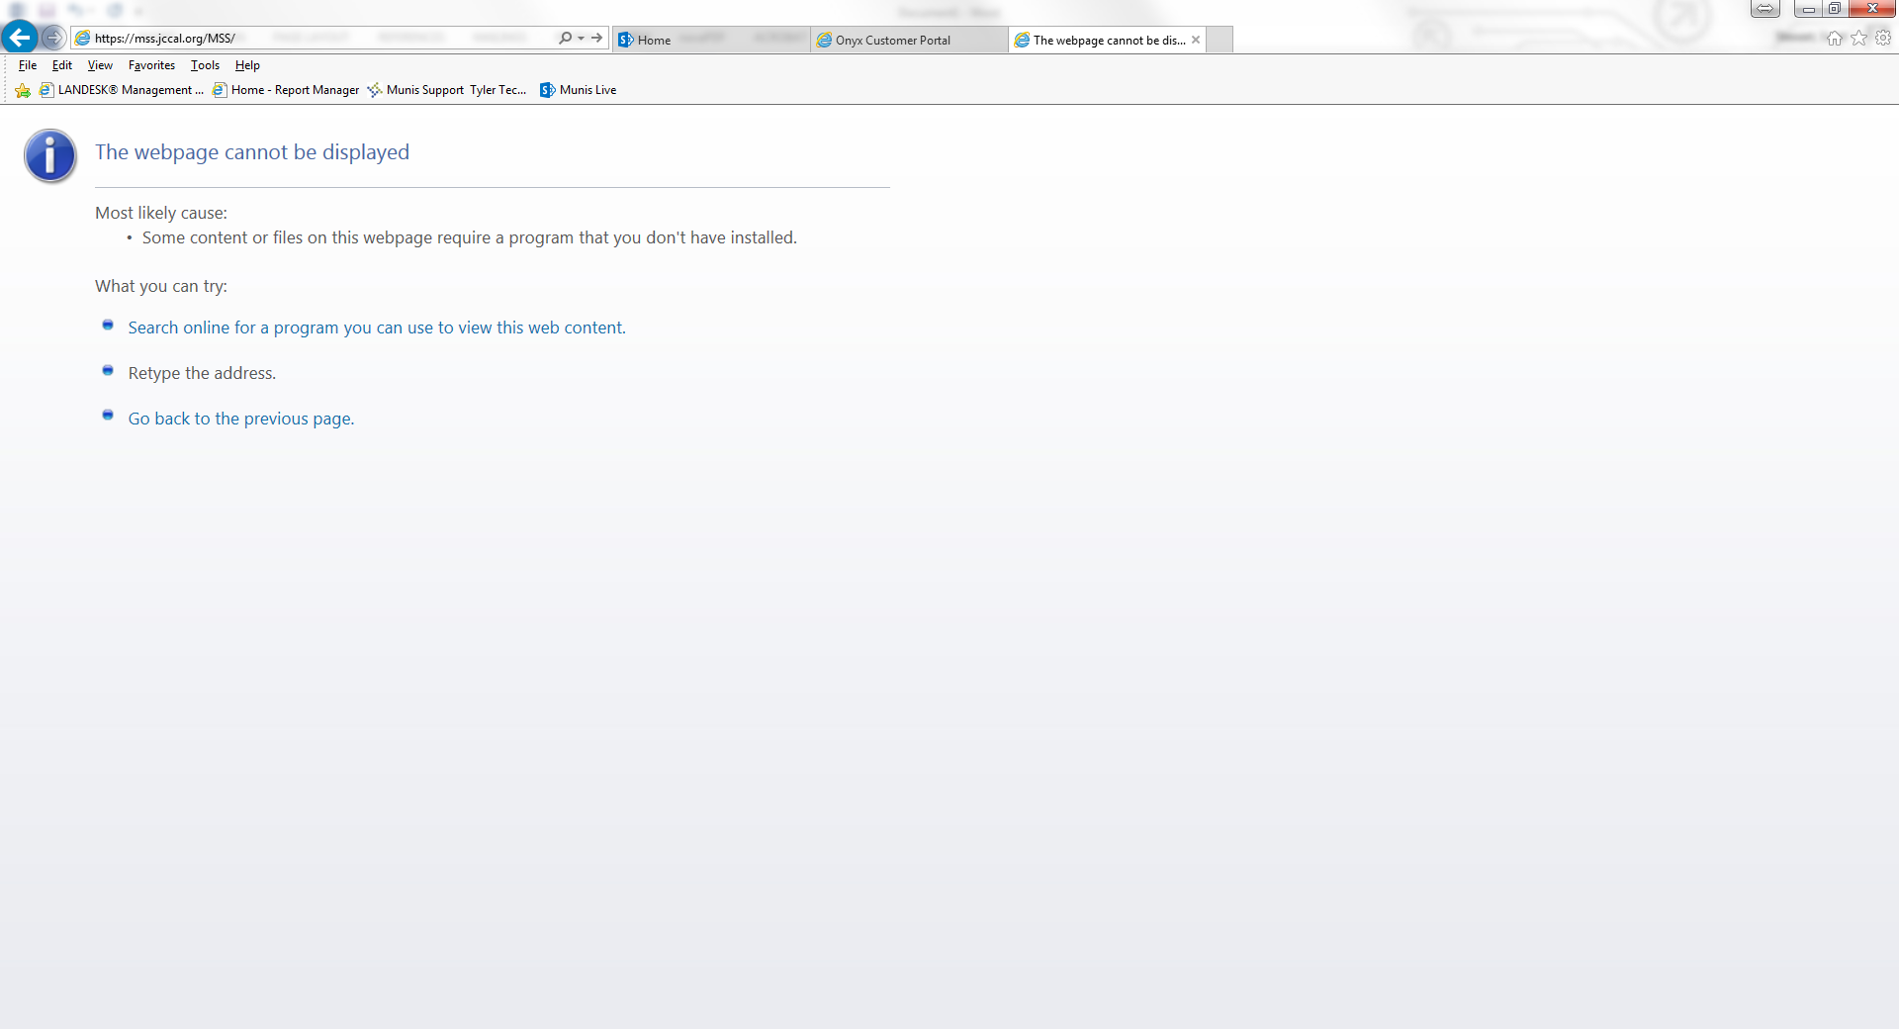

- Add the vendor self service web address to the list of Trusted Sites
Click on the Internet Options icon to open it up.
Click on “Internet Options” – the box below will show up when you do.
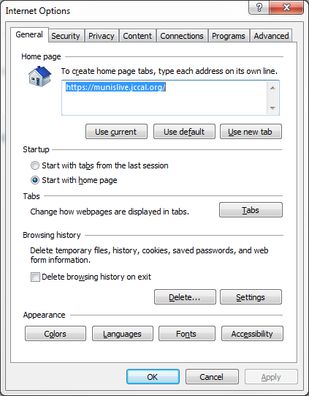

From there, click on the “Security” tab. Then, click on the green check for Trusted Sites.
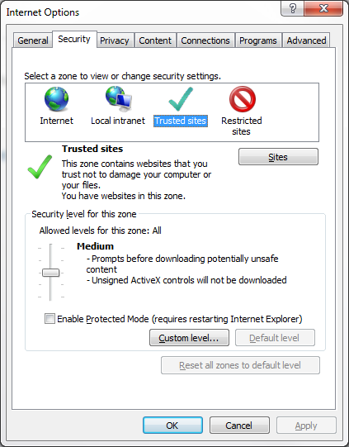

Then, click on the “Sites” button. When you do, the below box will pop up. Copy and paste the web address into the highlighted box and then click “Add”
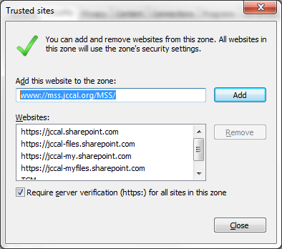
This will add the site to your list of trusted sites.
Then close the boxes out and try again to connect.
If that did not work to correct your issue, then please move on to item 2 below.

- Change your Compatibility View settings.
Click again to open Tools in Internet Explorer. From there, choose “Compatibility View Settings”
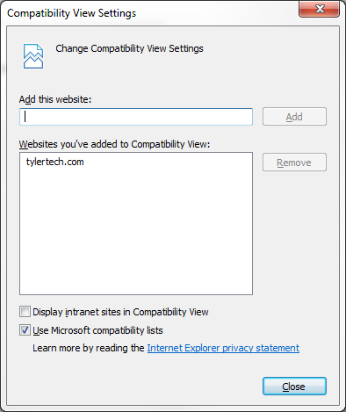
Copy and paste the web address into the box titled “Add this website:” then click the Add button to the right to add the compatibility view for.
Then close all boxes and try to open the web address up again.

