Munis Contract Management
______________________________________________________
Process Document
for
Jefferson County, Alabama

For more information, visit www.tylertech.com.
TABLE OF CONTENTS
Purchasing Contracts Process 4
Maintaining a Basic Contract Once Converted - Encumbered 7
Maintaining a Basic Contract Once Converted – Non Encumbered (Mou) 23
Entering a Basic Contract – Line/Item/Discount 39
Posting an Updated Contract 54
Contract Approvals 56
Contract Change Orders 59
Print Contracts 65

Disclaimer
Tyler Technologies, Inc. (hereinafter “Consultant”) believes that the information described in this manual is accurate and reliable, and much care has been taken in its preparation. However, no responsibility, financial or otherwise, shall be accepted for any consequences arising out of the use of this material, including loss of profit and indirect, special, or consequential damages. No warranties extend beyond the program specification.
The Client should exercise care to assure that use of Tyler Software Products and related sections are in full compliance with the laws, rules, and regulations of the jurisdictions in which it is used. These materials are confidential, unpublished works of Consultant and are provided contingent on Client’s agreement that the materials will be treated as Confidential Information as defined in the Agreement between Client and Consultant. Consultant grants to the Client a royalty-free nonexclusive license to use anything created or developed by Consultant for Client contained in this manual for internal purposes only. The license shall have a perpetual term and Client may not transfer it. Consultant shall retain all copyrights, patent rights and other intellectual property rights to this manual.
The information contained herein is subject to change with subsequent upgrades and releases. Consultant assumes no responsibility to advise clients of changes or additions.

Purchasing Contracts Process

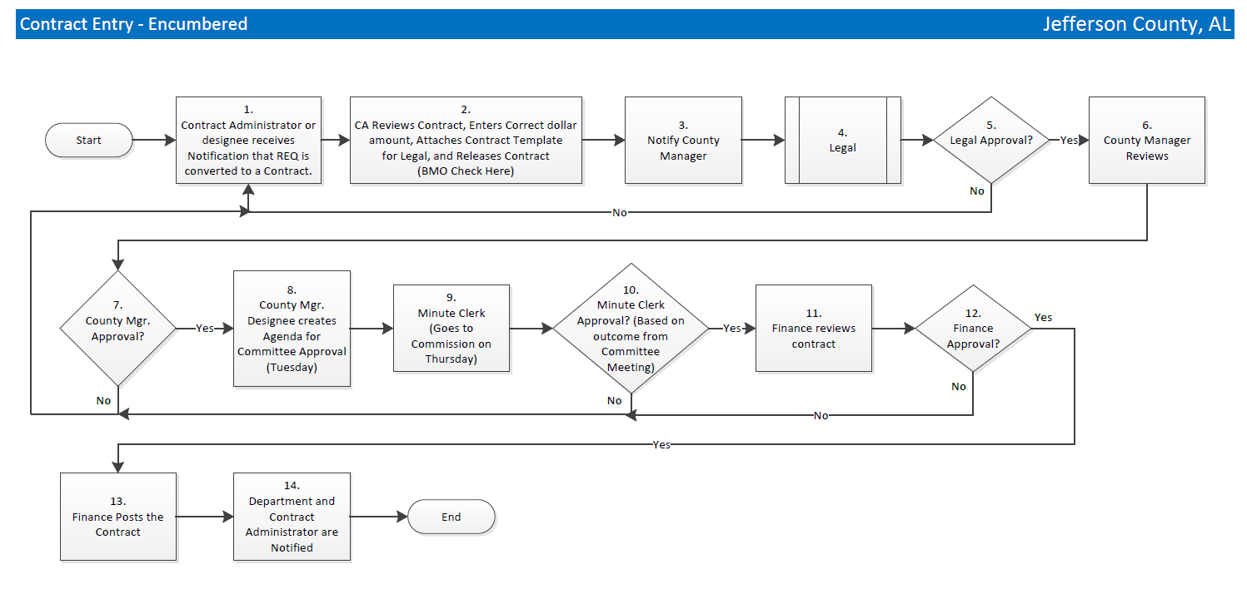
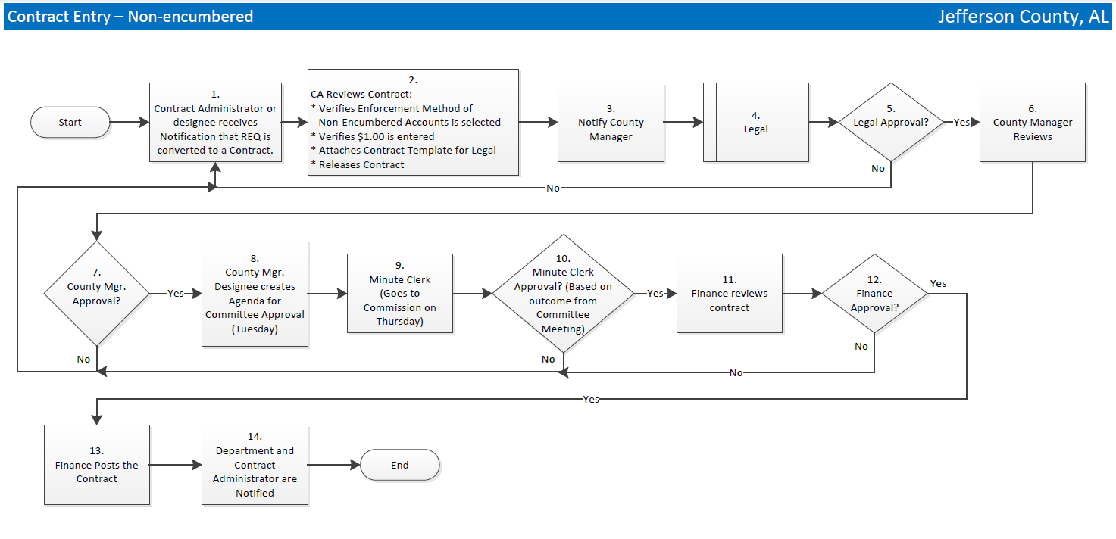

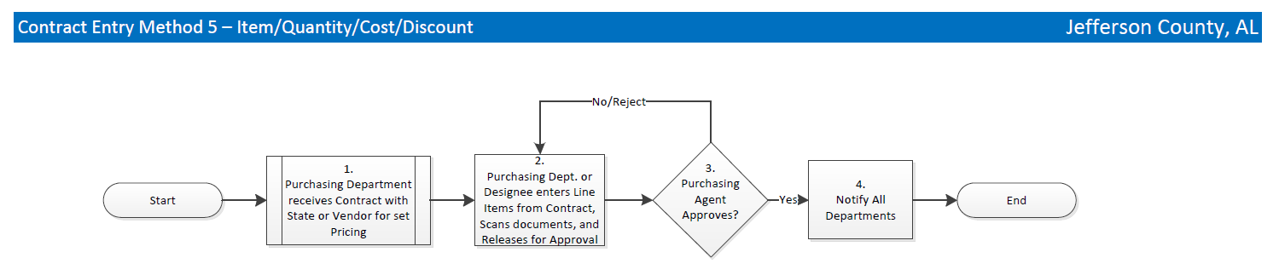
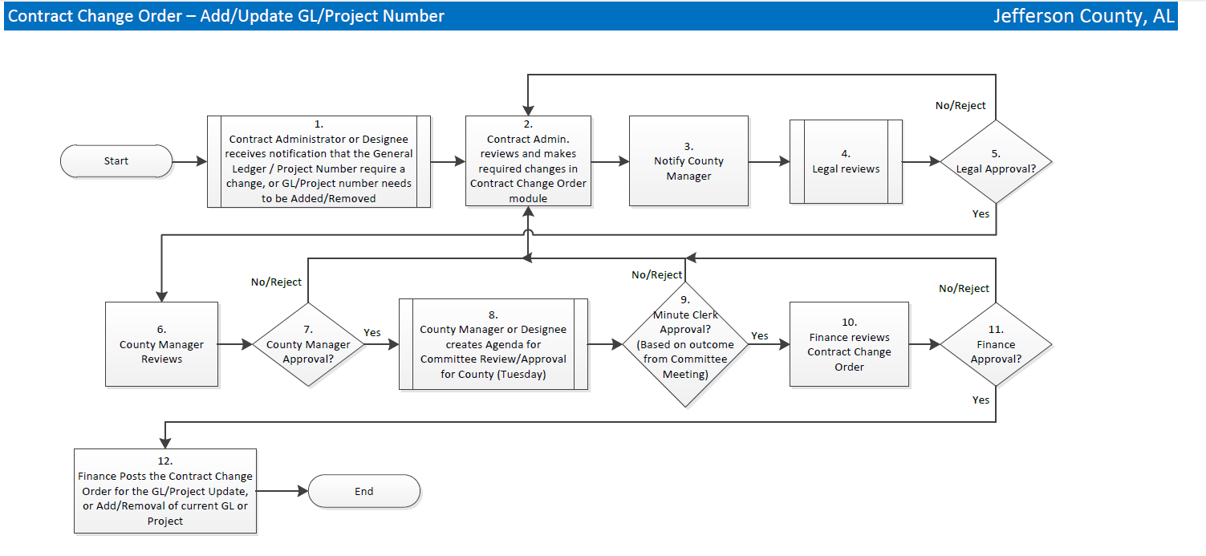
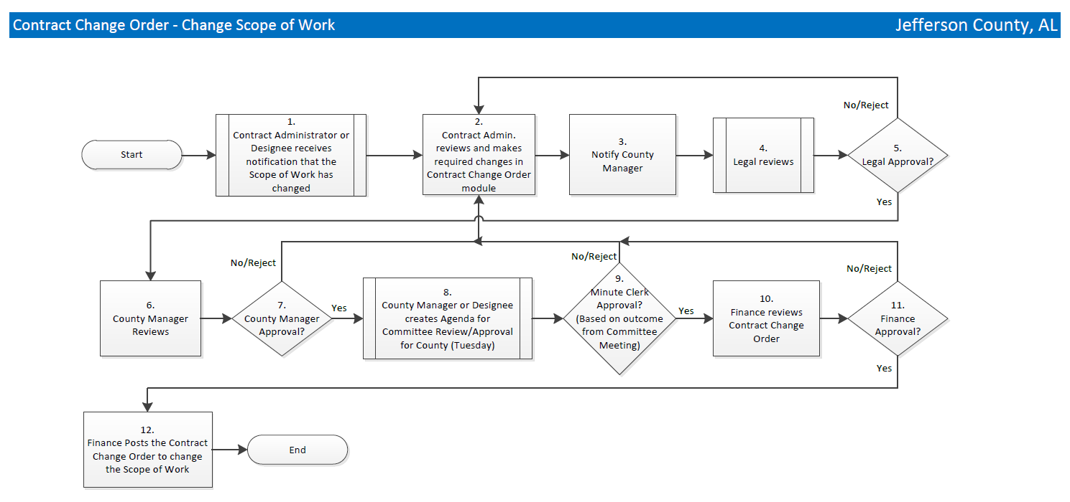
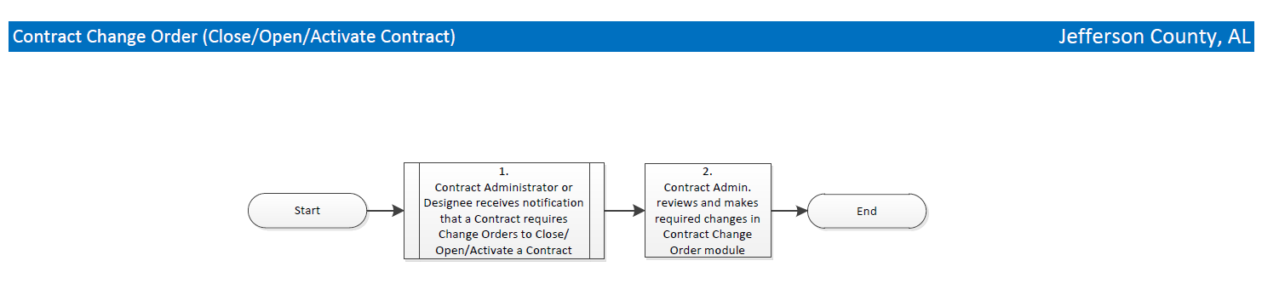

Maintaining a Basic Contract Once Converted - Encumbered

Objective
This document provides instructions on how to enter a manual contract record into the Munis Contract Entry program. When using this document as a guide, accept the default values in fields, unless otherwise indicated, to complete a contract record.

Overview
A contract in Munis is the end result of an agreement with a vendor. Contracts are converted from Munis Bid Management or entered directly through the Munis Contract Management program.

Prerequisites
Before you can successfully create a contract, you must ensure that the necessary settings and codes are in place. If settings and codes are not set up, or not set up correctly, you may need to contact the system administrator to have them updated or added into the Munis system.

Confirm the following:

- You have menu access to the Contract Entry program.
- You have the appropriate user permissions:
- Create New Contracts
- Release Own Contracts
- Create/Maintain Contracts
    - Encumbered
    - Non-Encumbered GL Accounts
    - Items with Encumbered Amounts
    - Items with Non-Encumbered Amounts
    - Data access View Contracts by Department (own department code at a minimum)
- Contract settings are established.
- Vendors are established in the Vendors program.
- Department codes are established in the Departments program.
- General ledger accounts are active.
- Workflow business rules for contracts are established, if applicable.

Procedure
Use the following steps to enter a contract:
- Open the Contract Entry program
Financials > Purchasing > Contract Management > Contract Entry
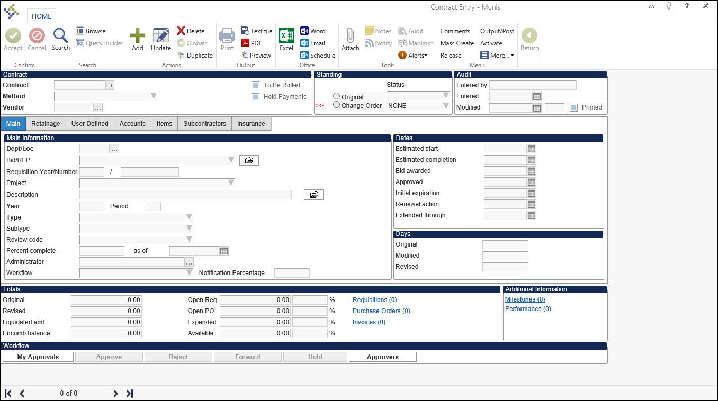
- On the ribbon, click Search.
- Enter in any search critia into the correct fields to find the contract that needs to be updated with the further data.
- Select Accept or hit Enter. The search will bring up the contracts that match your search criteria.
- Select Update and start to update the fields that require further information to be built that were not brought over from the requisition.
- Complete the header fields and the fields on the Main tab according to the following table.
Field | Description | Jefferson County
Contract
Contract | This box identifies the contract number. Use the plus one button to assign the next available number or manually assign a number by typing it into the field.
Method | This list specifies the contract enforcement method. The enforcement method designates how the contract will operate.  You may change this option if you have permission to do so. Once a contract has been posted, the enforcement method may not be changed.  Enforcement options are:  - Encumbered Accounts: The contract requires accounts and amounts to be entered, and the accounts are encumbered for the entered amounts. If the contract was converted from a bid, users are not held to the bid item total, but the GL account total. Requisitions, purchase orders, and invoices restrict accounts entered to those on the contract without exceeding the amount for the account and the appropriate fiscal year.  - Nonencumbered Accounts: The contract is encumbered as purchase orders are issued against it.  - Item/Qty/Cost/Disc: These contracts only have line items with no general ledger allocations, and therefore, are unencumbered. Each detail line lists a commodity code, inventory item, and item description. Each line must also have either a contracted quantity, unit price, discount percent, or cost plus amount. When this type of contract is used with a requisition or purchase order, the requisition or purchase order detail lines must conform to at least one contract line item. The contract unit price is enforced and the total quantity ordered against this contract cannot exceed the contracted quantity. | Multi-Year Encumbered Contracts need to be filled out on the Accounts Tab for the dollar amount for each year. The “To Be Rolled’ checkbox will roll the remaining dollar balance each year and this amount will be available for spending.
Vendor | This box identifies the number of the vendor associated with this contract.  The vendor must be established in the Munis Accounts Payable Vendors program.
To Be Rolled | This check box, if selected, indicates that the contract should be rolled to the next fiscal year when the current fiscal year is closed. The default value is selected, but you can clear the check box.  You cannot close the current fiscal year until all contracts with this status have been rolled to the next fiscal year.
Hold Payments | This check box directs the program to prevent invoices from posting if they are associated with this contract record. You can create contract invoices, but while this check box is selected, the invoices cannot be posted.
Standing
Original/Status | The Original option indicates that this is a record for an original contract, not a change order.  The Status list shows the status of the contract during the contract process.  When you add a new contract, the status is 2–Created and it updates automatically as the contract is moved through the process. You cannot modify the status, but you can use this field as search criteria during the Search process. Status indicators:  0-Rejected  2-Created  4-Released  6-Approved  8-Posted  10-Closed
Change Order/Status | The Change Order option indicates that this is a record for a contract change order.  The Status list that indicates the status of the change order.  The program updates the status as the change order is processed. You cannot modify the status, but you can use this field as search criteria during the Search process.  Status indicators are:  N- None  C-Created  P-Pending  A-Approved  R-Rejected
Audit
Entered By | This box displays the user ID of the person who created the record. This field is accessible as search criteria during the Search process.
Entered | This box displays the date that the record was created. This field is accessible as search criteria during the Search process.
Modified | This box contains the date that the contract was last modified.  The program automatically updates this date when the contract record is modified. The numeric box indicates how many times the contract has been modified.  This field is accessible as search criteria during the Search process.
Printed | This check box, if selected, indicates if the contract has been printed.

Main Tab
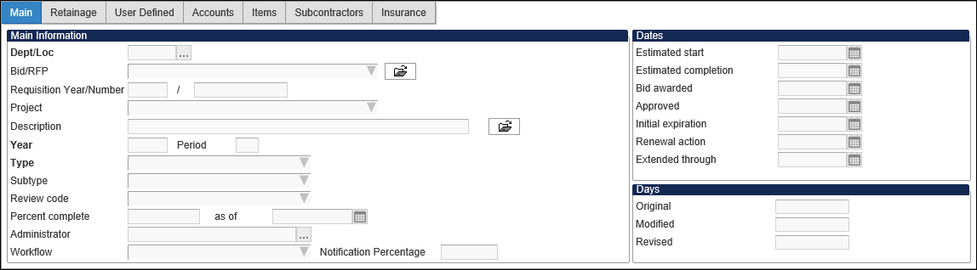

Field | Description | Jefferson County
Main Information
Dept/Loc | This box identifies the responsible department. Your department is the default value. To change it, enter a new department code or click the field help button to select a department from the list.
Bid/RFP | This box specifies an associated bid number, if applicable. The program completes the bid number from the Create Bids program when it is converted.
Requisition Year/Number | These boxes contain the fiscal year and period of the requisition that was used to create the bid. These boxes are completed automatically during the Requisition Conversion process, and you cannot access them.
Project | If your organization uses project codes, select the Munis project from the list of available choices. This is an optional value.
Description | This box contains the description for this contract. The description can contain up to 50 characters.  You can click the Add'l Desc button to add additional description text.
Year | This box specifies the first fiscal year in which the contract will be used. The program enters your current fiscal year as the default value, but you may change it, if necessary.  You must have the appropriate permissions to make changes to the fiscal year and period.
Period | This box specifies the first period in which the contract will be used. The program enters your current fiscal period as the default value, but you may change it, if necessary.  You must have the appropriate permissions to make changes to the fiscal year and period.
Type | This list identifies the contract type. Contract type codes are created and maintained in the Contract Types and Subtypes program.
Subtype | This list identifies the contract subtype. Contract subtype codes are created and maintained in the Contract Types and Subtypes program. This is an optional value.
Review Code | This list identifies a contract review code. Review codes are created and maintained in the Contract Management Miscellaneous Codes program for the code type REVW – Review Code.  This is an optional value.
Percent Complete | This box indicates the percentage of the contract that is complete.  This is an optional value.
As of | This box provides the date by which the specified percentage of the contract is complete. This is an optional value.
Administrator | This box identifies the contract administrator. Enter the user ID for the administrator of the contract, or click the field help button to select a Munis user from the list.  This is an optional value.
Workflow | This list identifies the workflow option for the contract. This list is only accessible if an Administrator is selected.  This is an optional value.
Notification Percentage | This box indicates the percentage level at which the administrator of the contract will be notified if any requisition, purchase order, or invoice brings the contract above this threshold.  This is an optional value.
Dates
Estimated Start | This box indicates an estimated start date for the contract. Enter the date or select a date by clicking the calendar button. This will require manual updates, if changed.  This is an optional value.
Estimated Completion | This box indicates an estimated completion date for the contract. Enter the date or select a date by clicking the calendar button. This will require manual updates, if changed.  This is an optional value.
Bid Awarded | This box indicates the date the contract is awarded. Enter the date or select a date by clicking the calendar button. This will require manual updates, if changed.  This is an optional value.
Approved | This box provides the contract approval date. Enter the date or select a date by clicking the calendar button. This will require manual updates, if changed.  This is an optional value.
Initial Expiration | This box indicates the contract expiration date. Enter the date or select a date by clicking the calendar button. This will require manual updates, if changed.  This is an optional value.
Renewal Action | This box indicates the renewal date for the contract. Enter the date required for renewal action or select a date by clicking the calendar button. This will require manual updates, if changed.  This is an optional value.
Extended Through | This box indicates the contract is extended through this defined date. Enter date or select a date by clicking the calendar button. This will require manual updates, if changed.  This is an optional value.
Days
Original | This box indicates the number of original contract days. If estimated start and estimated completion dates are entered, the program calculates this value. You may only access this field while the contract is a status 2-Created.  This is an optional value.
Modified | This box provides a system-calculated figure and you cannot change it. If there are changes to the number of days in the contract, only the amount changed reflects here.  This is an optional value.
Revised | This box provides a system-calculated figure and you cannot change this. If there are changes to the number of days in the contract, this shows the updated total of days in the contract. This can be changed in the Change Orders program.  This is an optional value.

- On the Munis toolbar, click Accept.

- If you are using the Encumbered Accounts, Nonencumbered Accounts, or Amounts by Segments enforcement method, all tabs are accessible.
- If using the Not to Exceed Contracts enforcement method, the Accounts tab is replaced by the Amounts tab. Note: This method will not be used by the county.
- If using the Item/Qty/Cost/Disc enforcement method, you do not have access to the Accounts or Amounts tab.
- If a contract uses any of the Items enforcement methods, the Accounts/Amounts tab in Contract Entry is hidden. For this enforcement type, the Items tab is available; however, in this case, the Items tab includes an Item and Accounts table.

The fields on the available tabs vary according to the enforcement method selected.
- When you have completed the information on the applicable tabs, click Accept to save the record.

Retainage Tab
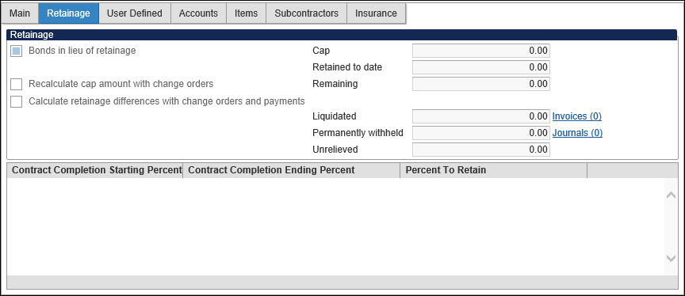

Field | Description | Jefferson County
Retainage
Bonds In Lieu of Retainage | This check box, if selected, indicates that bonds are retained in place of a lien.  This is an optional value.
Recalculate Cap and Retainage Differences with Change Orders and Payments | This check box causes the program to recalculate the value in the Cap box when contract change orders are posted.
Cap | This is the total amount to be retained from the contract.  The amount is set when the contract is initially posted, but it can be recalculated when change orders are posted and the Recalculate Cap check box is selected.
Retained to Date | This is the total amount of retainage posted to the contact, up to today's date/
Remaining | This box contains the amount of retainage withholding that has not yet been held.
Liquidated | This is the total amount of retained funds paid to date.
Permanently Retained | This is the total amount of retained funds to date that will not be paid out to a vendor.
Unrelieved | This is the retained amount that has not yet been relieved.
Contract Completion Starting Percent | These fields determine the retainage rate for a range of contract completion percentages.  Standard retainage rates remain the same for the life of the contract. The default value of the Starting and Ending fields are 0 and 100 for this retainage method, which indicates that the contract retains at the same percentage for its entirety.  Sliding scale retainage withholds funds from the vendor based on the completion percentage of the contract. For example, you can retain 5% of funds from the vendor until the contract is 50% complete, and then switch to a 2% retainage until the contract is complete.  This is achieved by entering a range of percentage completion and a retainage rate on each line of the table. Continue to enter ranges until you reach 100% completion.

User Defined Tab
The User Defined tab displays when your organization has activated user-defined fields and applied them to the Contract Entry or Contract Change Orders programs.
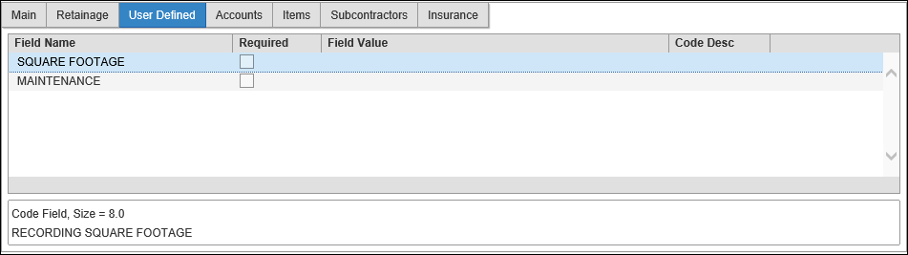

Accounts Tab – Mulit-year contracts-Enter each year under the Accounts tab.
Httphttps
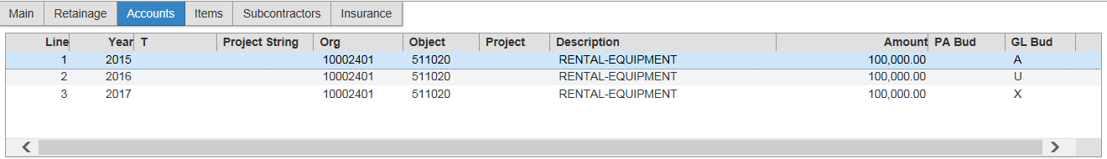

Field | Description | Jefferson County
Line | This is the system-assigned number for the contract accounts.
Year | This box contains the fiscal year of the line item.  The fiscal year is required when you are adding new details.  You can update the year if the contract status is 2-Created.
T | This box identifies the account type: expense, revenue, or balance sheet.
Account | This box contains the full general ledger account number for the account to be charged.  Account information is required when the value of the Method list is Encumbered Accounts or Nonencumbered Accounts.  Account information is optional when the value of the Method list is Amounts by Segments.  You can update the account information for an existing detail line when the contract status is 2-Created or the change order status is C-Created.
Description | This box provides is the description of the account number (org/object codes) entered.
Amount | This box contains the current contract amount for the account.  The value of this field must be 0 or greater.  The amount is required.
Open Req | This box displays amount remaining on the associated requisition.  This is a display-only field.
Open PO | The amount remaining on the associated purchase order.  This is a display-only field.
Expended | The amount that has been expended to date.  This is a display-only field.
Original | The original amount allocated to this general ledger account.  This is a display-only field.
Liquidated | The amount of the original amount liquidated to date.  This is a display-only field.

Items Tab
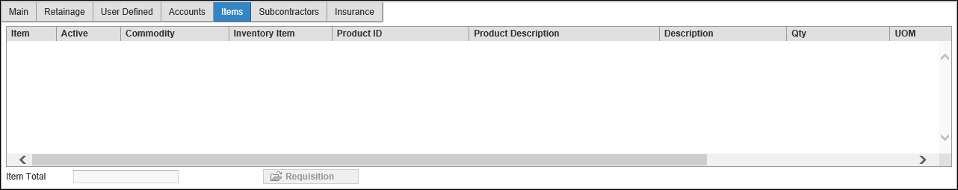

Field | Description | Jefferson County
Item | This is a system-assigned sequential number for the line.
Active | The value of this column indicates whether the contract item is currently active or inactive. Inactive items are not available for purchase using the contract terms.
Commodity | This is the commodity code for the item.  If applicable, enter the contracted commodity code.  If you do not know the commodity code, click the field help button to search by general commodity code. In the Commodity Help box, enter the general commodity code or click the field help button to search the list of all general commodity codes. Select the appropriate general commodity code; the program then provides a list of detailed commodity codes. Select the detailed commodity code.
Inventory Item | This identifies an inventory number.  If applicable, enter the inventory item. Note: This is applicable if you are using Munis Inventory. If you do not know the inventory item number, click the field help button to search a list of available inventory items.
Product ID/Product Description | These columns contain the product ID and description of the item. The columns are only available if your organization has selected the Use Product IDs check box in the Purchase Order Settings program
Description | This is the commodity or inventory item description. The program completes the description, but you can change it, if needed.
Qty | This is the contract quantity for the item. If known, enter the contracted quantity of this item.
Ordered Qty | This is the ordered quantity. The program completes this figure from the requisition or purchase order line detail.
Received Qty | This is the received quantity. The program enters this figure from the PO Receiving or the AP Invoice Entry Liquidation record.
Invoiced Quantity | This column provides the quantity of the item that has been invoiced.
UOM | This is the unit of measure for the item. The program completes the default value according to the commodity code, but you can change this. The UOM can contain up to four alphanumeric characters.
Unit Price | This is the unit price is associated with the commodity code. If there is a price associated with the commodity code, the program completes the value; if there is no unit price associated with the commodity code, you can enter the contracted unit cost.
Net Price | This field displays the calculation of the Qty x Unit Price.

Items Tab (Items Enforcement Entry Methods)
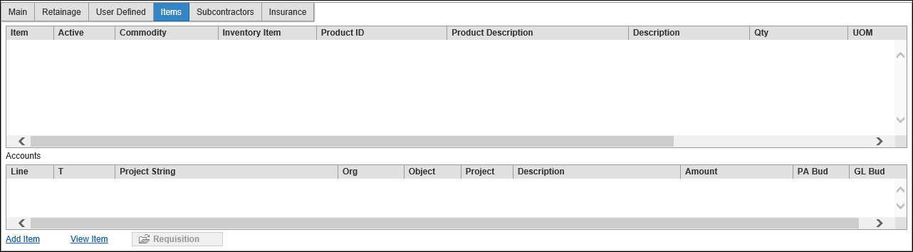

For Item enforcement methods, the Items tab contains an Item table and an Accounts table. The Item table lists the items for the contract, and the Accounts table lists the accounts and amounts associated with the currently selected item from the Item table.
Subcontractors Tab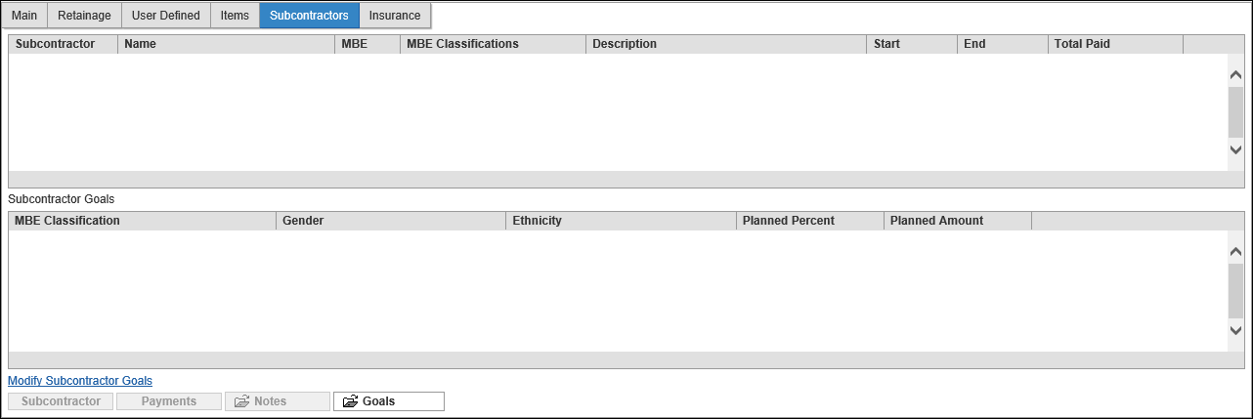

Field | Description | Jefferson County
Subcontractor | This box provides the vendor number for the subcontractor. If you do not know the vendor number, click the field help button to launch a vendor alpha search. Note: The subcontractor must exist as an active vendor in the Vendors program.
Name | This box displays the vendor name according to the vendor number entered.
MBE | This check box indicates whether the subcontractor is classified as a Minority Business Enterprise or not.
Description | This box provides a description of the work that the subcontractor is to complete.
Start | This box identifies the date that the subcontractor will begin work.
End | This box indicates the date that the subcontractor will complete the work.
Total Paid | This box displays the total amount paid to the subcontractor. This total is calculated from the sum of the payments entered.  Payments are recorded by clicking the Payments at the bottom of the Subcontractor tab. On the Subcontractor Payments screen, enter the payment information including the amount paid, comments, document, and invoice number.
Subcontractor Goals
 | This table is used to define usage-based goal percentages for subcontractors on the contract. The goals are typically defined based on minority business enterprise certifications. Please refer to additional Munis documentation in order to set up this optional feature.

Insurance Tab

Field | Description | Jefferson County
Carrier | This box specifies the insurance carrier code. If you do not know the code, click the field help button to search the list of available carrier codes. The carrier codes must exist in the Contract Miscellaneous Codes program with the code type INSR.
Carrier Name | This box provides the insurance carrier name, which the program completes according to the carrier code entered. The carrier name is defined in the Contract Miscellaneous Codes program.
Agency | This box identifies is the code of the insurance agency associated with the contract. The agency code must exist in Contract Miscellaneous Codes.
Agency Name | This box identifies the agency name, which the program completes according to the agency code entered. The agency name is defined in the Contract Miscellaneous Codes program.
Agent | This box provides is the insurance agent name. The name can contain up to 30 characters.
Type | This box contains the insurance type code. This code must exist in Contract Miscellaneous Codes.
Type Description | This box provides is the insurance type description, which the program completes according to the type entered. The description is defined in the Contract Miscellaneous Codes program.
Amount | This box provides the insurance amount.
Policy | This box specifies the policy number.
Policy Start | This box specifies is the policy start date.
Policy End | This box identifies is the policy expiration date.
Notes | This box contains any notes about the insurance. You can enter up to 40 alphanumeric characters.

Results
The contract record is complete.

Status Change
With workflow in place, a released contract is status of 6 – Released. Click the Approvers button to see the list of approvers. Without workflow, your contract is status 8 – Approved.

GL Impact
If the contract enforcement method is Encumbered Accounts, the funds for the selected general ledger accounts are automatically encumbered and the available budget is decreased.
If the contract enforcement method is Nonencumbered Accounts, there is no effect on the general ledger.

Other Munis Modules Impact
Once the contract is completed and approved, you are able to reference the contract through the purchasing module. When using the encumbered accounts enforcement method, a journal entry is created encumbering the funds from the specified account.

What’s Next?
With Workflow, the released contract is waiting for approval. Without Workflow, the approved contract is ready to have requisitions and purchase orders entered against it.

Maintaining a Basic Contract Once Converted – Non Encumbered (Mou)

Objective
This document provides instructions on how to enter a manual contract record into the Munis Contract Entry program. When using this document as a guide, accept the default values in fields, unless otherwise indicated, to complete a contract record.

Overview
A contract in Munis is the end result of an agreement with a vendor. Contracts are converted from Munis Bid Management or entered directly through the Munis Contract Management program.

Prerequisites
Before you can successfully create a contract, you must ensure that the necessary settings and codes are in place. If settings and codes are not set up, or not set up correctly, you may need to contact the system administrator to have them updated or added into the Munis system.

Confirm the following:

- You have menu access to the Contract Entry program.
- You have the appropriate user permissions:
- Create New Contracts
- Release Own Contracts
- Create/Maintain Contracts
    - Encumbered
    - Non-Encumbered GL Accounts
    - Items with Encumbered Amounts
    - Items with Non-Encumbered Amounts
    - Data access View Contracts by Department (own department code at a minimum)
- Contract settings are established.
- Vendors are established in the Vendors program.
- Department codes are established in the Departments program.
- General ledger accounts are active.
- Workflow business rules for contracts are established, if applicable.

Procedure
Use the following steps to enter a contract:
- Open the Contract Entry program
Financials > Purchasing > Contract Management > Contract Entry
- On the ribbon, click Search.
- Enter in any search critia into the correct fields to find the contract that needs to be updated with the further data.
- Select Accept or hit Enter. The search will bring up the contracts that match your search criteria.
- Select Update and start to update the fields that require further information to be built that were not brought over from the requisition.
- Complete the header fields and the fields on the Main tab according to the following table.
Field | Description | Jefferson County
Contract
Contract | This box identifies the contract number. Use the plus one button to assign the next available number or manually assign a number by typing it into the field.
Method | This list specifies the contract enforcement method. The enforcement method designates how the contract will operate.  You may change this option if you have permission to do so. Once a contract has been posted, the enforcement method may not be changed.  Enforcement options are:  - Encumbered Accounts: The contract requires accounts and amounts to be entered, and the accounts are encumbered for the entered amounts. If the contract was converted from a bid, users are not held to the bid item total, but the GL account total. Requisitions, purchase orders, and invoices restrict accounts entered to those on the contract without exceeding the amount for the account and the appropriate fiscal year.  - Nonencumbered Accounts: The contract is encumbered as purchase orders are issued against it.  - Item/Qty/Cost/Disc: These contracts only have line items with no general ledger allocations, and therefore, are unencumbered. Each detail line lists a commodity code, inventory item, and item description. Each line must also have either a contracted quantity, unit price, discount percent, or cost plus amount. When this type of contract is used with a requisition or purchase order, the requisition or purchase order detail lines must conform to at least one contract line item. The contract unit price is enforced and the total quantity ordered against this contract cannot exceed the contracted quantity.  .
Vendor | This box identifies the number of the vendor associated with this contract.  The vendor must be established in the Munis Accounts Payable Vendors program.
To Be Rolled | This check box, if selected, indicates that the contract should be rolled to the next fiscal year when the current fiscal year is closed. The default value is selected, but you can clear the check box.  You cannot close the current fiscal year until all contracts with this status have been rolled to the next fiscal year.
Hold Payments | This check box directs the program to prevent invoices from posting if they are associated with this contract record. You can create contract invoices, but while this check box is selected, the invoices cannot be posted.
Standing
Original/Status | The Original option indicates that this is a record for an original contract, not a change order.  The Status list shows the status of the contract during the contract process.  When you add a new contract, the status is 2–Created and it updates automatically as the contract is moved through the process. You cannot modify the status, but you can use this field as search criteria during the Search process. Status indicators:  0-Rejected  2-Created  4-Released  6-Approved  8-Posted  10-Closed
Change Order/Status | The Change Order option indicates that this is a record for a contract change order.  The Status list that indicates the status of the change order.  The program updates the status as the change order is processed. You cannot modify the status, but you can use this field as search criteria during the Search process.  Status indicators are:  N- None  C-Created  P-Pending  A-Approved  R-Rejected
Audit
Entered By | This box displays the user ID of the person who created the record. This field is accessible as search criteria during the Search process.
Entered | This box displays the date that the record was created. This field is accessible as search criteria during the Search process.
Modified | This box contains the date that the contract was last modified.  The program automatically updates this date when the contract record is modified. The numeric box indicates how many times the contract has been modified.  This field is accessible as search criteria during the Search process.
Printed | This check box, if selected, indicates if the contract has been printed.

Main Tab

Field | Description | Jefferson County
Main Information
Dept/Loc | This box identifies the responsible department. Your department is the default value. To change it, enter a new department code or click the field help button to select a department from the list.
Bid/RFP | This box specifies an associated bid number, if applicable. The program completes the bid number from the Create Bids program when it is converted.
Requisition Year/Number | These boxes contain the fiscal year and period of the requisition that was used to create the bid. These boxes are completed automatically during the Requisition Conversion process, and you cannot access them.
Project | If your organization uses project codes, select the Munis project from the list of available choices. This is an optional value.
Description | This box contains the description for this contract. The description can contain up to 50 characters.  You can click the Add'l Desc button to add additional description text.
Year | This box specifies the first fiscal year in which the contract will be used. The program enters your current fiscal year as the default value, but you may change it, if necessary.  You must have the appropriate permissions to make changes to the fiscal year and period.
Period | This box specifies the first period in which the contract will be used. The program enters your current fiscal period as the default value, but you may change it, if necessary.  You must have the appropriate permissions to make changes to the fiscal year and period.
Type | This list identifies the contract type. Contract type codes are created and maintained in the Contract Types and Subtypes program.
Subtype | This list identifies the contract subtype. Contract subtype codes are created and maintained in the Contract Types and Subtypes program. This is an optional value.
Review Code | This list identifies a contract review code. Review codes are created and maintained in the Contract Management Miscellaneous Codes program for the code type REVW – Review Code.  This is an optional value.
Percent Complete | This box indicates the percentage of the contract that is complete.  This is an optional value.
As of | This box provides the date by which the specified percentage of the contract is complete. This is an optional value.
Administrator | This box identifies the contract administrator. Enter the user ID for the administrator of the contract, or click the field help button to select a Munis user from the list.  This is an optional value.
Workflow | This list identifies the workflow option for the contract. This list is only accessible if an Administrator is selected.  This is an optional value.
Notification Percentage | This box indicates the percentage level at which the administrator of the contract will be notified if any requisition, purchase order, or invoice brings the contract above this threshold.  This is an optional value.
Dates
Estimated Start | This box indicates an estimated start date for the contract. Enter the date or select a date by clicking the calendar button. This will require manual updates, if changed.  This is an optional value.
Estimated Completion | This box indicates an estimated completion date for the contract. Enter the date or select a date by clicking the calendar button. This will require manual updates, if changed.  This is an optional value.
Bid Awarded | This box indicates the date the contract is awarded. Enter the date or select a date by clicking the calendar button. This will require manual updates, if changed.  This is an optional value.
Approved | This box provides the contract approval date. Enter the date or select a date by clicking the calendar button. This will require manual updates, if changed.  This is an optional value.
Initial Expiration | This box indicates the contract expiration date. Enter the date or select a date by clicking the calendar button. This will require manual updates, if changed.  This is an optional value.
Renewal Action | This box indicates the renewal date for the contract. Enter the date required for renewal action or select a date by clicking the calendar button. This will require manual updates, if changed.  This is an optional value.
Extended Through | This box indicates the contract is extended through this defined date. Enter date or select a date by clicking the calendar button. This will require manual updates, if changed.  This is an optional value.
Days
Original | This box indicates the number of original contract days. If estimated start and estimated completion dates are entered, the program calculates this value. You may only access this field while the contract is a status 2-Created.  This is an optional value.
Modified | This box provides a system-calculated figure and you cannot change it. If there are changes to the number of days in the contract, only the amount changed reflects here.  This is an optional value.
Revised | This box provides a system-calculated figure and you cannot change this. If there are changes to the number of days in the contract, this shows the updated total of days in the contract. This can be changed in the Change Orders program.  This is an optional value.

- On the Munis toolbar, click Accept.

- If you are using the Encumbered Accounts, Nonencumbered Accounts, or Amounts by Segments enforcement method, all tabs are accessible.
- If using the Not to Exceed Contracts enforcement method, the Accounts tab is replaced by the Amounts tab. Note: This method will not be used by the county.
- If using the Item/Qty/Cost/Disc enforcement method, you do not have access to the Accounts or Amounts tab.
- If a contract uses any of the Items enforcement methods, the Accounts/Amounts tab in Contract Entry is hidden. For this enforcement type, the Items tab is available; however, in this case, the Items tab includes an Item and Accounts table.

The fields on the available tabs vary according to the enforcement method selected.
- When you have completed the information on the applicable tabs, click Accept to save the record.

Retainage Tab

Field | Description | Jefferson County
Retainage
Bonds In Lieu of Retainage | This check box, if selected, indicates that bonds are retained in place of a lien.  This is an optional value.
Recalculate Cap and Retainage Differences with Change Orders and Payments | This check box causes the program to recalculate the value in the Cap box when contract change orders are posted.
Cap | This is the total amount to be retained from the contract.  The amount is set when the contract is initially posted, but it can be recalculated when change orders are posted and the Recalculate Cap check box is selected.
Retained to Date | This is the total amount of retainage posted to the contact, up to today's date/
Remaining | This box contains the amount of retainage withholding that has not yet been held.
Liquidated | This is the total amount of retained funds paid to date.
Permanently Retained | This is the total amount of retained funds to date that will not be paid out to a vendor.
Unrelieved | This is the retained amount that has not yet been relieved.
Contract Completion Starting Percent | These fields determine the retainage rate for a range of contract completion percentages.  Standard retainage rates remain the same for the life of the contract. The default value of the Starting and Ending fields are 0 and 100 for this retainage method, which indicates that the contract retains at the same percentage for its entirety.  Sliding scale retainage withholds funds from the vendor based on the completion percentage of the contract. For example, you can retain 5% of funds from the vendor until the contract is 50% complete, and then switch to a 2% retainage until the contract is complete.  This is achieved by entering a range of percentage completion and a retainage rate on each line of the table. Continue to enter ranges until you reach 100% completion.

User Defined Tab
The User Defined tab displays when your organization has activated user-defined fields and applied them to the Contract Entry or Contract Change Orders programs.

Accounts Tab
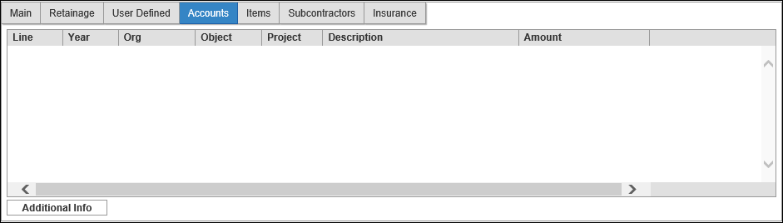

Field | Description | Jefferson County
Line | This is the system-assigned number for the contract accounts.
Year | This box contains the fiscal year of the line item.  The fiscal year is required when you are adding new details.  You can update the year if the contract status is 2-Created.
T | This box identifies the account type: expense, revenue, or balance sheet.
Account | This box contains the full general ledger account number for the account to be charged.  Account information is required when the value of the Method list is Encumbered Accounts or Nonencumbered Accounts.  Account information is optional when the value of the Method list is Amounts by Segments.  You can update the account information for an existing detail line when the contract status is 2-Created or the change order status is C-Created.
Description | This box provides is the description of the account number (org/object codes) entered.
Amount | This box contains the current contract amount for the account.  The value of this field must be 0 or greater.  The amount is required.
Open Req | This box displays amount remaining on the associated requisition.  This is a display-only field.
Open PO | The amount remaining on the associated purchase order.  This is a display-only field.
Expended | The amount that has been expended to date.  This is a display-only field.
Original | The original amount allocated to this general ledger account.  This is a display-only field.
Liquidated | The amount of the original amount liquidated to date.  This is a display-only field.

Items Tab

Field | Description | Jefferson County
Item | This is a system-assigned sequential number for the line.
Active | The value of this column indicates whether the contract item is currently active or inactive. Inactive items are not available for purchase using the contract terms.
Commodity | This is the commodity code for the item.  If applicable, enter the contracted commodity code.  If you do not know the commodity code, click the field help button to search by general commodity code. In the Commodity Help box, enter the general commodity code or click the field help button to search the list of all general commodity codes. Select the appropriate general commodity code; the program then provides a list of detailed commodity codes. Select the detailed commodity code.
Inventory Item | This identifies an inventory number.  If applicable, enter the inventory item. Note: This is applicable if you are using Munis Inventory. If you do not know the inventory item number, click the field help button to search a list of available inventory items.
Product ID/Product Description | These columns contain the product ID and description of the item. The columns are only available if your organization has selected the Use Product IDs check box in the Purchase Order Settings program
Description | This is the commodity or inventory item description. The program completes the description, but you can change it, if needed.
Qty | This is the contract quantity for the item. If known, enter the contracted quantity of this item.
Ordered Qty | This is the ordered quantity. The program completes this figure from the requisition or purchase order line detail.
Received Qty | This is the received quantity. The program enters this figure from the PO Receiving or the AP Invoice Entry Liquidation record.
Invoiced Quantity | This column provides the quantity of the item that has been invoiced.
UOM | This is the unit of measure for the item. The program completes the default value according to the commodity code, but you can change this. The UOM can contain up to four alphanumeric characters.
Unit Price | This is the unit price is associated with the commodity code. If there is a price associated with the commodity code, the program completes the value; if there is no unit price associated with the commodity code, you can enter the contracted unit cost.
Net Price | This field displays the calculation of the Qty x Unit Price.

Items Tab (Items Enforcement Entry Methods)

For Item enforcement methods, the Items tab contains an Item table and an Accounts table. The Item table lists the items for the contract, and the Accounts table lists the accounts and amounts associated with the currently selected item from the Item table.
Subcontractors Tab

Field | Description | Jefferson County
Subcontractor | This box provides the vendor number for the subcontractor. If you do not know the vendor number, click the field help button to launch a vendor alpha search. Note: The subcontractor must exist as an active vendor in the Vendors program.
Name | This box displays the vendor name according to the vendor number entered.
MBE | This check box indicates whether the subcontractor is classified as a Minority Business Enterprise or not.
Description | This box provides a description of the work that the subcontractor is to complete.
Start | This box identifies the date that the subcontractor will begin work.
End | This box indicates the date that the subcontractor will complete the work.
Total Paid | This box displays the total amount paid to the subcontractor. This total is calculated from the sum of the payments entered.  Payments are recorded by clicking the Payments at the bottom of the Subcontractor tab. On the Subcontractor Payments screen, enter the payment information including the amount paid, comments, document, and invoice number.
Subcontractor Goals
 | This table is used to define usage-based goal percentages for subcontractors on the contract. The goals are typically defined based on minority business enterprise certifications. Please refer to additional Munis documentation in order to set up this optional feature.

Insurance Tab

Field | Description | Jefferson County
Carrier | This box specifies the insurance carrier code. If you do not know the code, click the field help button to search the list of available carrier codes. The carrier codes must exist in the Contract Miscellaneous Codes program with the code type INSR.
Carrier Name | This box provides the insurance carrier name, which the program completes according to the carrier code entered. The carrier name is defined in the Contract Miscellaneous Codes program.
Agency | This box identifies is the code of the insurance agency associated with the contract. The agency code must exist in Contract Miscellaneous Codes.
Agency Name | This box identifies the agency name, which the program completes according to the agency code entered. The agency name is defined in the Contract Miscellaneous Codes program.
Agent | This box provides is the insurance agent name. The name can contain up to 30 characters.
Type | This box contains the insurance type code. This code must exist in Contract Miscellaneous Codes.
Type Description | This box provides is the insurance type description, which the program completes according to the type entered. The description is defined in the Contract Miscellaneous Codes program.
Amount | This box provides the insurance amount.
Policy | This box specifies the policy number.
Policy Start | This box specifies is the policy start date.
Policy End | This box identifies is the policy expiration date.
Notes | This box contains any notes about the insurance. You can enter up to 40 alphanumeric characters.

Results
The contract record is complete.

Status Change
With workflow in place, a released contract is status of 6 – Released. Click the Approvers button to see the list of approvers. Without workflow, your contract is status 8 – Approved.

GL Impact
If the contract enforcement method is Encumbered Accounts, the funds for the selected general ledger accounts are automatically encumbered and the available budget is decreased.
If the contract enforcement method is Nonencumbered Accounts, there is no effect on the general ledger.

Other Munis Modules Impact
Once the contract is completed and approved, you are able to reference the contract through the purchasing module. When using the encumbered accounts enforcement method, a journal entry is created encumbering the funds from the specified account.

What’s Next?
With Workflow, the released contract is waiting for approval. Without Workflow, the approved contract is ready to have requisitions and purchase orders entered against it.

Entering a Basic Contract – Line/Item/Discount

Objective
This document provides instructions on how to enter a manual contract record into the Munis Contract Entry program. When using this document as a guide, accept the default values in fields, unless otherwise indicated, to complete a contract record.

Overview
A contract in Munis is the end result of an agreement with a vendor. Contracts are converted from Munis Bid Management or entered directly through the Munis Contract Management program.

Prerequisites
Before you can successfully create a contract, you must ensure that the necessary settings and codes are in place. If settings and codes are not set up, or not set up correctly, you may need to contact the system administrator to have them updated or added into the Munis system.

Confirm the following:

- You have menu access to the Contract Entry program.
- You have the appropriate user permissions:
- Create New Contracts
- Release Own Contracts
- Create/Maintain Contracts
    - Encumbered
    - Non-Encumbered GL Accounts
    - Items with Encumbered Amounts
    - Items with Non-Encumbered Amounts
    - Data access View Contracts by Department (own department code at a minimum)
- Contract settings are established.
- Vendors are established in the Vendors program.
- Department codes are established in the Departments program.
- General ledger accounts are active.
- Workflow business rules for contracts are established, if applicable.

Procedure
Use the following steps to enter a contract:
- Open the Contract Entry program
Financials > Purchasing > Contract Management > Contract Entry
- On the ribbon, click Add (+).
- In the Method field enter in Line Item method.
- Complete the header fields and the fields on the Main tab according to the following table.
Field | Description | Jefferson County
Contract
Contract | This box identifies the contract number. Use the plus one button to assign the next available number or manually assign a number by typing it into the field.
Method | This list specifies the contract enforcement method. The enforcement method designates how the contract will operate.  You may change this option if you have permission to do so. Once a contract has been posted, the enforcement method may not be changed.  Enforcement options are:  - Encumbered Accounts: The contract requires accounts and amounts to be entered, and the accounts are encumbered for the entered amounts. If the contract was converted from a bid, users are not held to the bid item total, but the GL account total. Requisitions, purchase orders, and invoices restrict accounts entered to those on the contract without exceeding the amount for the account and the appropriate fiscal year.  - Nonencumbered Accounts: The contract is encumbered as purchase orders are issued against it.  - Item/Qty/Cost/Disc: These contracts only have line items with no general ledger allocations, and therefore, are unencumbered. Each detail line lists a commodity code, inventory item, and item description. Each line must also have either a contracted quantity, unit price, discount percent, or cost plus amount. When this type of contract is used with a requisition or purchase order, the requisition or purchase order detail lines must conform to at least one contract line item. The contract unit price is enforced and the total quantity ordered against this contract cannot exceed the contracted quantity.
Vendor | This box identifies the number of the vendor associated with this contract.  The vendor must be established in the Munis Accounts Payable Vendors program.
To Be Rolled | This check box, if selected, indicates that the contract should be rolled to the next fiscal year when the current fiscal year is closed. The default value is selected, but you can clear the check box.  You cannot close the current fiscal year until all contracts with this status have been rolled to the next fiscal year.
Hold Payments | This check box directs the program to prevent invoices from posting if they are associated with this contract record. You can create contract invoices, but while this check box is selected, the invoices cannot be posted.
Standing
Original/Status | The Original option indicates that this is a record for an original contract, not a change order.  The Status list shows the status of the contract during the contract process.  When you add a new contract, the status is 2–Created and it updates automatically as the contract is moved through the process. You cannot modify the status, but you can use this field as search criteria during the Search process. Status indicators:  0-Rejected  2-Created  4-Released  6-Approved  8-Posted  10-Closed
Change Order/Status | The Change Order option indicates that this is a record for a contract change order.  The Status list that indicates the status of the change order.  The program updates the status as the change order is processed. You cannot modify the status, but you can use this field as search criteria during the Search process.  Status indicators are:  N- None  C-Created  P-Pending  A-Approved  R-Rejected
Audit
Entered By | This box displays the user ID of the person who created the record. This field is accessible as search criteria during the Search process.
Entered | This box displays the date that the record was created. This field is accessible as search criteria during the Search process.
Modified | This box contains the date that the contract was last modified.  The program automatically updates this date when the contract record is modified. The numeric box indicates how many times the contract has been modified.  This field is accessible as search criteria during the Search process.
Printed | This check box, if selected, indicates if the contract has been printed.

Main Tab

Field | Description | Jefferson County
Main Information
Dept/Loc | This box identifies the responsible department. Your department is the default value. To change it, enter a new department code or click the field help button to select a department from the list.
Bid/RFP | This box specifies an associated bid number, if applicable. The program completes the bid number from the Create Bids program when it is converted.
Requisition Year/Number | These boxes contain the fiscal year and period of the requisition that was used to create the bid. These boxes are completed automatically during the Requisition Conversion process, and you cannot access them.
Project | If your organization uses project codes, select the Munis project from the list of available choices. This is an optional value.
Description | This box contains the description for this contract. The description can contain up to 50 characters.  You can click the Add'l Desc button to add additional description text.
Year | This box specifies the first fiscal year in which the contract will be used. The program enters your current fiscal year as the default value, but you may change it, if necessary.  You must have the appropriate permissions to make changes to the fiscal year and period.
Period | This box specifies the first period in which the contract will be used. The program enters your current fiscal period as the default value, but you may change it, if necessary.  You must have the appropriate permissions to make changes to the fiscal year and period.
Type | This list identifies the contract type. Contract type codes are created and maintained in the Contract Types and Subtypes program.
Subtype | This list identifies the contract subtype. Contract subtype codes are created and maintained in the Contract Types and Subtypes program. This is an optional value.
Review Code | This list identifies a contract review code. Review codes are created and maintained in the Contract Management Miscellaneous Codes program for the code type REVW – Review Code.  This is an optional value.
Percent Complete | This box indicates the percentage of the contract that is complete.  This is an optional value.
As of | This box provides the date by which the specified percentage of the contract is complete. This is an optional value.
Administrator | This box identifies the contract administrator. Enter the user ID for the administrator of the contract, or click the field help button to select a Munis user from the list.  This is an optional value.
Workflow | This list identifies the workflow option for the contract. This list is only accessible if an Administrator is selected.  This is an optional value.
Notification Percentage | This box indicates the percentage level at which the administrator of the contract will be notified if any requisition, purchase order, or invoice brings the contract above this threshold.  This is an optional value.
Dates
Estimated Start | This box indicates an estimated start date for the contract. Enter the date or select a date by clicking the calendar button. This will require manual updates, if changed.  This is an optional value.
Estimated Completion | This box indicates an estimated completion date for the contract. Enter the date or select a date by clicking the calendar button. This will require manual updates, if changed.  This is an optional value.
Bid Awarded | This box indicates the date the contract is awarded. Enter the date or select a date by clicking the calendar button. This will require manual updates, if changed.  This is an optional value.
Approved | This box provides the contract approval date. Enter the date or select a date by clicking the calendar button. This will require manual updates, if changed.  This is an optional value.
Initial Expiration | This box indicates the contract expiration date. Enter the date or select a date by clicking the calendar button. This will require manual updates, if changed.  This is an optional value.
Renewal Action | This box indicates the renewal date for the contract. Enter the date required for renewal action or select a date by clicking the calendar button. This will require manual updates, if changed.  This is an optional value.
Extended Through | This box indicates the contract is extended through this defined date. Enter date or select a date by clicking the calendar button. This will require manual updates, if changed.  This is an optional value.
Days
Original | This box indicates the number of original contract days. If estimated start and estimated completion dates are entered, the program calculates this value. You may only access this field while the contract is a status 2-Created.  This is an optional value.
Modified | This box provides a system-calculated figure and you cannot change it. If there are changes to the number of days in the contract, only the amount changed reflects here.  This is an optional value.
Revised | This box provides a system-calculated figure and you cannot change this. If there are changes to the number of days in the contract, this shows the updated total of days in the contract. This can be changed in the Change Orders program.  This is an optional value.

- On the Munis toolbar, click Accept.

- If you are using the Encumbered Accounts, Nonencumbered Accounts, or Amounts by Segments enforcement method, all tabs are accessible.
- If using the Not to Exceed Contracts enforcement method, the Accounts tab is replaced by the Amounts tab. Note: This method will not be used by the county.
- If using the Item/Qty/Cost/Disc enforcement method, you do not have access to the Accounts or Amounts tab.
- If a contract uses any of the Items enforcement methods, the Accounts/Amounts tab in Contract Entry is hidden. For this enforcement type, the Items tab is available; however, in this case, the Items tab includes an Item and Accounts table.

The fields on the available tabs vary according to the enforcement method selected.
- When you have completed the information on the applicable tabs, click Accept to save the record.

Retainage Tab

Field | Description | Jefferson County
Retainage
Bonds In Lieu of Retainage | This check box, if selected, indicates that bonds are retained in place of a lien.  This is an optional value.
Recalculate Cap and Retainage Differences with Change Orders and Payments | This check box causes the program to recalculate the value in the Cap box when contract change orders are posted.
Cap | This is the total amount to be retained from the contract.  The amount is set when the contract is initially posted, but it can be recalculated when change orders are posted and the Recalculate Cap check box is selected.
Retained to Date | This is the total amount of retainage posted to the contact, up to today's date/
Remaining | This box contains the amount of retainage withholding that has not yet been held.
Liquidated | This is the total amount of retained funds paid to date.
Permanently Retained | This is the total amount of retained funds to date that will not be paid out to a vendor.
Unrelieved | This is the retained amount that has not yet been relieved.
Contract Completion Starting Percent | These fields determine the retainage rate for a range of contract completion percentages.  Standard retainage rates remain the same for the life of the contract. The default value of the Starting and Ending fields are 0 and 100 for this retainage method, which indicates that the contract retains at the same percentage for its entirety.  Sliding scale retainage withholds funds from the vendor based on the completion percentage of the contract. For example, you can retain 5% of funds from the vendor until the contract is 50% complete, and then switch to a 2% retainage until the contract is complete.  This is achieved by entering a range of percentage completion and a retainage rate on each line of the table. Continue to enter ranges until you reach 100% completion.

User Defined Tab
The User Defined tab displays when your organization has activated user-defined fields and applied them to the Contract Entry or Contract Change Orders programs.

Accounts Tab

Field | Description | Jefferson County
Line | This is the system-assigned number for the contract accounts.
Year | This box contains the fiscal year of the line item.  The fiscal year is required when you are adding new details.  You can update the year if the contract status is 2-Created.
T | This box identifies the account type: expense, revenue, or balance sheet.
Account | This box contains the full general ledger account number for the account to be charged.  Account information is required when the value of the Method list is Encumbered Accounts or Nonencumbered Accounts.  Account information is optional when the value of the Method list is Amounts by Segments.  You can update the account information for an existing detail line when the contract status is 2-Created or the change order status is C-Created.
Description | This box provides is the description of the account number (org/object codes) entered.
Amount | This box contains the current contract amount for the account.  The value of this field must be 0 or greater.  The amount is required.
Open Req | This box displays amount remaining on the associated requisition.  This is a display-only field.
Open PO | The amount remaining on the associated purchase order.  This is a display-only field.
Expended | The amount that has been expended to date.  This is a display-only field.
Original | The original amount allocated to this general ledger account.  This is a display-only field.
Liquidated | The amount of the original amount liquidated to date.  This is a display-only field.

Items Tab
On the items Tab, the user will need to enter in all the Line items they wish to have added to the contract.

Field | Description | Jefferson County
Item | This is a system-assigned sequential number for the line.
Active | The value of this column indicates whether the contract item is currently active or inactive. Inactive items are not available for purchase using the contract terms.
Commodity | This is the commodity code for the item.  If applicable, enter the contracted commodity code.  If you do not know the commodity code, click the field help button to search by general commodity code. In the Commodity Help box, enter the general commodity code or click the field help button to search the list of all general commodity codes. Select the appropriate general commodity code; the program then provides a list of detailed commodity codes. Select the detailed commodity code.
Inventory Item | This identifies an inventory number.  If applicable, enter the inventory item. Note: This is applicable if you are using Munis Inventory. If you do not know the inventory item number, click the field help button to search a list of available inventory items.
Product ID/Product Description | These columns contain the product ID and description of the item. The columns are only available if your organization has selected the Use Product IDs check box in the Purchase Order Settings program
Description | This is the commodity or inventory item description. The program completes the description, but you can change it, if needed.
Qty | This is the contract quantity for the item. If known, enter the contracted quantity of this item.
Ordered Qty | This is the ordered quantity. The program completes this figure from the requisition or purchase order line detail.
Received Qty | This is the received quantity. The program enters this figure from the PO Receiving or the AP Invoice Entry Liquidation record.
Invoiced Quantity | This column provides the quantity of the item that has been invoiced.
UOM | This is the unit of measure for the item. The program completes the default value according to the commodity code, but you can change this. The UOM can contain up to four alphanumeric characters.
Unit Price | This is the unit price is associated with the commodity code. If there is a price associated with the commodity code, the program completes the value; if there is no unit price associated with the commodity code, you can enter the contracted unit cost.
Net Price | This field displays the calculation of the Qty x Unit Price.

Items Tab (Items Enforcement Entry Methods)

For Item enforcement methods, the Items tab contains an Item table and an Accounts table. The Item table lists the items for the contract, and the Accounts table lists the accounts and amounts associated with the currently selected item from the Item table.
Subcontractors Tab

Field | Description | Jefferson County
Subcontractor | This box provides the vendor number for the subcontractor. If you do not know the vendor number, click the field help button to launch a vendor alpha search. Note: The subcontractor must exist as an active vendor in the Vendors program.
Name | This box displays the vendor name according to the vendor number entered.
MBE | This check box indicates whether the subcontractor is classified as a Minority Business Enterprise or not.
Description | This box provides a description of the work that the subcontractor is to complete.
Start | This box identifies the date that the subcontractor will begin work.
End | This box indicates the date that the subcontractor will complete the work.
Total Paid | This box displays the total amount paid to the subcontractor. This total is calculated from the sum of the payments entered.  Payments are recorded by clicking the Payments at the bottom of the Subcontractor tab. On the Subcontractor Payments screen, enter the payment information including the amount paid, comments, document, and invoice number.
Subcontractor Goals
 | This table is used to define usage-based goal percentages for subcontractors on the contract. The goals are typically defined based on minority business enterprise certifications. Please refer to additional Munis documentation in order to set up this optional feature.

Insurance Tab

Field | Description | Jefferson County
Carrier | This box specifies the insurance carrier code. If you do not know the code, click the field help button to search the list of available carrier codes. The carrier codes must exist in the Contract Miscellaneous Codes program with the code type INSR.
Carrier Name | This box provides the insurance carrier name, which the program completes according to the carrier code entered. The carrier name is defined in the Contract Miscellaneous Codes program.
Agency | This box identifies is the code of the insurance agency associated with the contract. The agency code must exist in Contract Miscellaneous Codes.
Agency Name | This box identifies the agency name, which the program completes according to the agency code entered. The agency name is defined in the Contract Miscellaneous Codes program.
Agent | This box provides is the insurance agent name. The name can contain up to 30 characters.
Type | This box contains the insurance type code. This code must exist in Contract Miscellaneous Codes.
Type Description | This box provides is the insurance type description, which the program completes according to the type entered. The description is defined in the Contract Miscellaneous Codes program.
Amount | This box provides the insurance amount.
Policy | This box specifies the policy number.
Policy Start | This box specifies is the policy start date.
Policy End | This box identifies is the policy expiration date.
Notes | This box contains any notes about the insurance. You can enter up to 40 alphanumeric characters.

Results
The contract record is complete.

Status Change
With workflow in place, a released contract is status of 6 – Released. Click the Approvers button to see the list of approvers. Without workflow, your contract is status 8 – Approved.

GL Impact
If the contract enforcement method is Encumbered Accounts, the funds for the selected general ledger accounts are automatically encumbered and the available budget is decreased.
If the contract enforcement method is Nonencumbered Accounts, there is no effect on the general ledger.

Other Munis Modules Impact
Once the contract is completed and approved, you are able to reference the contract through the purchasing module. When using the encumbered accounts enforcement method, a journal entry is created encumbering the funds from the specified account.

What’s Next?
With Workflow, the released contract is waiting for approval. Without Workflow, the approved contract is ready to have requisitions and purchase orders entered against it.

Posting an Updated Contract

Once approved, the contract is ready for posting to the general ledger.
- Click Output/Post.
The program displays the Output screen.
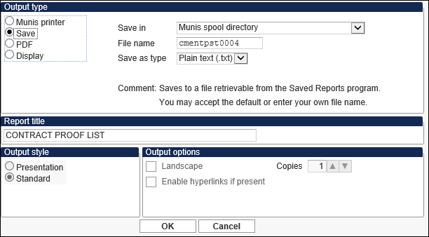
- Select the Output Type and the remaining output options.
- Click OK.
If no out of balance errors are detected, the program displays a Post confirmation message.
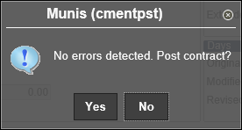
- Click No and review the proof report.
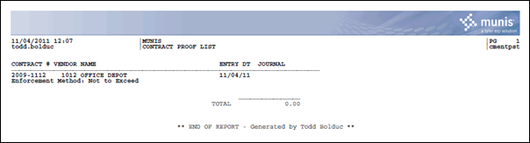
- If the proof report is correct, click Output/Post again, and click Yes for the Post confirmation message.

Status Change
Once posted, the contract has a status of 8–Posted and can no longer be updated. Any changes must be completed using a contract change order.

GL Impact
For an Encumbered Accounts contract, any account entered on the Accounts tab is encumbered for the amount entered. This also reduces the available budget on the general ledger account.

Other Munis Modules Impact
At this point, there is no impact on other Munis modules.

What’s Next?
Once posted, this contract can be referenced on a requisition, purchase order, or accounts payable invoice. Referencing a contract on one of these documents reduces the available amount on the contract and affects the general ledger accordingly.

Contract Approvals

Objective
This document provides instructions on how to review and approve contracts or contract change orders that have been submitted to you through the workflow approval process.

Overview
The contract approval process is initiated when someone enters and releases a new contract or a contract change in the Contract Change Orders program.

Prerequisites
Before you can successfully enter or change a contract, you must ensure that the necessary settings and codes are in place. If settings and codes are not set up, or not set up correctly, you may need to contact your Munis system administrator to have them updated or added into the Munis system.

Confirm the following:

- You have menu access to Contract Change Orders.
- You have the following contract permissions:
- Approve Others’ Contracts (Limit or Full)
- Purchasing department only: Post Others’ Contracts (Full)
- A contract or change order is available for approval.
- At least one COM workflow business rule has been established.
- Your Munis user ID has been entered as a contract approver in the Workflow User Attributes program.
As an approver, you are notified by email or Workflow Assistant of pending contracts for approval.

Procedure
Use the following steps to review and take action on a contract approval:

- Open the Tyler Dashboard.
- Review the Work Flow Manager Web part for the contract approvals that require action. A summary of each record displays.
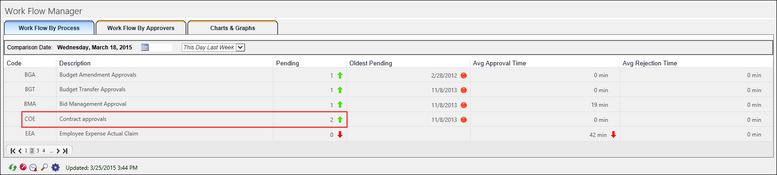
Note: Click the Refresh option to update this window for any new pending records.
- Click the number in the Pending column to expand the Web part and display the records awaiting approval.
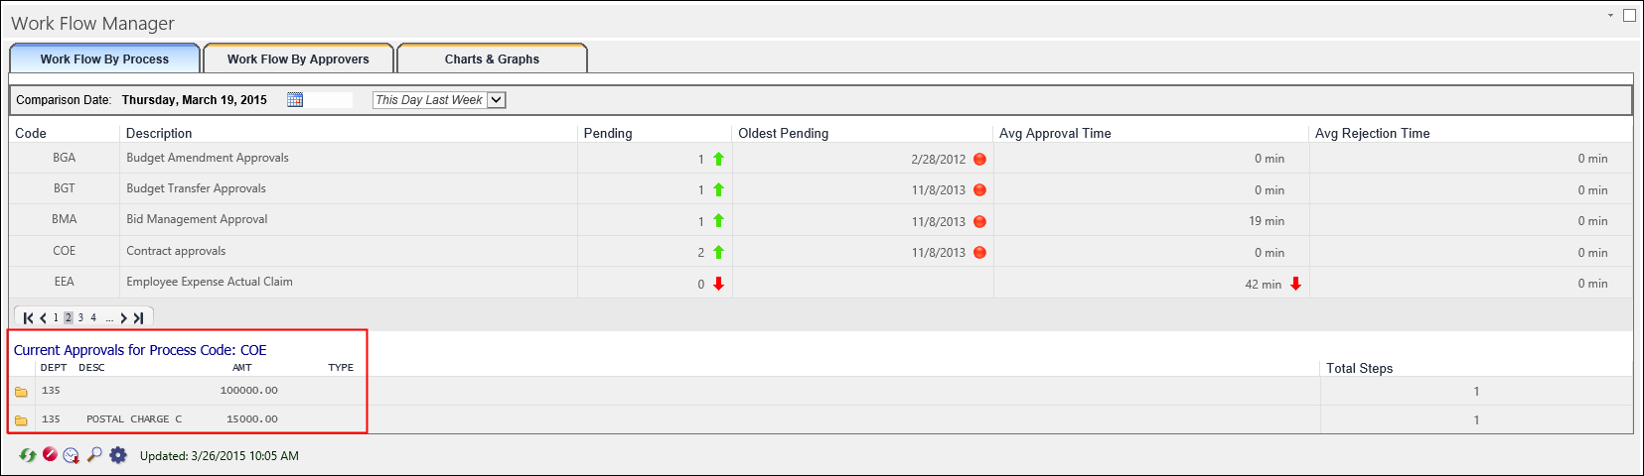
- Click the folder button for a record to view additional information regarding the approval of the record.
- Click the View button for any record to open the Contract Entry program with all of the records awaiting approval as the active set.
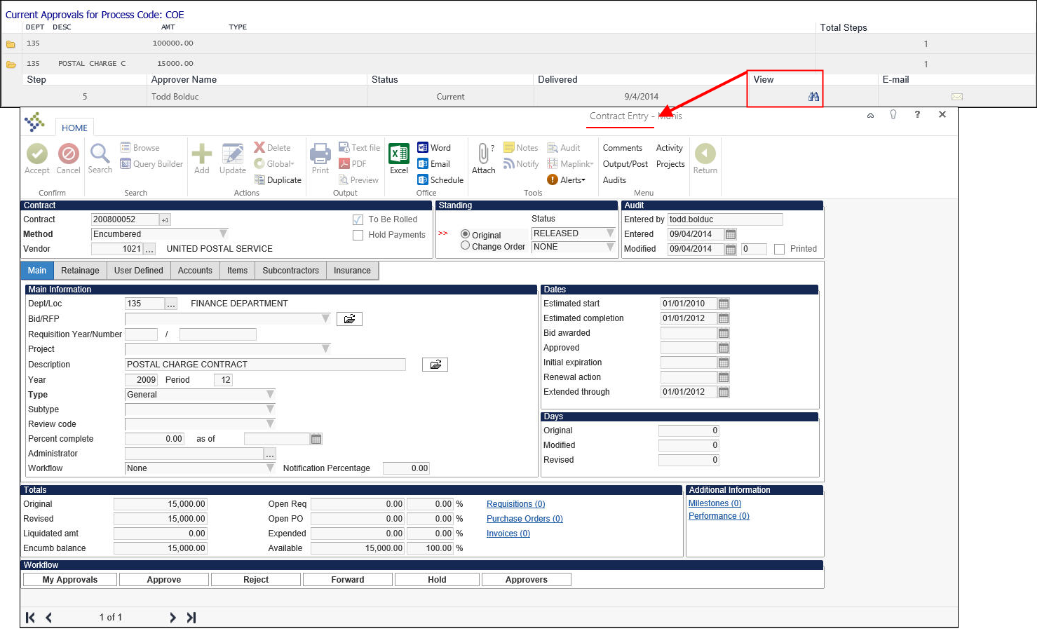
- Review all data included for each contract.
- Select the appropriate workflow action button for the record.
Button | Description
Accept | Identifies the record as approved, and sends notification to the next approver in sequence.
Reject | Rejects the item. You must enter a rejection reason. The program notifies the originator of the rejection and reason. The originator determines the next course of action (alteration and resubmission or deletion).
Forward | Allows you to choose another Munis user to review this pending record
Hold | Retains an item in your approval queue for additional review. It will remain here until further action is taken.
- Close the Contract Entry program and return to the Work Flow Manager Web part.

What’s Next?
After a contract has been approved and posted, it may be referenced on requisitions, purchase orders, and AP invoices. If additional changes need to be made, they may be entered now, as only one change order per contract may be processed at one time.

Contract Change Orders

Objective
This document provides instructions on how to create contract change orders.

Overview
Occasionally, during the life-cycle of a contract, it becomes necessary to make changes to amounts, accounts, line items, or other aspect of the contract. This is done using a contract change order. Changes that involve encumbering or liquidating amounts require the change order to be posted to the general ledger.
When a contract is in the process of being changed, two versions of the contract exist: the original contract and the change order. Only one change order may exist at any time. If your organization uses Workflow, the change order is routed through an online workflow approval process and once approved, the contract change is posted. This incorporates it into the original contract and the change order no longer exists. The original contract, however, has a change number denoting the number of changes that have occurred.
Below are the changes that are possible for each contract type. Note that updates to prior year lines are not allowed.
- Amounts by Segment:
  - Main tab, User Defined tab (if applicable), Subcontractor tab, and Insurance tab information.
  - Accounts tab: Increase or decrease the current fiscal year allocated amount, add a future fiscal year, remove or add an account segment. (If there are line items, change these first because line item totals and the Accounts tab totals must match.)
  - Line Items tab: Add or remove a line item, increase or decrease the quantity or amount of a line item.
- Item/Qty/Cost/Discount:
  - Main tab, User Defined tab (if applicable), Subcontractor tab, and Insurance tab information.
  - Line Items tab: Add or remove a line item, increase or decrease the quantity or amount of a line item.
- Not to Exceed:
  - Main tab, User Defined tab (if applicable), Subcontractor tab, and Insurance tab information.
  - Accounts tab: Increase or decrease the current fiscal year allocated amount, add a future fiscal year amount.
- Encumbered Accounts:
  - Main tab, User Defined tab (if applicable), Subcontractor tab, and Insurance tab information.
  - Accounts tab: Increase or decrease a current fiscal year allocated amount and account, add a future fiscal year account and amount.
- Non Encumbered Accounts:
  - Main tab, User Defined tab (if applicable), Subcontractor tab, and Insurance tab information.
  - Accounts tab: Increase or decrease a current fiscal year allocated amount and account, add a future fiscal year account and amount.

Prerequisites
Before you can successfully change a contract, you must ensure that the necessary settings and codes are in place. If settings and codes are not set up, or not set up correctly, you may need to contact your Munis system administrator to have them updated or added into the Munis system.

Confirm the following:
- You have menu access to the Contract Entry program.
- You have the appropriate user permissions for Contract Management:
  - Maintain Own Posted Contracts
  - View Contracts by Department: Limited to own departments
  - Create/Maintain Amounts by Segment
- Active general ledger accounts exist in the General Ledger Accounts program.
- There must be a valid e-mail address for your user ID in the User Attributes program.
- The Use Workflow for Posted Contract Changes check box must be selected in the Contract Settings program.

Procedure
Use the following steps to make changes to a contract:
- Open the Munis Contract Change Orders program.
Financials > Purchasing > Contract Management > Contract Change Orders
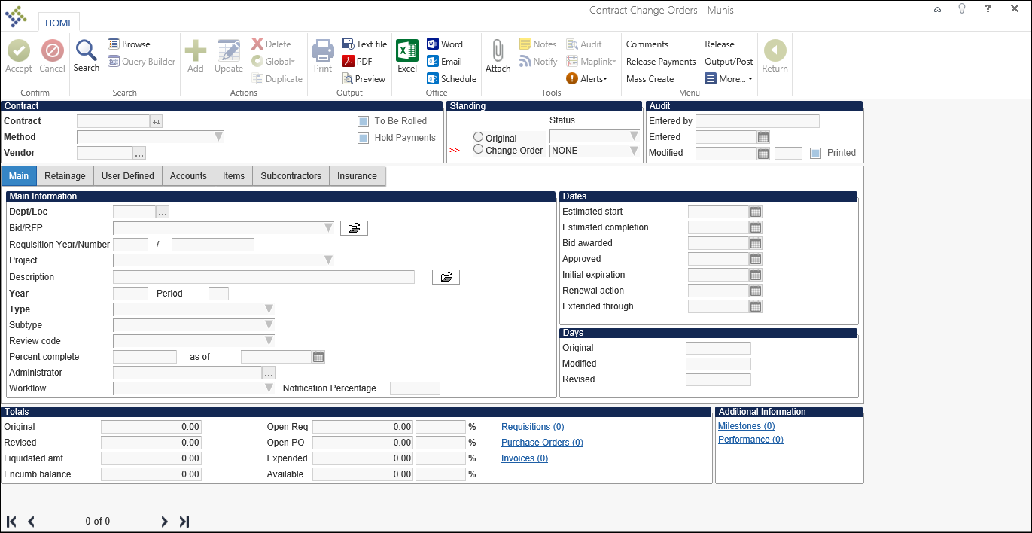
- Click Search to search for the contract to change.
- Enter the applicable search criteria. Search criteria might include the contract number, vendor, or project. According to permissions, you are restricted to viewing contracts for your department.
- Click Accept to initiate the search. If you find more than one contract, scroll through the list to find the contract to change.

Changes to Informational Details
To update information on the Main, User Defined, Subcontractor, or Insurance tabs:
- Click Update.
The program displays the Change Order Reason box.
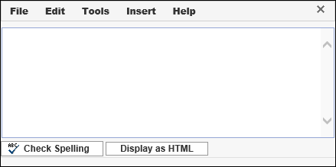
- Enter the reason and click Save on the File menu.
- Click Exit on the File menu to return to the contract record.
- Make the required changes, and then click Accept to save the changes.
- Click Release to release the change to the Workflow process or, if Workflow is not in place, to complete the change.

Changes to Accounts or Amounts (No Line Items)
To add new general ledger accounts or to increase or decrease the existing contracted amounts on a contract that does not contain line items:
- Select the Accounts or Amounts tab and click Update.
The program displays the Change Order Reason box.
- Click Save on the File menu to save the note.
- Click Exit in the File menu to close the Change Order Reason screen and return to the main screen.
For existing accounts, enter the new total amount for that account. For example, if the amount for the line is currently $500 and you want to add $100, enter $600. For new accounts, move to the first available field and enter the account or segments and amount.
- Click Accept to save the changes.
- Click Release to release the change to the Workflow process or, if Workflow is not in place, to complete the change.

Changes to Line Items
To add new items/commodities, general ledger accounts or to increase or decrease the existing contracted amounts on a contract that has line items:
- Select the Items tab and click Update.
The program displays the Change Order Reason box.
- Enter the change reason, and then click Save on the File menu to save the note.
- Click Exit in the File menu to close the Change Order Reason screen and return to the main screen.
- Enter the required changes.
- Click Accept to save the changes.
- Click Release to release the change to the Workflow process or, if Workflow is not in place, to complete the change.

Change Order Options
Option | Description
Comments | The Comments option allows you to enter or change free form contract notes.
Hold/Release Payments | Selects or clears the Hold Payments check box on the contract header. You can create invoices, but cannot post invoices against the contract when the Hold Payments check box is selected.
Mass Create | The Mass Create option displays the Mass Create screen, where you can create or update genereral ledger accounts for a contract. This option is applicable when the value of the Account Entry Method field on the Attributes tab in the User Attributes program is Org.
Release | The Release option submits the contract change order to the workflow approval process.
Output/Post | The Output/Post option is used by Purchasing to post the approved contract changes to the general ledger.
Activate | The Activate option is only used in Contract Entry to reactivate a rejected contract so that changes may be made.
Close Contract | The Close Contract option is only accessible when the contract status is 8-Posted and there is no existing change orders, no open requisitions or purchase orders against the contract, and no invoices in the proof file that contain a purchase order that was entered against this contract.  When you click Close Contract, the program fully liquidates the contract, reversing any remaining general ledger encumbered amounts, if the contract encumbered accounts. A COL journal is created for encumbered contracts when open amounts remain on lines for the current year, next year, and a report is produced. Contract detail lines that did not encumber accounts are liquidated, but no journal or general ledger update occurs and they are not included on the report. The contract status is updated to 10-Closed and the contract number is no longer available to use on a requisition or purchase order. Purchase orders that contain this contract number are no longer available for use during Invoice Entry. You cannot process change orders against a closed contract.  For contracts that encumber accounts, a journal entry is created and accounts are updated for current year and next year only. All other years update the contract detail lines only and do not update the general ledger. If none of the accounts have money needing to be unencumbered/liquidated, the program updates the contract status to 10-Closed.  For each account that has money to be unencumbered or liquidated, the program updates the account's liquidated amount for the appropriate fiscal year, increasing it by the calculated amount.  If the account is not a balance sheet account and the detail line is for the current or next year, the program updates the general ledger by reducing the encumbrance amount by the calculated amount. If the journal's fiscal year is equal to the current fiscal year, then update the current year's encumbrance amount. Otherwise update the next year's encumbrance amount.
Open Contract | The Open Contract option allows you to reopen a status 10-Closed contract that has not been completely expended on detail lines for the current year or greater. The program re-encumbers the portion of the contract that has not yet been expended on those detail lines only, creating an available amount. It also reduces the liquidated amount by the same value, thereby creating an encumbrance open balance. A COL journal is created when the contract encumbers accounts for current and next year lines only and a report is produced. The contract status is updated to 8-Posted.
Audits | The Change History option will display all changes to a contract. The display includes the date, time, and reason for a change. You cannot update the information, but you can create a report or export the information to Microsoft Excel.
Activity | The Activity option displays actions taken on the contract. The display includes activities such as printing, approval, or closing. You cannot update the information, but you can create a report or export the information to Microsoft Excel.
Projects | The Projects option displays all project codes that exist on the contract detail lines. It also displays purchase order and invoice amounts that are currently outstanding for the contract/project combination. You can select a record from the list to view a purchase order or invoice details.

What’s Next?
The contract is routed to the appropriate approver according to the defined business rules. Click Approvers to view the list of approvers for the action.

The contract is comprised of two parts until it is approved: the original contract and the change order. Once the contract is approved, it is posted to the general ledger. You can only process one contract change at a time; if there are additional changes, you must process these once the current change order is posted.

Print Contracts
The Print Contracts program prints contracts in XML format. You can print the contracts immediately or you can use the Munis® Scheduler program to print the contracts at a later time or at recurring intervals. When printing a contract, the program also prints any public attachments for the contract.

Field | Descriptions
Define Criteria
Execute This Report | This list allows you to use Munis Scheduler to process the report. If you select Now to process the report immediately, click the Preview, PDF, Print, or Text File button to view, print, or save the report. If you select In Background (now) to process the report a single time using the event log and e-mail notification features, or if you select At a Scheduled Time to establish a specific time when the report runs, the program uses Munis Scheduler.
Report Type | This list determines the type of report to create: Standard or Rolled. Standard reports include all contracts, while a Rolled report is filtered based on whether contracts have been rolled to a new year or not.  Selecting Rolled makes the Rolled Status list accessible.
Print/Reprint | These options indicate whether this is an initial print for the selected contracts or a reprint of previously printed contracts.  The default selection is Print.
Encumbered/Non-encumbered/All | These options direct the program to include only contracts that are encumbered, contracts that are not encumbered, or all contracts.  Contracts are determined to be encumbered or non-encumbered by their enforcement method.
Include Contracts | This is the range of contracts to include in the print.
Department/Location | This is the department/location code associated with the contract.
Entered | This is the fiscal year for the contracts to be printed.  Type a year in YYYY format or type 0 to include all years.
GL Allocation | This is the general ledger allocation year for the contract.  Type a year in YYYY format or type 0 to include all years.
Status | This list refines the report to include contracts of a specific status. Select All to include all contracts, regardless of status.
Exclude Contracts with Change Orders | When this check box is selected, the report does not include any contracts for which pending change orders exist.
Rolled Status | This list allows you to define the report to include only contracts that have not been rolled to the new year, partially rolled, fully rolled, not rolled and partially rolled, or all contracts regardless of rolled status. This reporting option is intended to be used as part of the year end close process to identify any contracts that have not yet been rolled.  The list is only available when the value of the Report Type list is Rolled.
Totals
Selected | This box displays the number of records selected to print.
Printed | This box displays the number of records actually printed.

Procedure
Use the following steps to print contracts.
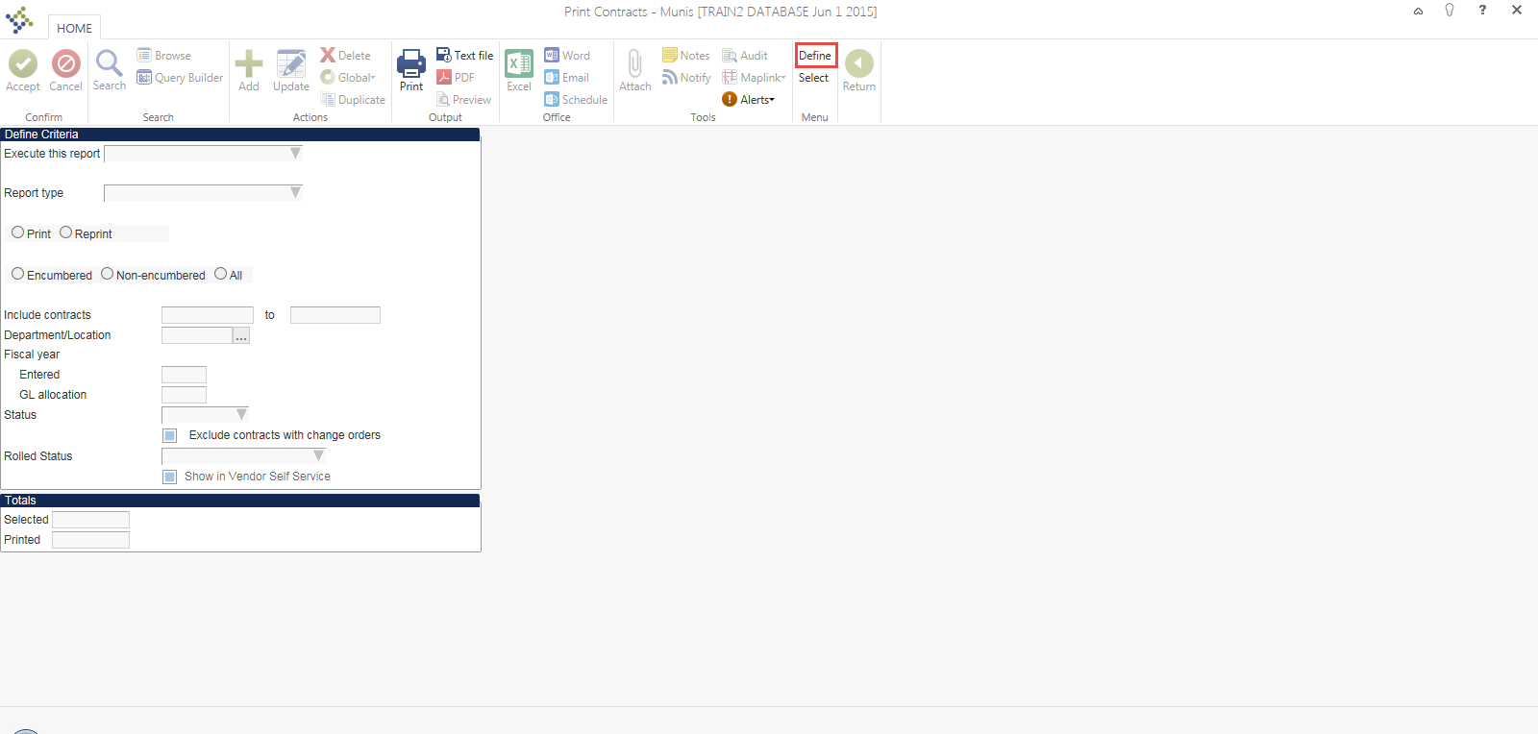

- Select Define in the top right portion of the Ribbon.
- The fields will then allow the user to select when the user would like to have the report to print. Now, In the Background (now) or At a scheduled time).
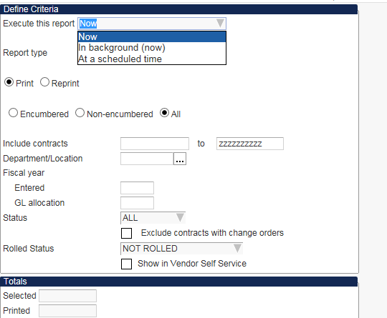

- Select if the print job will be a Print or reprint of the Contract.
- The user can select to search for Encumbered, Non-Encumbered or all contract types.
- The user also has the availability to print a range of contracts.
- Once all options for the users selection has been satisfied select the Accept button from the Ribbon.
- Then click Select from the Ribbon.
- The total contracts that have been selected form the search criteria will be displayed at the bottom of the screen.

- After the items have been selected.
- Click the Print Icon from the Ribbon.
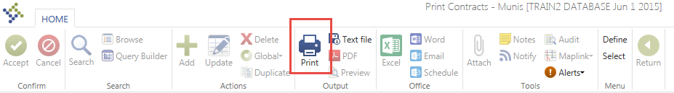

- On the following screen, click the elipses.

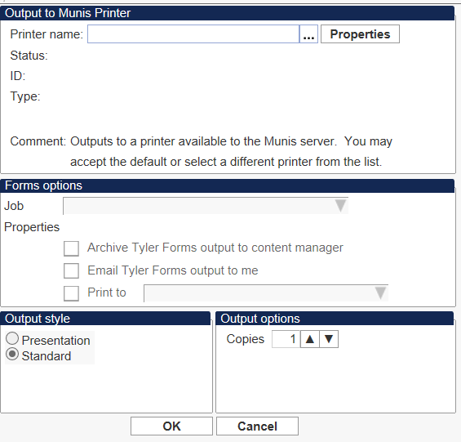

- The following screen will come up. Choose TYLERFORMS GEN and click 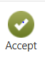.

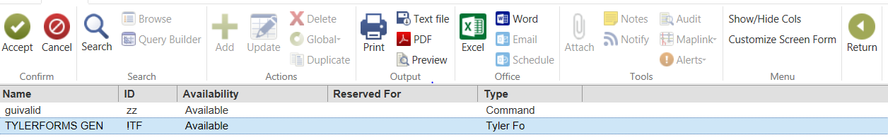

- On the following screen ensure that:
Job = “Print AP Contracts”
“Archive Tyler Forms output to content manager” is selected
“Print to Contracts Printer” is selected.
If you wish to have a copy of the Tyler Forms output emailed to you, select that box also.

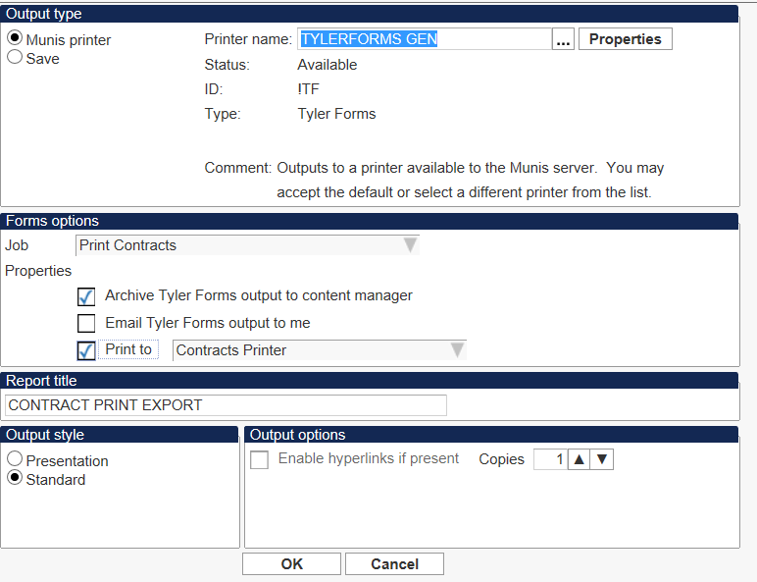
- Click “OK”.

