Munis Bid Management
______________________________________________________
Procedural Documentation

For more information, visit www.tylertech.com.

TABLE OF CONTENTS

Setting up Bid Codes 3
Create a Basic Bid Record 6
Define Bid Groups and Items 11
Add Vendors to a Bid 15
Define Requesting Departments 19
Enter Requested Quantities 23
Bid Evaluations and Templates 27
Assign Bid Evaluators 35
Add Attachments and Define Bid Events 39
Release a Bid for Proposals 44
Create Bid Addenda 49
Award Bids 54
Convert a Bid 59

Setting up Bid Codes

Objective
This document provides instructions on how to define the various codes needed to successfully create and process Munis bid records.

Overview
Munis Bids requires the creation of question priority and category codes, as well as event type codes. Each of these codes is defined in a separate Munis program.

Prerequisites
Before you can successfully complete this process, you must ensure that roles granting the necessary permissions have been assigned to your user account. If the roles have not been established, contact the system administrator to have them updated or added into the Munis system.

Confirm the following:

- You have menu access to the Bid Question Priorities, Bid Question Categories, and Bid Event Types programs.

Procedure
Complete the following steps to create the required codes:
- Open the Bid Question Priorities program.
Financials > Purchasing > Bid Management > Setup > Bid Question Priorities
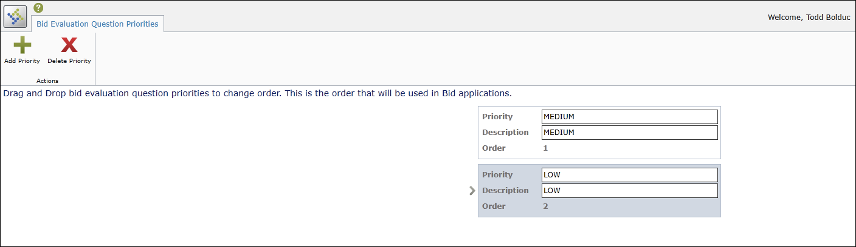
- On the ribbon, click Add Priority.
The program adds a new set of priority fields to the screen.
- Enter the priority code in the Priority box, and a description in the Description box.
The program automatically places the code in the last available order position. The order position determines the order in which the priorities are presented as options in other Bid Management programs.
- If the priority code should be in a different position in the order, click and drag the code tile to a new position.
The program automatically renumbers all of the codes according to the new positions.
- Click Save.
The program saves the new priority code in the assigned position.
- Close the Bid Question Priorities program.
- Open the Bid Question Categories program.
Financials > Purchasing > Bid Management > Setup > Bid Question Categories
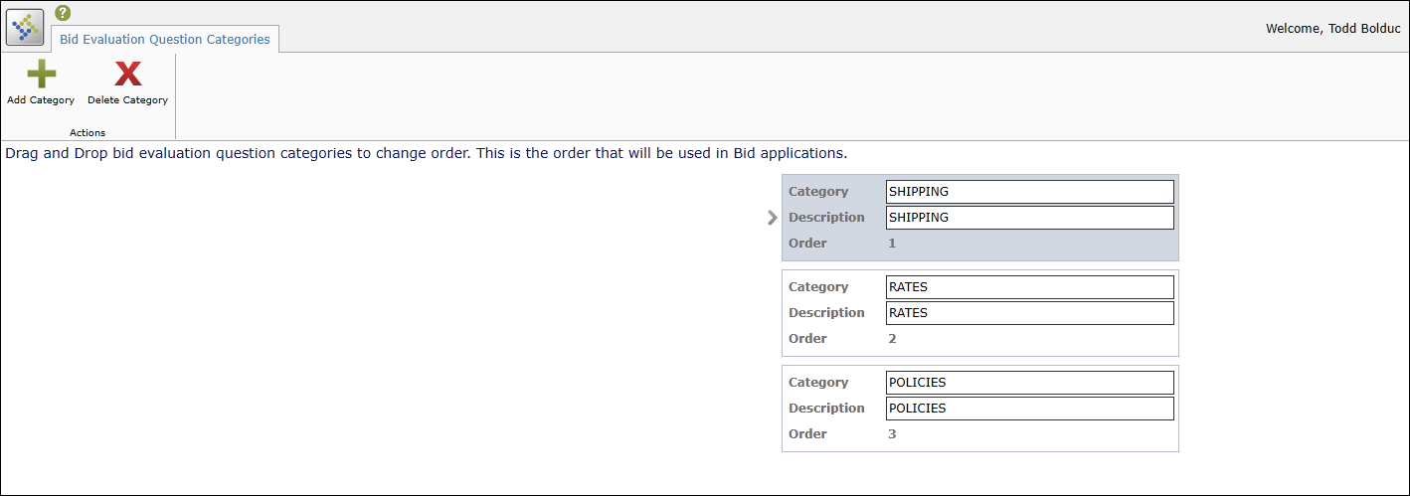
- On the ribbon, click Add Category.
The program adds a new set of category fields to the screen.
- Enter a code value in the Category box, and a description in the Description box.
The program automatically places the code in the last available order position. The order position determines the order in which the categories are presented as options in other Bid Management programs.
- If the category code should be in a different position in the order, click and drag the code tile to a new position.
The program automatically renumbers all of the codes according to the new positions.
- Click Save.
The program saves the new category code in the assigned position.
- Close the Bid Question Categories program.
- Open the Bid Event Types program.
Financials > Purchasing > Bid Management > Setup > Bid Event Types
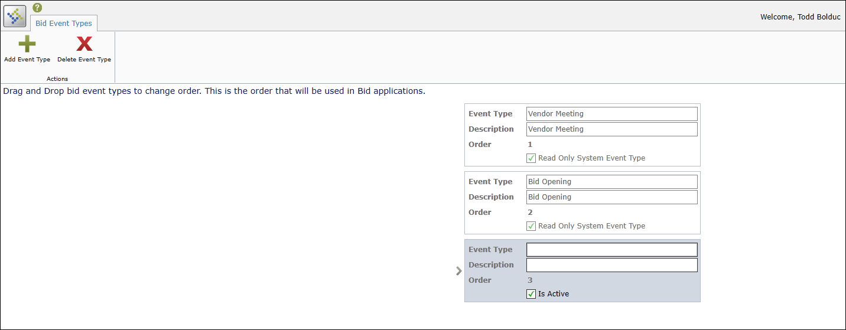
- On the ribbon, click Add Event Type.
The program adds a new set of event type fields to the screen.
- Enter a code value in the Event Type box, and a description in the Description box.
- Select or clear the Is Active check box to activate or deactivate the event type code. Inactive event codes cannot be used to create new bid records. The program automatically places the code in the last available order position. The order position determines the order in which the events are presented as options in other Bid Management programs.
- If the event type code should be in a different position in the order, click and drag the code tile to a new position.
The program automatically renumbers all of the codes according to the new positions.
- Click Save.
The program saves the new event type code in the assigned position.
- Close the Bid Event Types program.

Results
You have defined one or more codes of each of the required types (priority, category, and event). These codes are used when you create a new bid record.

What’s Next?
Use the Bid Central program to create bid records using the codes.
Create a Basic Bid Record

Objective
This document provides instructions on how to initiate a bid using the Bid Central program.

Overview
The Bid Central program provides the ability to create and process Munis bids.

Prerequisites
Before you can successfully complete this process, you must ensure that roles granting the necessary permissions have been assigned to your user account. If the roles have not been established, contact the system administrator to have them updated or added into the Munis system.

Confirm the following:

- You have menu access to the Bid Central program.
- In the Bid Settings program, the Next Bid Number field has been completed.
- Bid question priority and category codes have been defined
- Bid event type codes have been defined.

Procedure
Complete the following steps to create a bid:
- Open the Bid Central program.
Financials > Purchasing > Bid Management > Bid Central
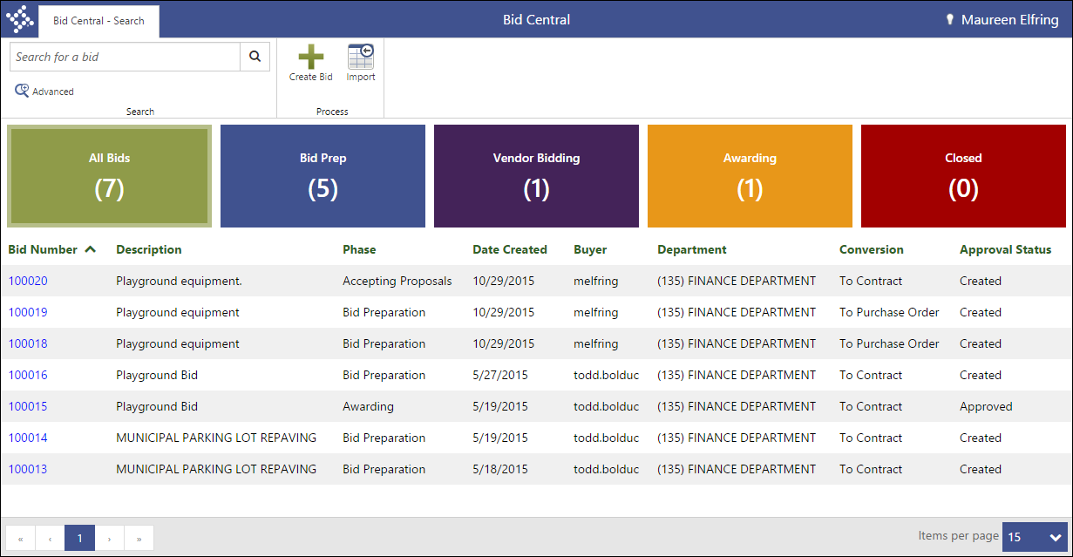
- On the ribbon, click Create Bid.
The program refreshes to display the Bid Preparation page.
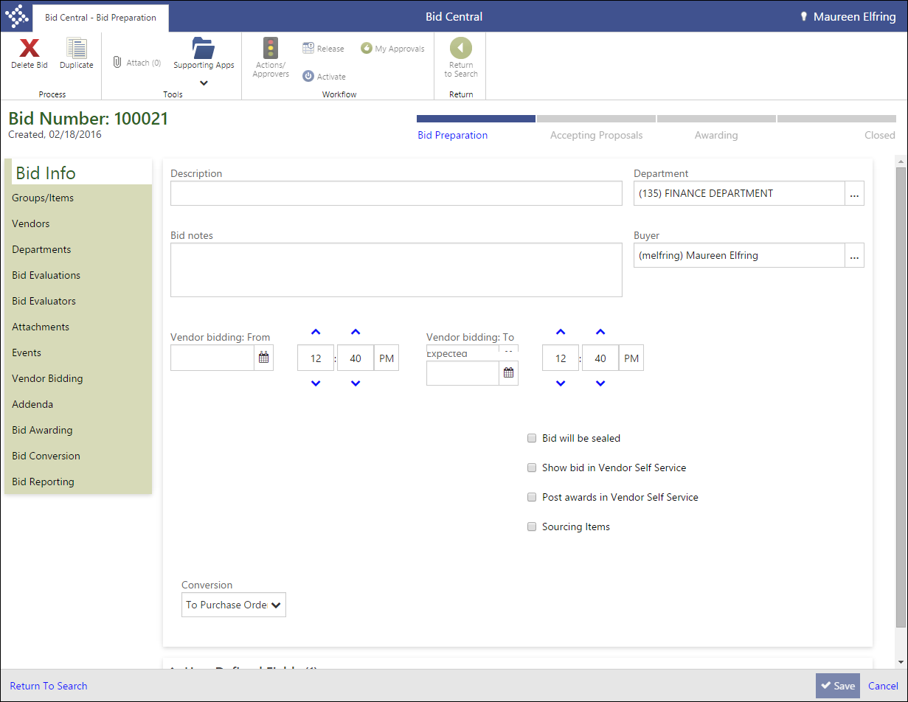
- Complete the fields on the Bid Info tab, using the Field Descriptions table as a reference.
Field | Description | Notes
Bid Number | Defines the bid number using the next available number as defined in Bid Settings. You cannot manually change this value.
Bid Info
Description | Provides a general description of the bid.
Department | Identifies the department responsible for administration of the bid. The default value is the department associated with your Munis user ID.
Bid Notes | Stores notes associated with the bid.
Buyer | Contains the Munis user ID of the bid buyer.
Vendor Bidding From/To | Sets the dates and time within which vendor proposals for the bid record are accepted. Vendors cannot submit bids in Vendor Self Service outside of the opening and closing dates.
Bid Opening | Indicates the date and time upon which the bid will be opened by your organization in order to review and evaluate the submitted vendor proposals.
Bid Awarding | Identifies the expected date upon which the bid will be awarded by your organization to one or more vendors.
Bid Will Be Sealed | Indicates that the bid record is sealed. Vendor responses to sealed bids cannot be viewed until the Bid Opening date.
Show Bid in Vendor Self Service | Causes the bid record to be visible to vendors in Vendor Self Service (VSS). If the bid is not available in VSS, vendors must submit hard copy responses and those responses must be manually entered in Bid Central by your organization.
Post Awards in Vendor Self Service | Directs the program to publish the results of the bid awarding process to Vendor Self Service.
Sourcing Items | Defines the bid as requiring each line item to have an item reference from the Item File. When a bid with this check box selected is awarded, the program creates Item Supplier Records in the Item File.
Include Manufacturer Information | Displays manufacturer and part information on the Groups/Items page. For organizations that use Vendor Self Service, selecting this option also displays manufacturer and part information in bid invitations in VSS.
Bid by Invitation | When selected, VSS allows only the vendors on the Vendors tab’s Included Vendors list to view and submit proposals for the bid.
Type | Indicates the type of bid. Bid types are created and maintained in the Bill Types program.
Conversion | Determines the type of record to create when converting the awarded bid. Select Requisition, Purchase Order, or Contract.
Enforcement Method | Provides the enforcement method of the contract created when the bid is converted. This list is only visible when you select Contract from the Conversion list.
User Defined Fields
Field Name  Required  Value | Contains any custom fields that have been defined for your organization using the User Defined Fields program.  In order for a user-defined field to display in this group, it must have an Application ID of bqcatbld.
- Click Save.
The program saves your entries and creates the basic bid record.

Results

A basic bid has been created with a minimum of information.

What’s Next?
You must add additional bid information to the record on the remaining tabs.

Define Bid Groups and Items

Objective
This document describes the steps taken in order to define groups and items for a bid record.

Overview
The Groups/Items tab of the Bid Central program defines the line items and item groups that make up a bid record. Every bid must contain at least one bid group, but the group is not required to contain any items. To this end, Bid Central automatically adds a single default group to every bid record. If the bid will not require any additional items, you can skip this step of the bid creation process.
Bid Items can be items from the Items program, commodity codes, or text descriptions of items or tasks needed by your organization. Bid items can also be automatically defined when a bid record is created from an item request in the Request for Items program.

Prerequisites
Before you can successfully complete this process, you must ensure that roles granting the necessary permissions have been assigned to your user account. If the roles have not been established, contact the system administrator to have them updated or added into the Munis system.

Confirm the following:

- You have menu access to the Bid Central program.
- The bid to which to add groups and items has been created.
- If the bid was created by another user, your user role has been assigned permission to view and maintain others’ bids in the Bid Management Roles program.

Procedure
Use the following steps to add bid groups and items to a bid record:
- Open the Bid Central program.
Financials > Purchasing > Bid Management > Bid Central
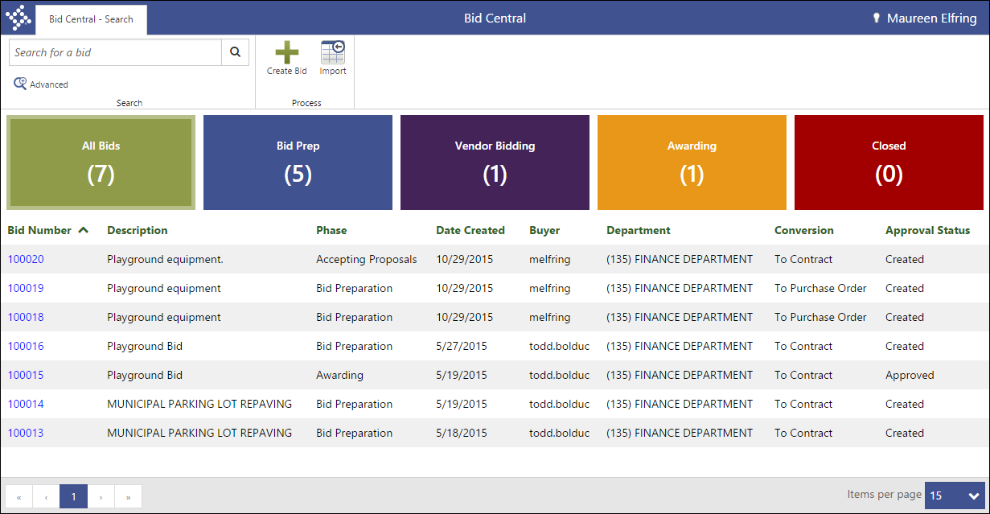
- From the Bid Number column, click the bid for which to add groups and items.
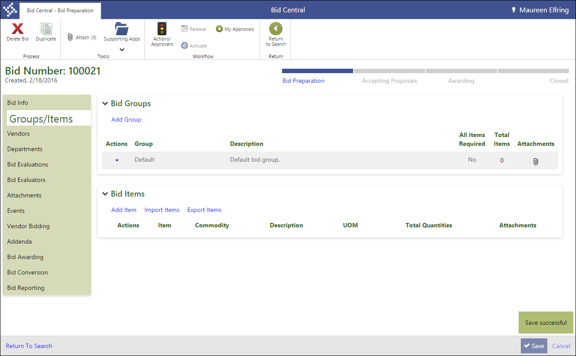
- On the Bid Preparation page, select Group/Items.
- Click Add Group.
The page refreshes to include the Bid Groups fields.
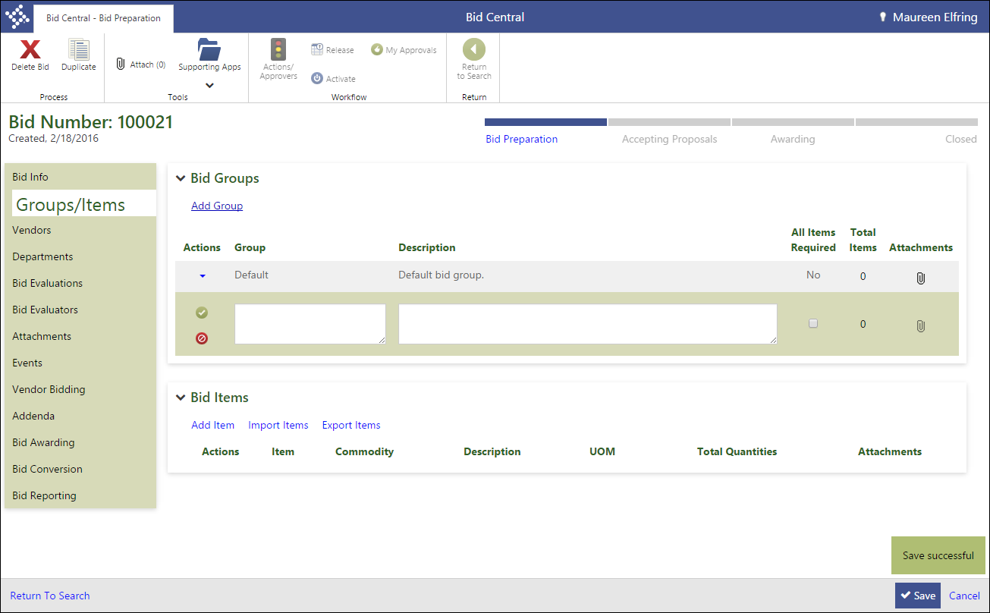
- Enter a group name and description.
- If a vendor must enter a response for every item in the bid group when creating a proposal, select the All Items Required check box.
- Click Save for the individual group.
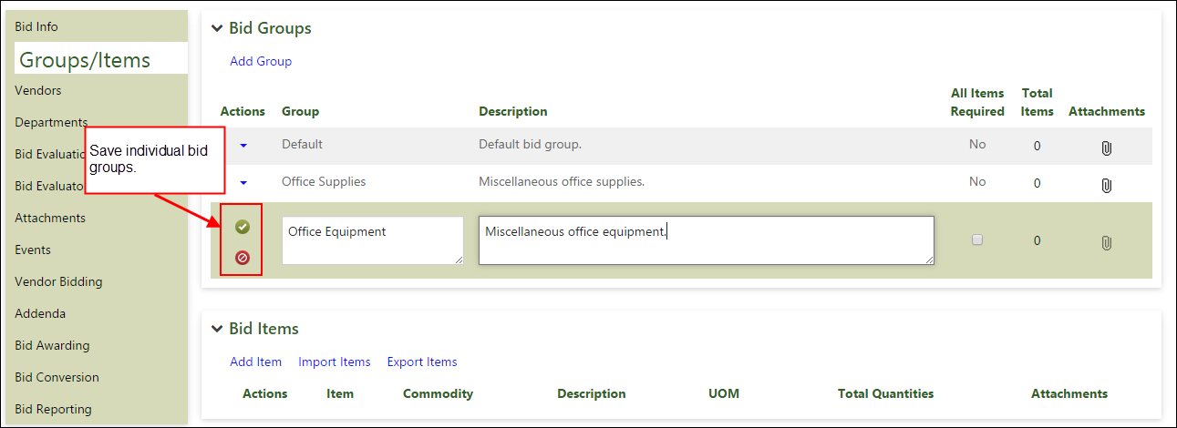
- Continue to add bid groups as needed.
- Once you have added groups, use the Actions menu for each to edit or delete the group details.
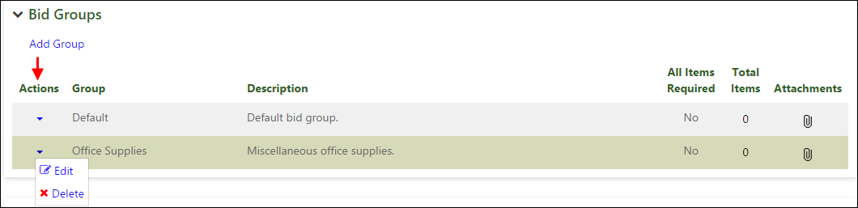
- When you have finished adding groups, highlight a group name and then click Add Item in the Bid Items group.
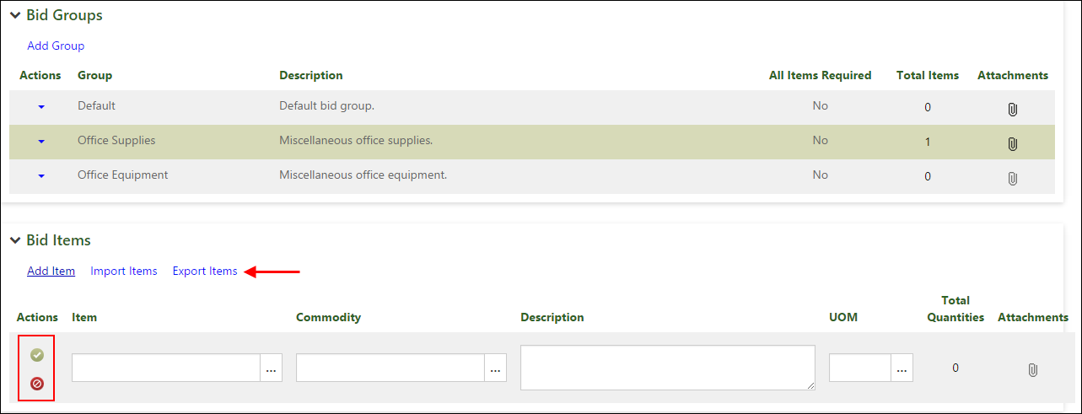
- Complete the item details, selecting either an item or a commodity for each.
- Complete the Description and UOM fields. If the program enters default values, you can change the values as needed.
- Save each individual item as you add it.
- Click Save.
The program saves the groups and items.
For Bid Items, the Import Items and Export Items options are available to support your bid item management.

Results
You have added one or more groups and items to the bid record.

What’s Next?
Specific vendors must be added to the bid in order to invite those vendors to bid using Vendor Self Service.

Add Vendors to a Bid

Objective
This document provides instructions on the steps needed in order to add vendors to a bid using the Bid Central program.

Overview
When you create a bid, you must add vendors to the bid record that are invited to submit proposals. These vendors are then notified by email that the bid is available for submissions. The vendors can submit their proposals using Vendor Self Service.

Prerequisites
Before you can successfully complete this process, you must ensure that roles granting the necessary permissions have been assigned to your user account. If the roles have not been established, contact the system administrator to have them updated or added into the Munis system.

Confirm the following:

- You have menu access to the Bid Central program.
- The bid to which to add vendors has been created.
- If the bid was created by another user, your user role has been assigned permission to view and maintain others’ bids in the Bid Management Roles program.

Procedure
To add vendors to a bid:
- Open the Bid Central program.
Financials > Purchasing > Bid Management > Bid Central
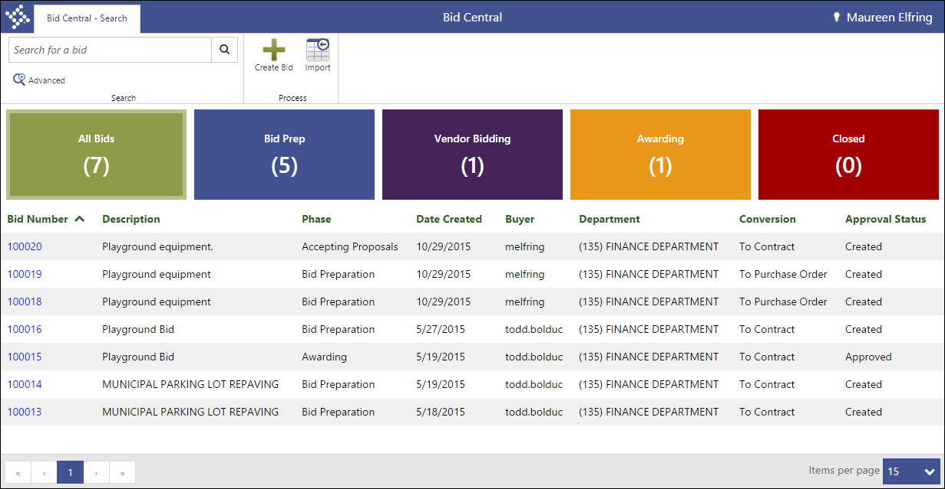
- From the Bid Number column, click the bid for which to add groups and items.
- On the Bid Preparation page, select Vendors.
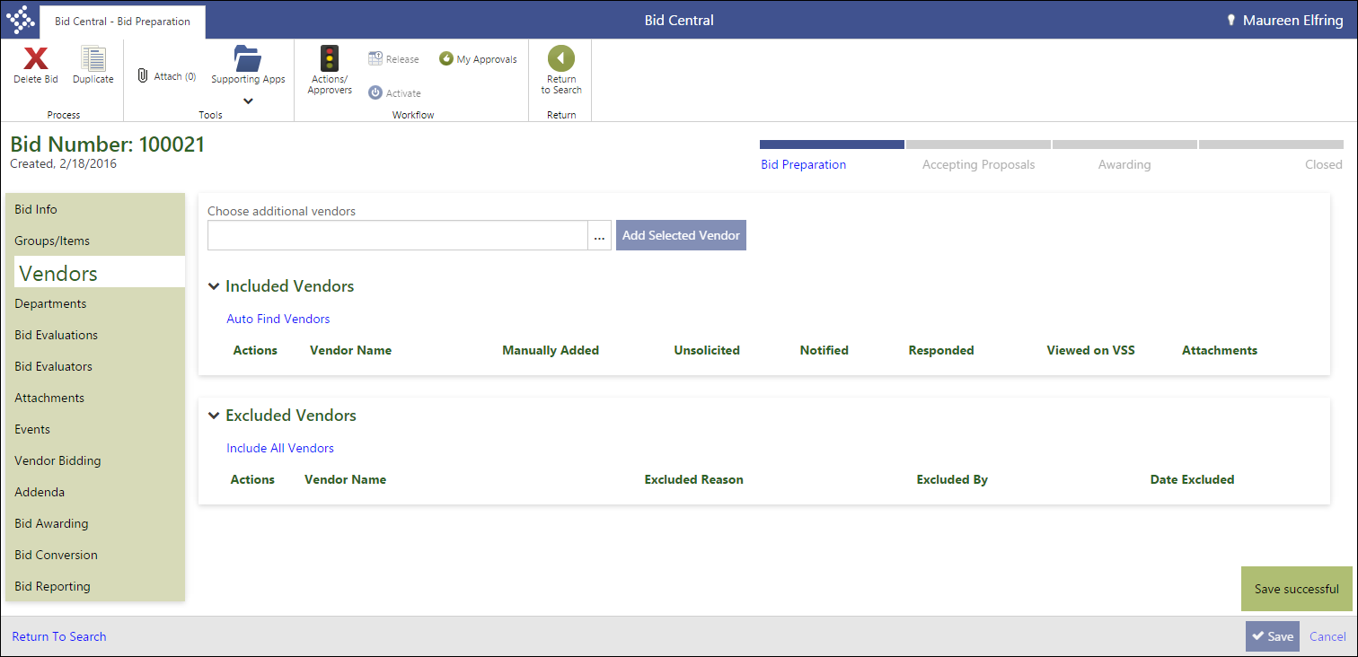
- In the Included Vendors group, click Auto Find Vendors.
The program examines the bid items and commodities on the bid, and adds any vendor that has been defined as a supplier for that item or commodity.
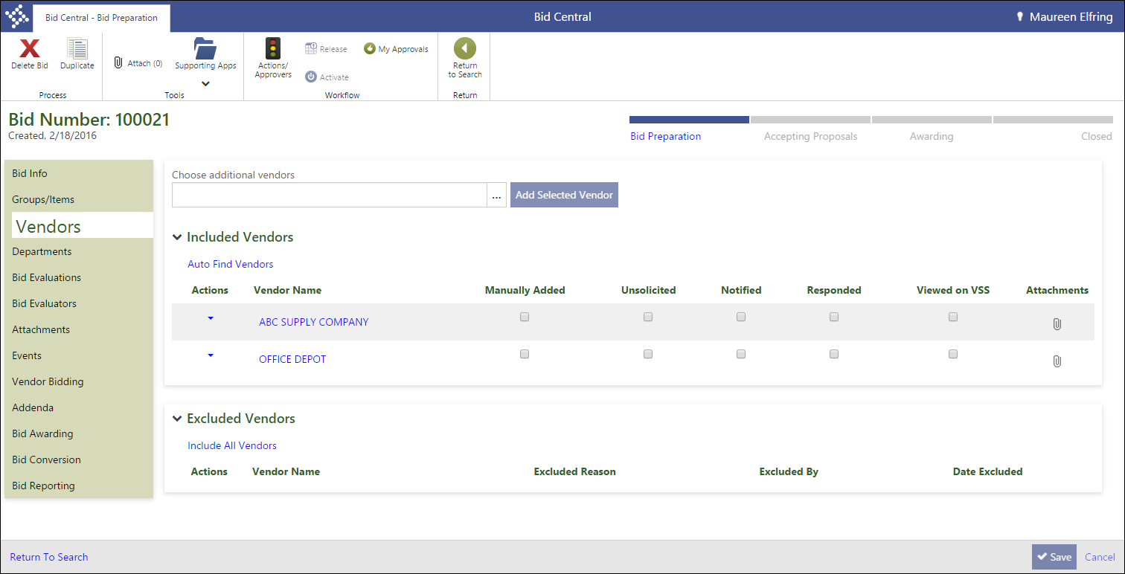
- Use the Choose Additional Vendors list to select any vendors to add to the bid that the program did not automatically add.
- To move a vendor to the Excluded list, click the Actions menu and select Exclude.
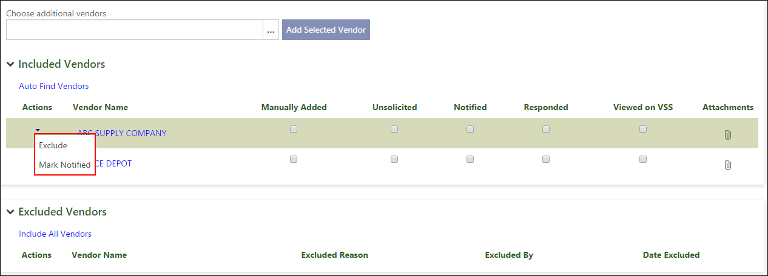
- Enter a reason for the exclusion in the dialog that displays.
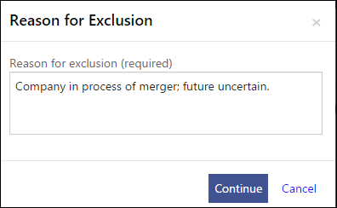
The program moves the vendor to the Excluded Vendors groups.
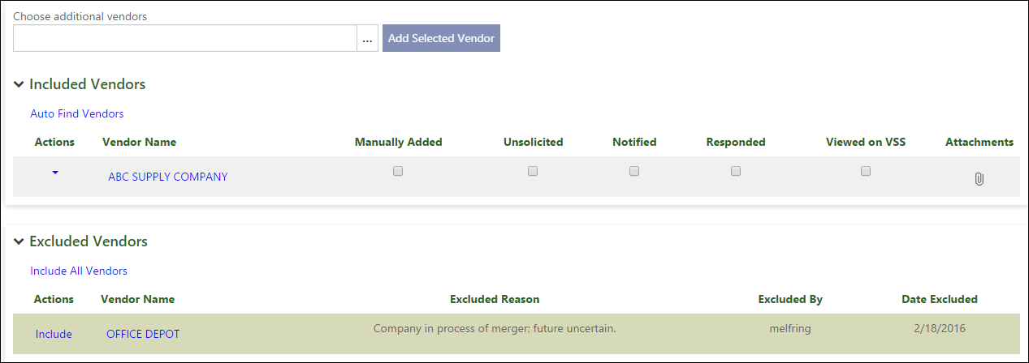
- Click Save.
The program saves your entries and exclusions.

Results
You have added one or more vendors to the bid record.

What’s Next?
You must define the departments within your organization that are eligible to submit requested quantities of bid items. The requested quantities are totaled across all departments when the bid is made available for vendor proposals.

Define Requesting Departments

Objective
This document provides instructions regarding the addition of departments to a bid record.

Overview
In order to enter requested bid item quantities on a bid, a department must be assigned permission to do so in the Bid Central Program.

Prerequisites
Before you can successfully complete this process, you must ensure that roles granting the necessary permissions have been assigned to your user account. If the roles have not been established, contact the system administrator to have them updated or added into the Munis system.

Confirm the following:

- You have menu access to the Bid Central program.
- The bid to which to add departments has been created.
- If the bid was created by another user, your user role has been assigned permission to view and maintain others’ bids in the Bid Management Roles program.
- In order to use Munis Workflow to notify departments of bid availability, you must create the BON - Bid Ordering Notifications business rule.

Procedure
To add departments to a bid:
- Open the Bid Central program.
Financials > Purchasing > Bid Management > Bid Central
- From the Bid Number column, click the bid for which to add groups and items.
- On the Bid Preparation page, select Departments.
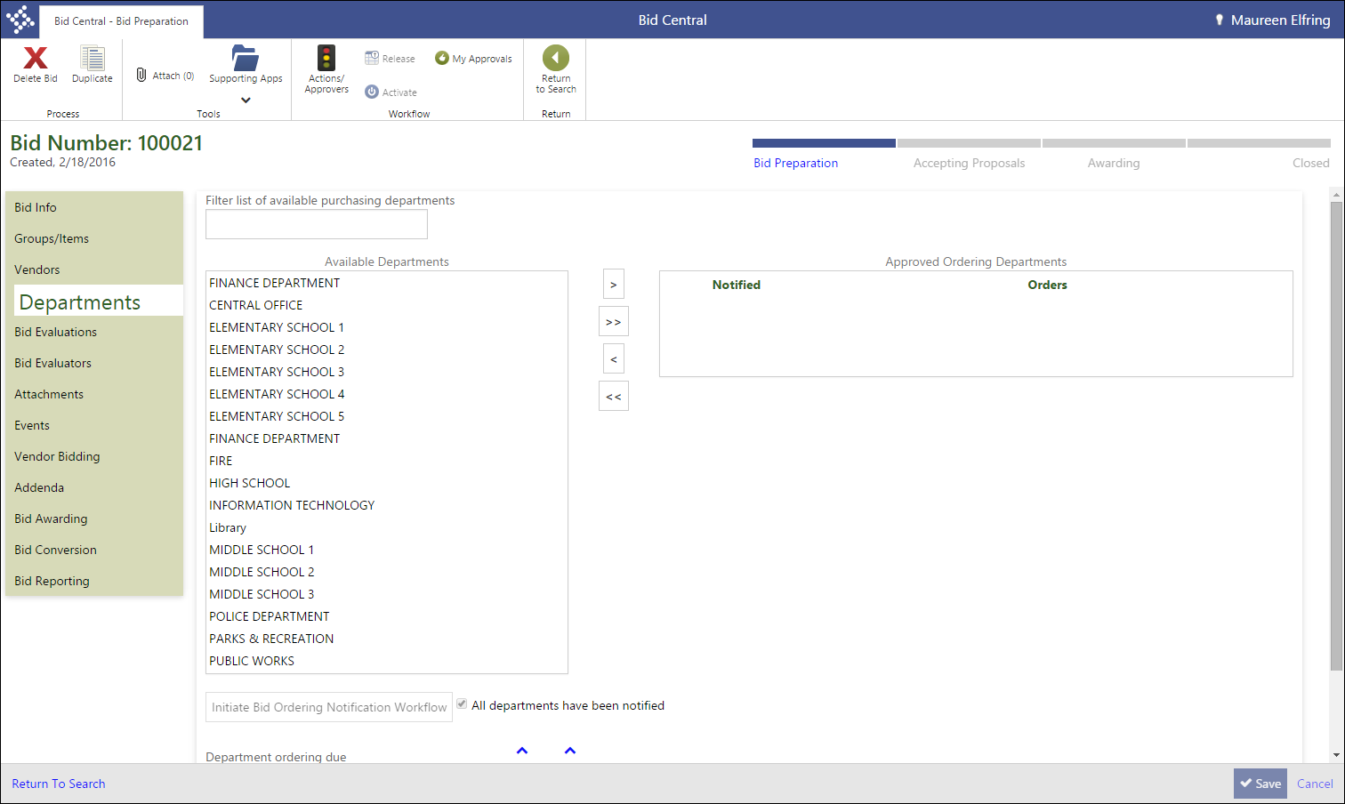
The Departments tab lists all of the departments that exist in your Munis database.
- Select a department from the Available Departments list by clicking the department name.
- Use the right arrow button to move the selected department to the Approved Ordering Departments list.
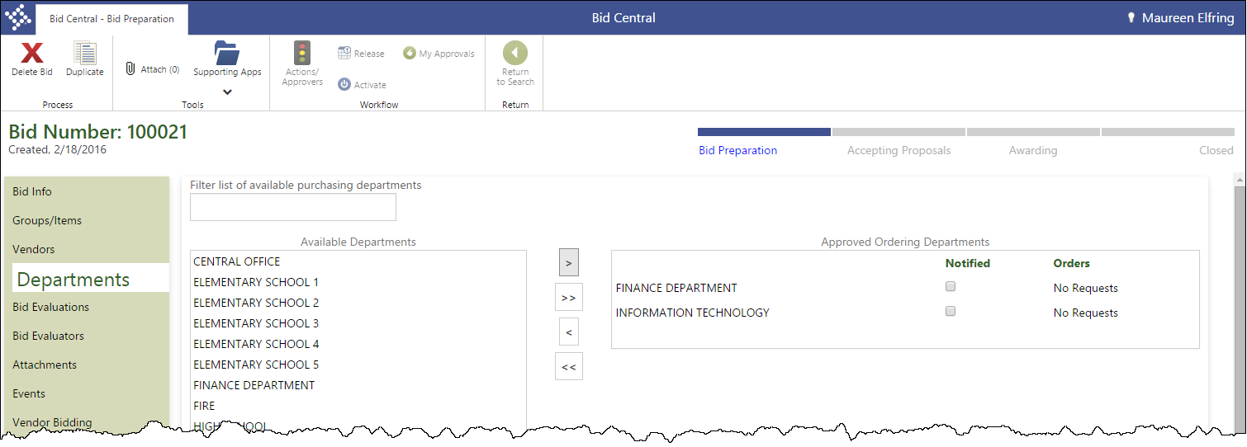
Alternatively, use the double right arrow to move all departments in the Available Departments list to the Approved Ordering Departments list.
In the Department Ordering Due fields, specify the date and time by which all departments’ requests must be submitted.
- Click Save.
The program saves your entries and makes the Initiate Bid Ordering Notification Workflow option accessible.
- Click this option to notify the approved departments using the BON–Bid Ordering Notification workflow business rule.
The program displays a confirmation message.
- Click OK.
The program generates the notification emails, and selects the Notified check box for each department that was successfully notified.
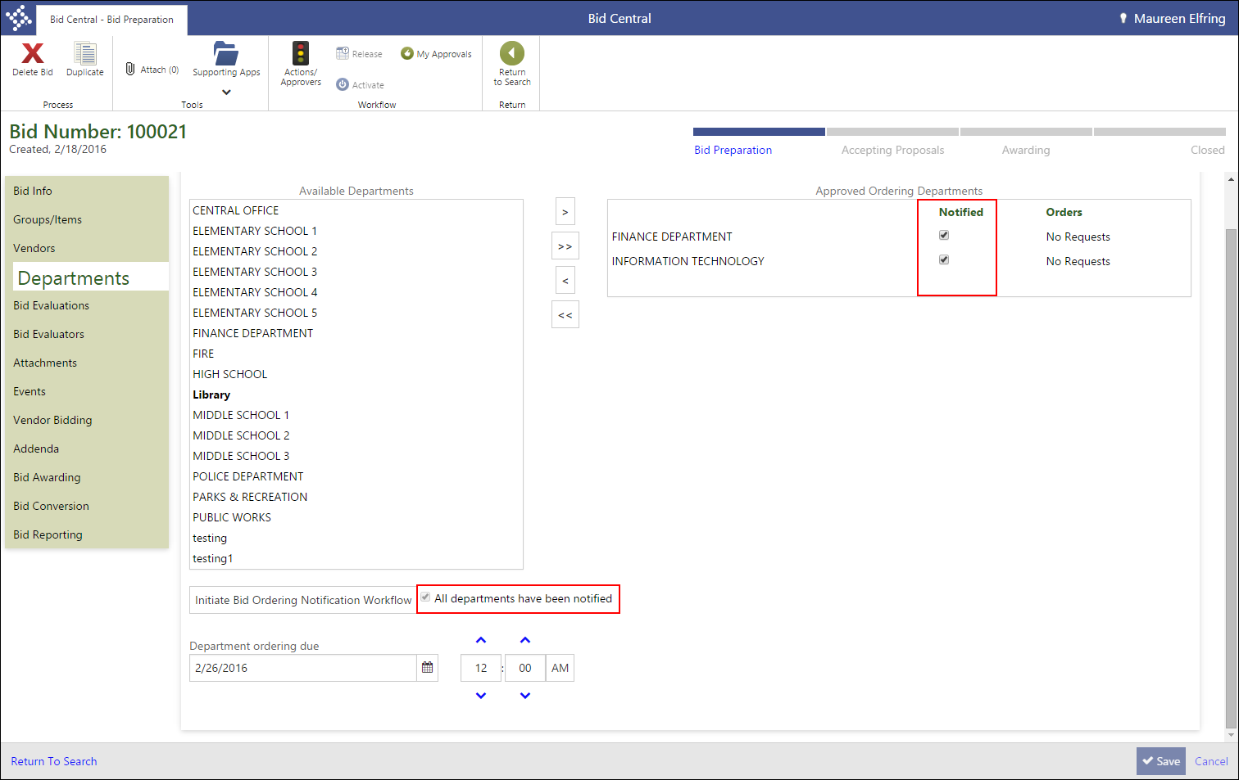

Results
You have added one or more requesting departments to the bid record. Each department receives a notification email that indicates that the bid is available for quantity requests. The email provides a direct link to the record in the Bid Request Quantities program.

What’s Next?
Department buyers can enter their requested quantities in the Bid Request Quantities program while you create bid evaluation questions and assign bid evaluators.

Enter Requested Quantities

Objective
This document describes the process of entering a department’s requested quantities against a bid record.

Overview
In order to create a bid record that can be released to vendors for proposals, the departments in your organization typically submit the number of each bid item required by their staff. The entered quantities are combined across all departments in order to fully define the item quantities required by your organization. The request process is performed in the Bid Request Quantities program.

Prerequisites
Before you can successfully complete this process, you must ensure that roles granting the necessary permissions have been assigned to your user account. If the roles have not been established, contact the system administrator to have them updated or added into the Munis system.

Confirm the following:

- You have menu access to the Bid Request Quantities program.
- Your user role has been assigned the Maintain Requested Quantities permission for at least one department in the Bid Management Roles program.

Procedure
To enter requested quantities:
- Open the Bid Request Quantities program.
Financials > Purchasing > Bid Management > Bid Request Quantities
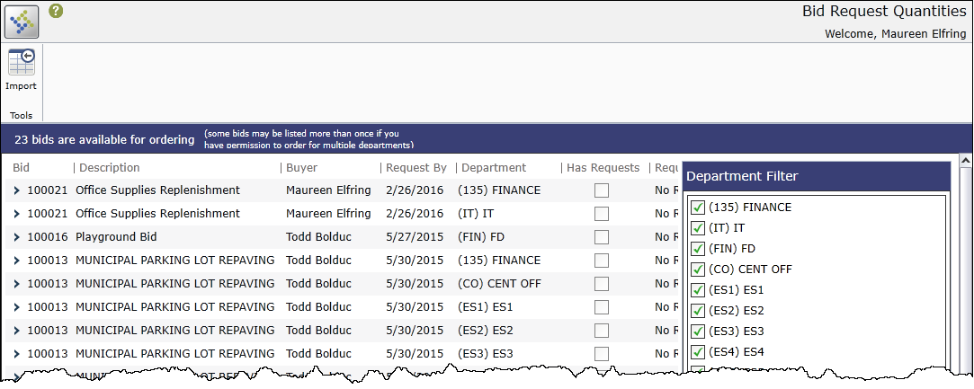
The program initially displays every bid for which you have the ability to submit requested quantities. Bids are displayed multiple times based on the number of departments for which you are responsible.
- Use the check boxes in the Department Filter group to display or hide bids based on the department code.
For example, clearing the check box for the Finance department hides all bid request records for Finance from the screen.
- If a department has no requested quantities for a bid, click Refuse.
The program updates the Request Status column for that bid to Refused, and also updates the Orders column of the Approved Ordering Departments list on the Departments tab of the Bid Central program.
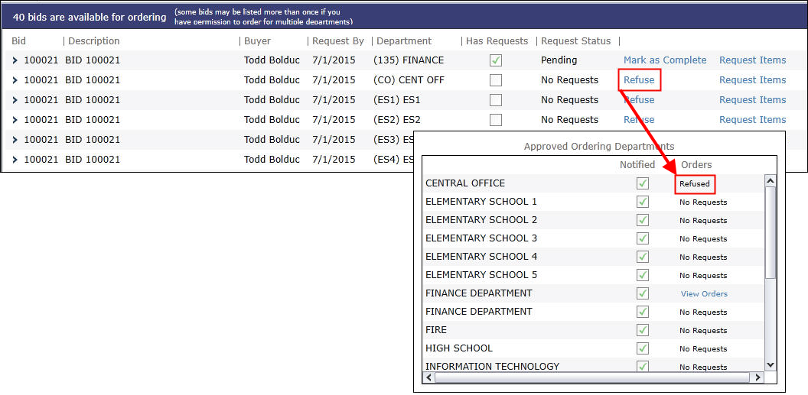
- For departments that have requested quantities, click the Request Items link.
The program refreshes the screen to display the groups that make up the bid record.
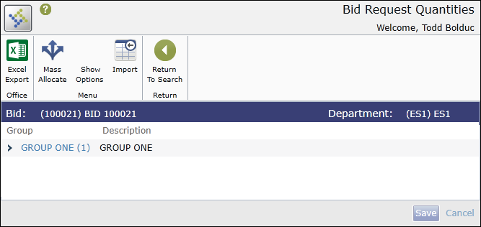
- Click a group name to expand the group and display the group items.
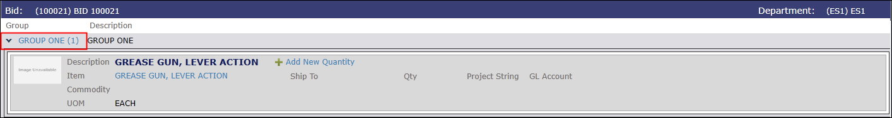
- Click Add New Quantity for any item.
The program displays the Ship To, Qty, Project String, and GL Account fields.
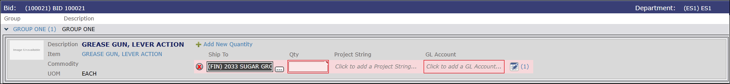
- Select a Ship To code, and then enter the requested quantity of the item in the Qty box.
- After you complete the Qty box, enter the project string and/or general ledger account to which the item costs should be allocated.
- Continue to enter quantities for the remaining items in the group, as well as any additional items in other groups.
- When you have finished entering quantities, click Save.
The program saves your entries.
- Click Return to Search on the ribbon to return to the main program screen.
The screen displays the updated request information, including the Has Requests check box, Request Status, and Refuse, and Request Items options.
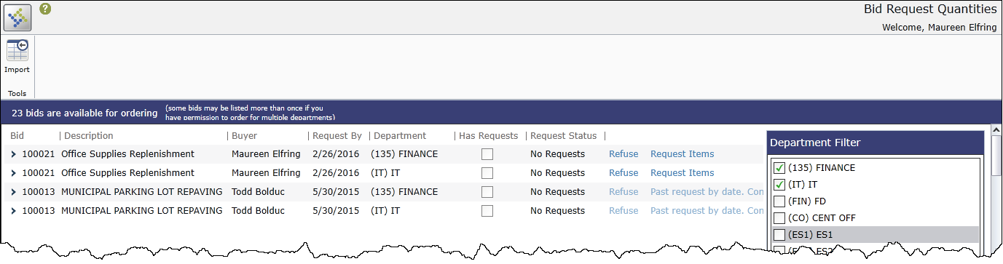
- If the request is complete for the department, click Mark as Complete.
The program updates the value of the Request Status column to Complete.

Results
You have entered requested quantities of bid items for your department.

What’s Next?
When the bid ordering due date has passed for the bid record, or when all departments have submitted or refused requested quantities, the bid is manually advanced to the Accepting Proposals stage of bid ordering. Vendors can then use Vendor Self Service to submit proposals for the bid items.

Bid Evaluations and Templates

Objective
This document provides instructions for creating and applying bid evaluation questions and templates, which are groups of questions added to a bid all at one time.

Overview
Bid records typically include a series of request for proposal (RFP) questions that responding vendors are required to complete and return to with their proposal. Munis refers to RFP questions as Bid Evaluations. Your organization can manually enter questions, and then save those questions as a template for future use.

Prerequisites
Before you can successfully complete this process, you must ensure that roles granting the necessary permissions have been assigned to your user account. If the roles have not been established, contact the system administrator to have them updated or added into the Munis system.

Confirm the following:

- You have menu access to the Bid Central program.
- The bid for which to add evaluation questions has been created.
- If the bid was created by another user, your user role has been assigned permission to view and maintain others’ bids in the Bid Management Roles program.

Procedure

Creating Bid Question Templates
To add new bid questions:
- Open the Bid Central program.
Financials > Purchasing > Bid Management > Bid Central
- From the Bid Number column, click the bid for which to add groups and items.
- On the Bid Preparation page, click Bid Evaluations.
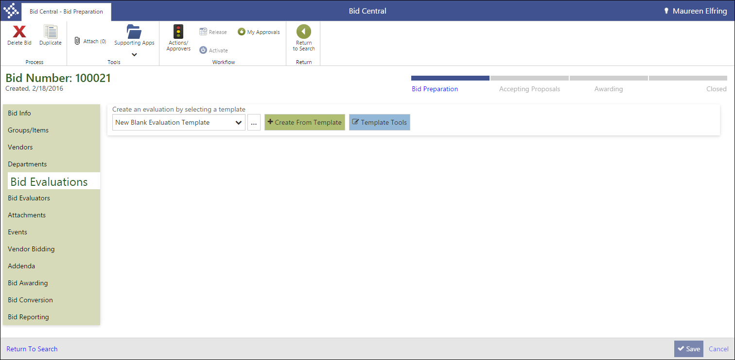
- Click Template Tools.
The program displays the Bid Evaluation Template Tools dialog box.
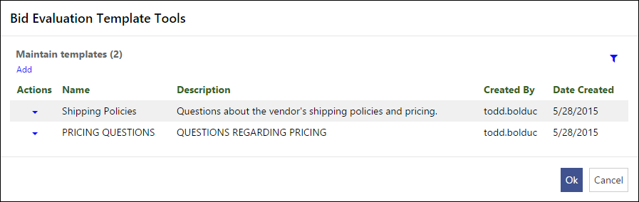
- Click Add.
The program refreshes the screen to display the Evaluation fields.
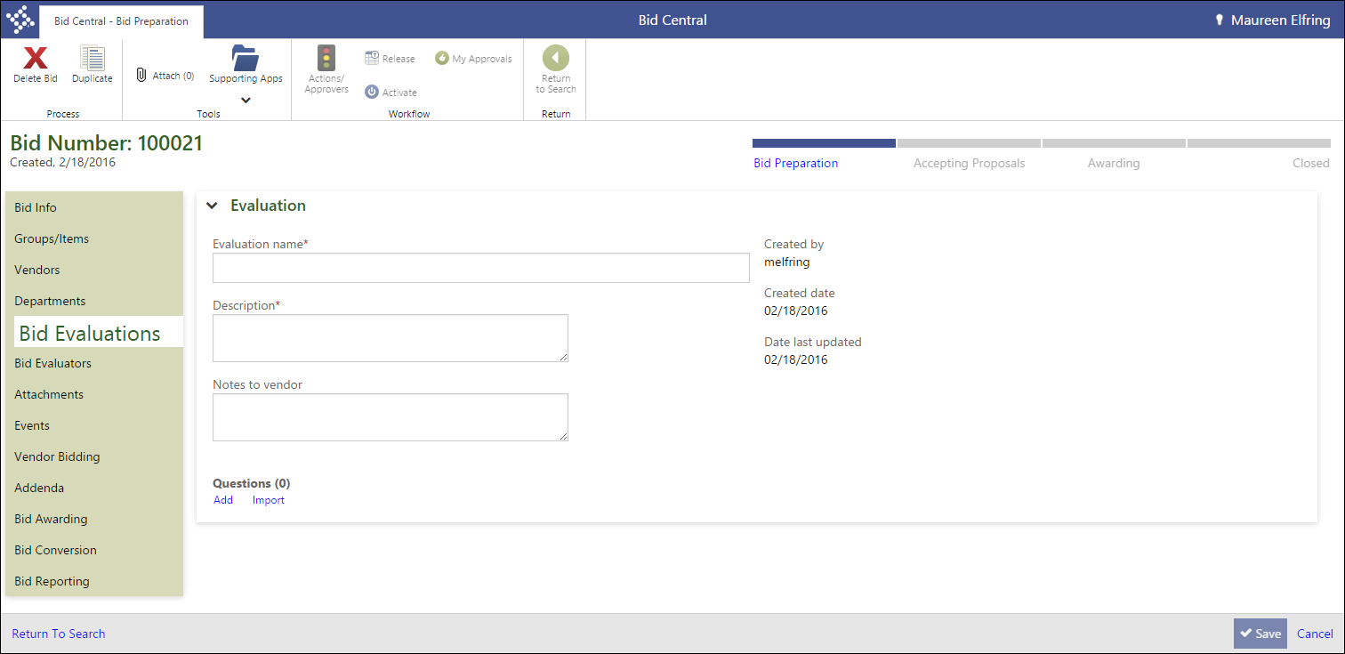
- Complete the Evaluation Name, Description, and Notes to Vendor fields.
The Evaluation Name is used as the template title for later use. The Notes to Vendor value is displayed to vendors when they access the evaluation questions in VSS.
- After you complete the fields, click Add in the Questions group.
The program displays the Bid Evaluation Questions dialog box.
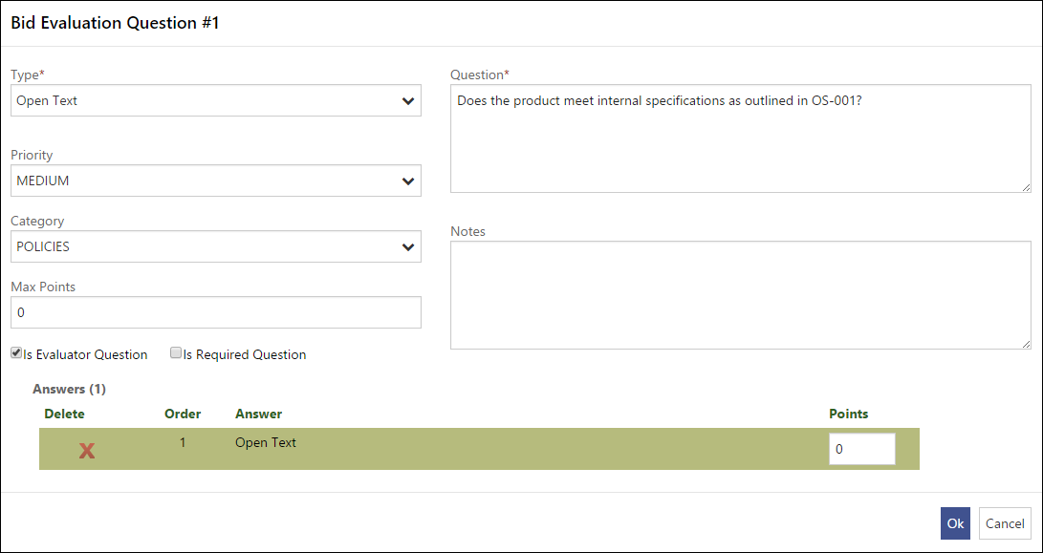
- Complete the fields to define the question, using the Field Descriptions table as a reference.
Field | Description | Notes
Question Type | Determines the type of question to create. The question type controls the manner of response vendors are allowed to submit. The following options are available:  - Multiple Choice – Requires you to define the available responses in the Answers group.  - Yes/No – Allows only a Yes or No response from the vendor.  - True/False – Requires the vendor to answer True or False.  - Open Text – Provides the vendor with a text box in which they can type a complete answer.
Question | Contains the text of the question, as it will be displayed to the vendor.
Priority | Indicates the priority code of the question. Priority codes are defined in the Bid Question Priorities program.
Category | Identifies the category code of the question. Category codes are defined in the Bid Question Categories program.
Max Points | Defines the maximum allowable points a bid evaluator can award based to the vendor based on the response to the question.
Is Evaluator Question | Signifies that the question is for bid evaluators only, and that the question will not be displayed to vendors.
Is Required Question | Requires vendors to submit a response to the question in order to successfully submit their proposal.
Notes | Provides space for any additional notes that pertain to the bid question.
- After you complete the fields, the program automatically adds the available answers to the Answers group based on the question type. However, if you selected Multiple Choice, click Add Answer to define the answers to multiple choice questions.
- Complete the Answer and Points boxes for each response, and then click OK.
The program closes the dialog box and adds the question to the Questions group.
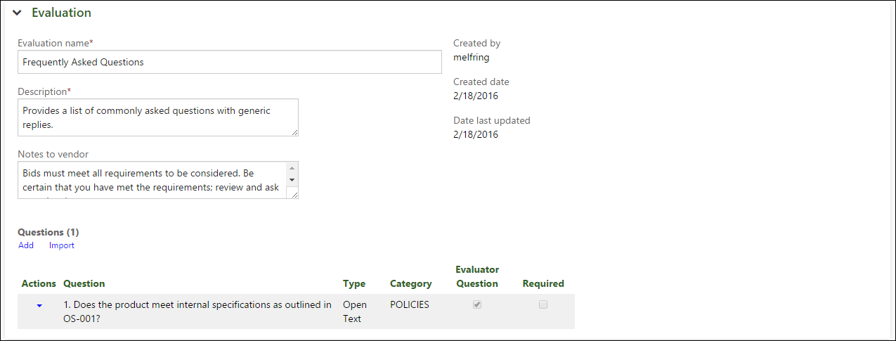
- Continue to add questions, as required.
- After you create each new question, use the Reorder Questions buttons to change the order in which questions are presented to vendors.
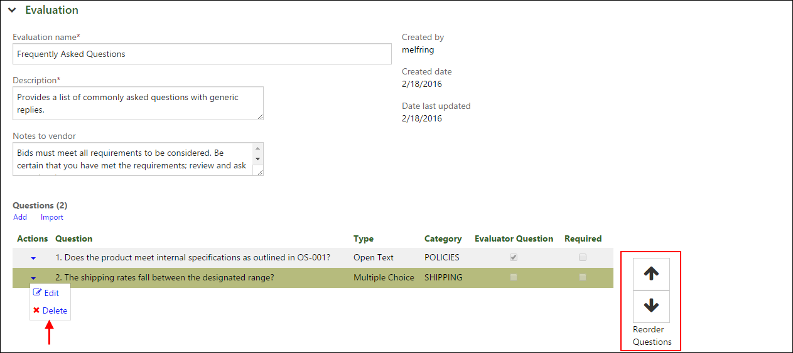
- To edit or delete a question, use the Actions menu.
- When you have finished adding questions to the template, click Save.
The program saves the template and returns to the Bid Evaluations tab. The template is available in the Create an Evaluation by Selecting Template list.
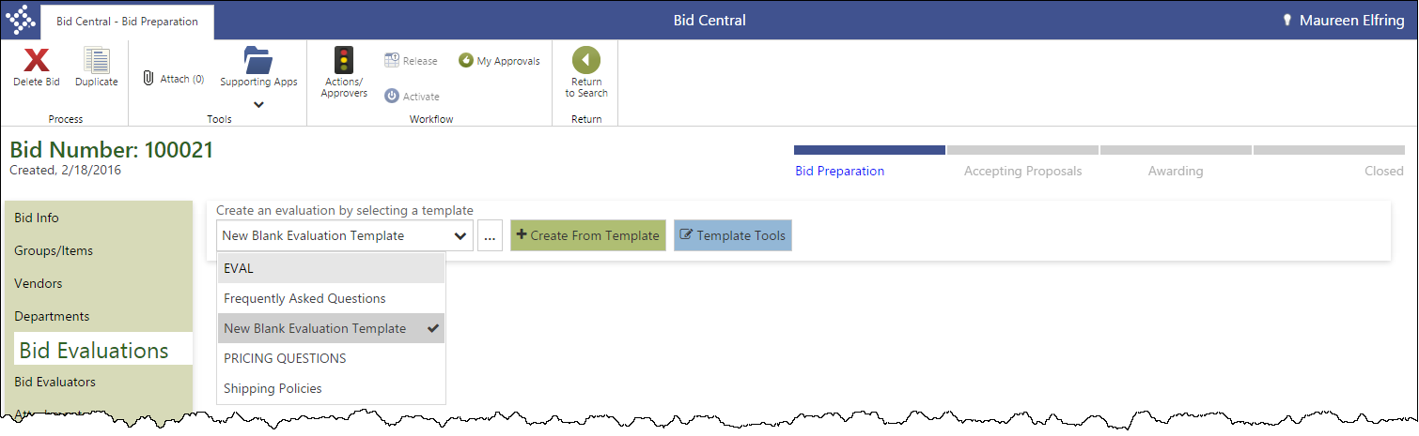
- From the Selecting a Template list, select the template that contains the questions to add to the bid.
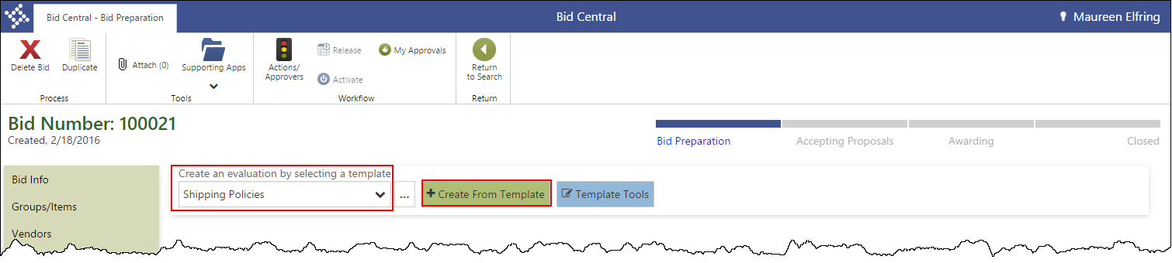
- Click Create from Template.
The program refreshes the screen to add the template questions.
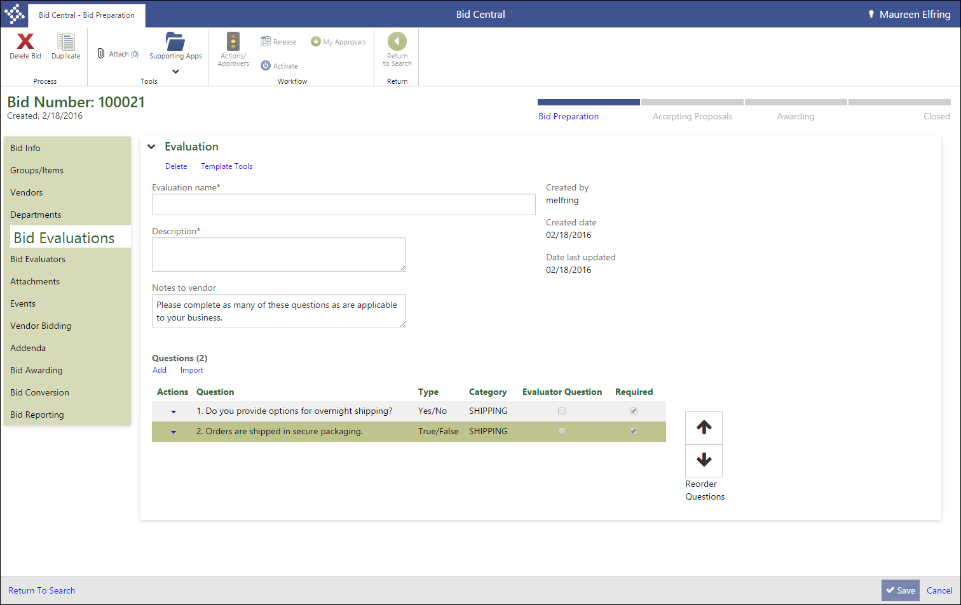
- Enter an evaluation name, description, and any notes to vendors.
- Click Save.
The program saves the questions as part of the bid evaluation.
- Use the Add Question button to add any additional questions to the bid using the Bid Evaluation Questions dialog box. Alternatively, you can click Import Question to select a question that exists on any bid evaluation template or bid evaluation in the Munis database.
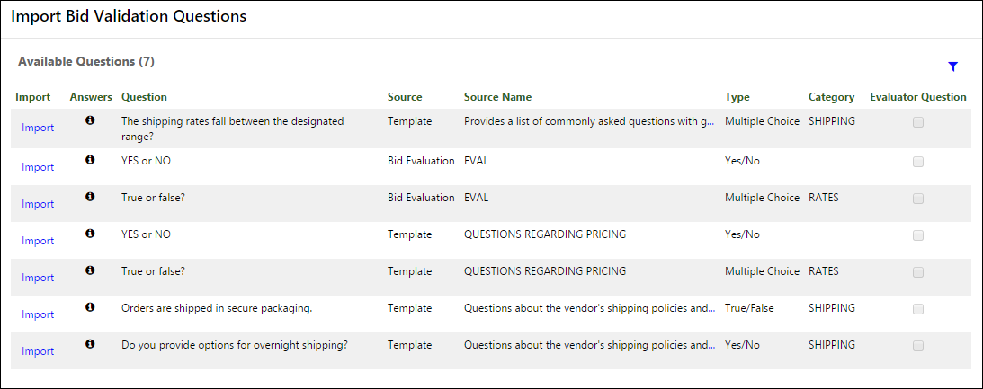
- Click Save.
The program saves any additional questions you added to the bid evaluation.

Results
You have defined the bid’s evaluation questions.

What’s Next?
You must assign one or more bid evaluators that are responsible for examining bidding vendors’ responses to the evaluation questions, and then assigning a score to each response.

Assign Bid Evaluators

Objective
This document illustrates the steps taken to assign evaluators to a bid using the Bid Central program.

Overview
During the creation of a bid proposal, vendors must respond to your organization’s bid evaluation questions. After the questions have been answered and the proposal submitted, a bid evaluator evaluates the responses and assigns scores that serve as a guideline for vendor awards. You must assign bid evaluators to a bid record before the bid is released for proposals. This assignment is performed in the Bid Central program.

Prerequisites
Before you can successfully complete this process, you must ensure that roles granting the necessary permissions have been assigned to your user account. If the roles have not been established, contact the system administrator to have them updated or added into the Munis system.

Confirm the following:

- You have menu access to the Bid Central program.
- The bid for which to add evaluators has been created.
- If the bid was created by another user, your user role has been assigned permission to view and maintain others’ bids in the Bid Management Roles program.

Procedure
To assign bid evaluators:
- Open the Bid Central program.
Financials > Purchasing > Bid Management > Bid Central
- From the Bid Number column, click the bid for which to add groups and items.
- On the Bid Preparation page, click Bid Evaluators.
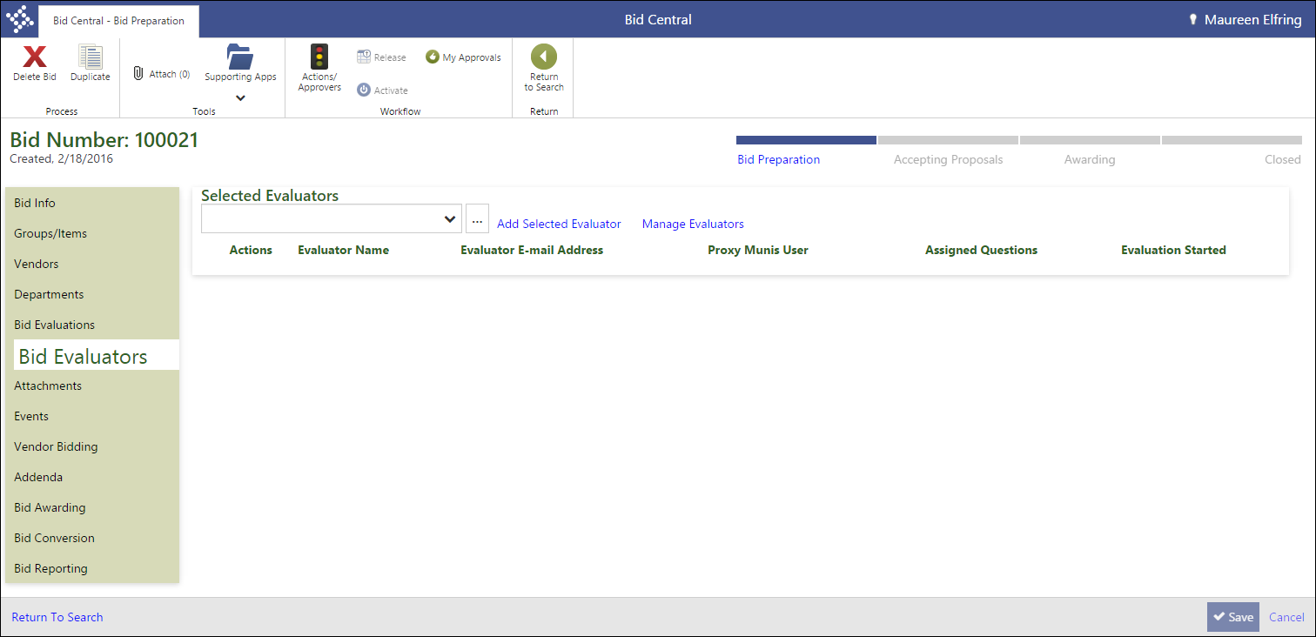
- From the Selected Evaluators, select an available evaluator.
- Click Add Selected Evaluator
- Use the Actions menu to assign questions, edit the evaluator record, or remove the evaluator.
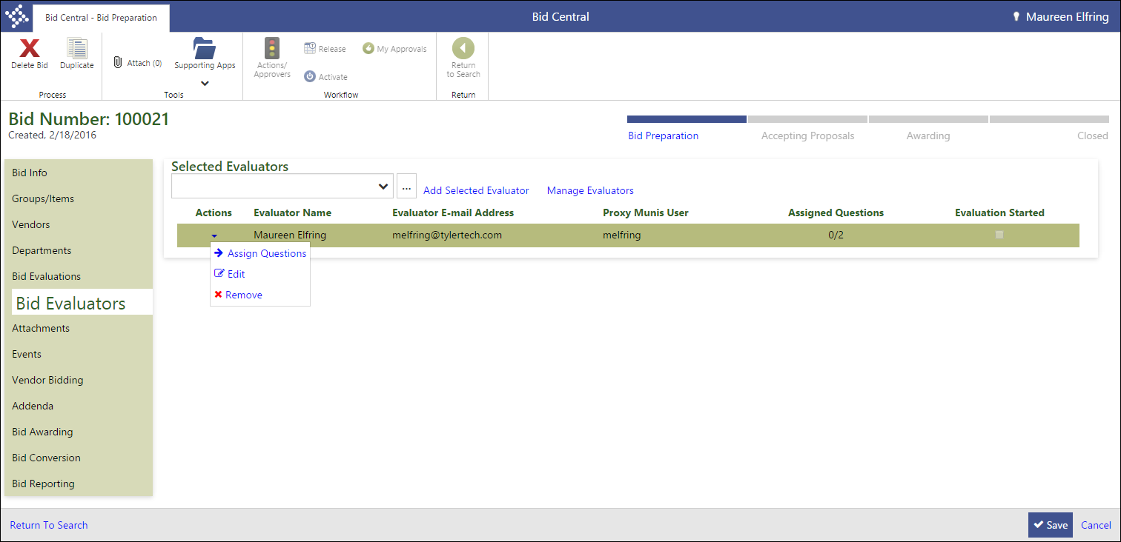
- When you select Assign Questions, the program provides a list of questions to assign. Use the Assignment Tools and Assign by Cateogry options to assign/remove all questions at one time or to assign the questions by category.
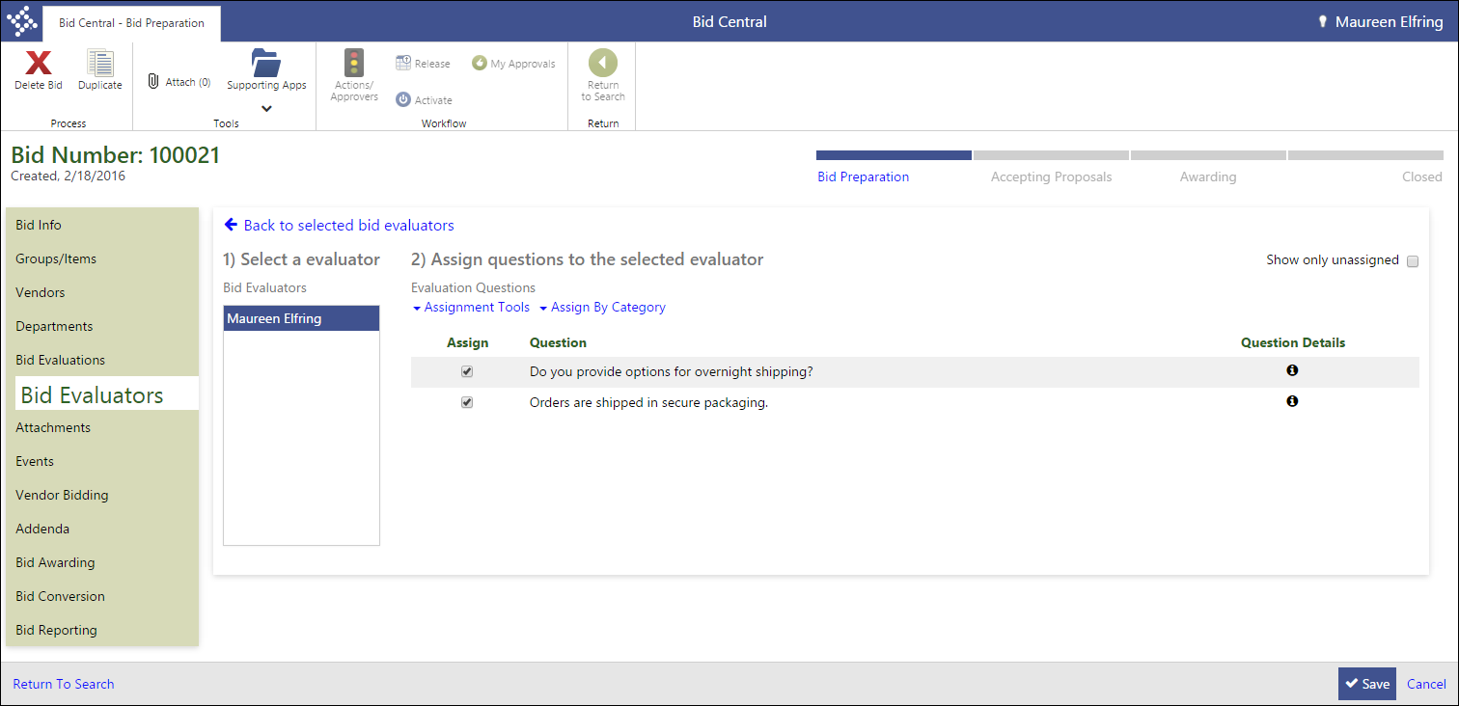
- Click Back to Selected Bid Evaluators to continue.
- To add new evaluators, click Manage Evaluators and complete the Edit Bid Evaluator dialog box.
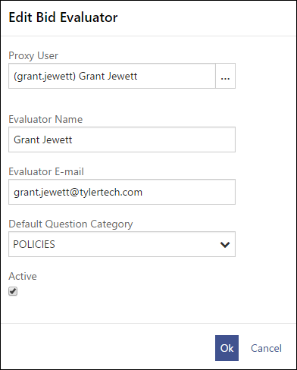
- Make a selection from the Proxy User list. A proxy user is the Munis user ID that represents the bid evaluator if the evaluator is not a Munis user. If the evaluator is a Munis user, select the evaluator’s user ID.
- Enter the evaluator’s full name and email address.
- If the evaluator typically only evaluates questions of a specific category, select that category from the Default Question Category list.
For example, if the evaluator is a warehouse supervisor who only evaluates questions regarding shipping and receiving, select your organization’s Shipping and Receiving category for that evaluator. The program provides an option in later steps to quickly assign all questions with that category to the evaluator.
- Select or clear the Active check box. Inactive evaluators cannot be assigned to bids, but are not removed from existing bids.
- Click OK.
The program closes the dialog box and adds the evaluator to the Selected Evaluators list.

Results
You have defined one or more evaluators for the bid.

What’s Next?
Before the bid can be released to vendors for proposal submission, you must define any attachment files for the bid record and define the bid events and contacts. These processes are performed in Bid Central.

Add Attachments and Define Bid Events

Objective
This document describes the procedure for defining file attachments for a bid, and then defining bid events and contacts using the Bid Central program.

Overview
Your organization must define the files and file types that are required from vendors for successful submission of bid proposals. For example, you can define a required attachment for insurance certificates that must be submitted in PDF format.
Bid events and contacts provide vendors with contact information and a calendar that they can reference during the bidding process.

Prerequisites
Before you can successfully complete this process, you must ensure that roles granting the necessary permissions have been assigned to your user account. If the roles have not been established, contact the system administrator to have them updated or added into the Munis system.

Confirm the following:

- You have menu access to the Bid Central program.
- The bid for which to define attachments, events, and contacts has been created.
- If the bid was created by another user, your user role has been assigned permission to view and maintain others’ bids in the Bid Management Roles program.

Procedure
To add bid attachments, contacts, and events:
- Open the Bid Central program.
Financials > Purchasing > Bid Management > Bid Central
- From the Bid Number column, click the bid for which to add groups and items.
- On the Bid Preparation page, click Attachments.
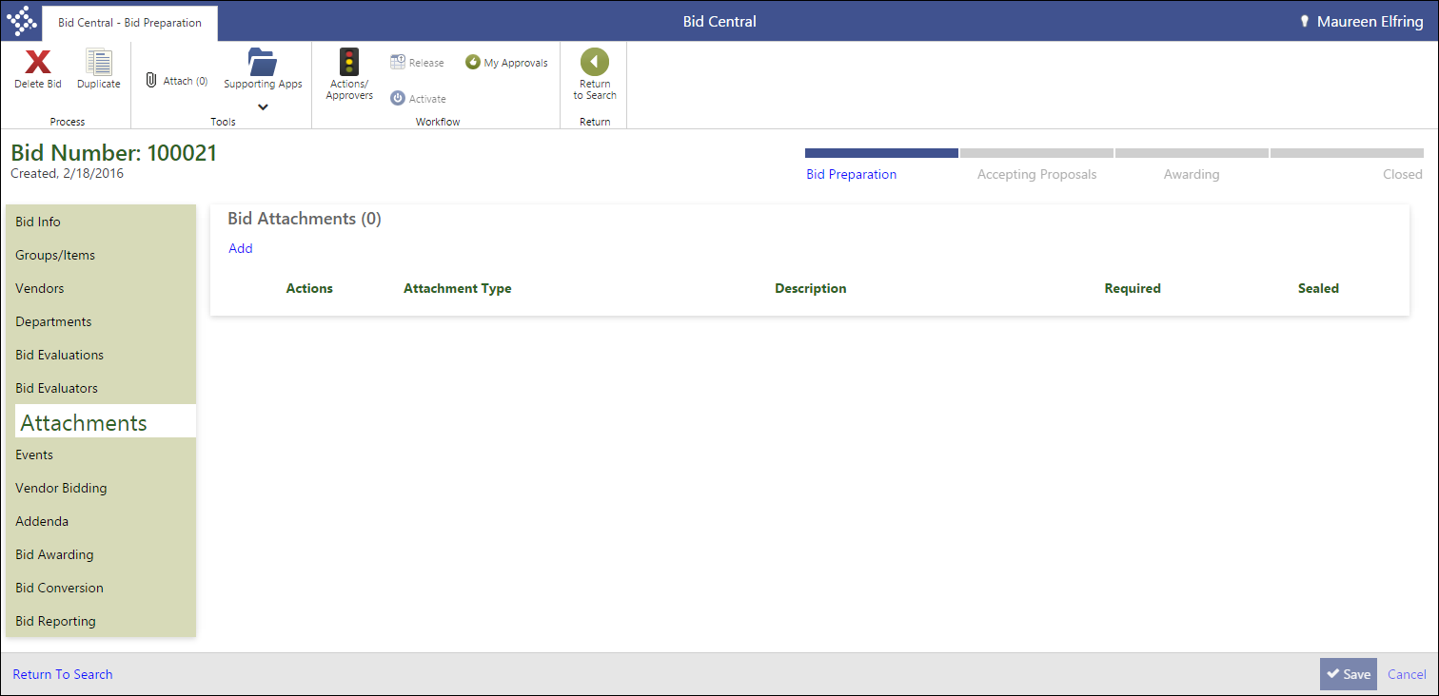.

- Click Add. .
The program displays the Add/Edit Bid Attachments dialog box.
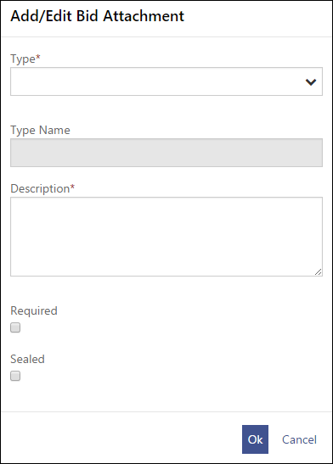
- Select a file type from the Type list, and provide a description of the attachment.
For example, select a Type of PDF and enter Insurance Certificates in the Description box to indicate that the vendor’s insurance certificate should be attached in PDF format.
- Select or clear the Required check box to determine whether the attachment is mandatory or optional.
- If the bid record is a sealed bid, select or clear the Sealed check box to also seal the bid attachment. The check box is not accessible for unsealed bids.
- Click OK.
The program closes the dialog box and adds the attachment to the bid.
- Use the Actions menu to edit or remove the attachment.
- Click Save to save the attachment requirements.
- Click the Events tab.
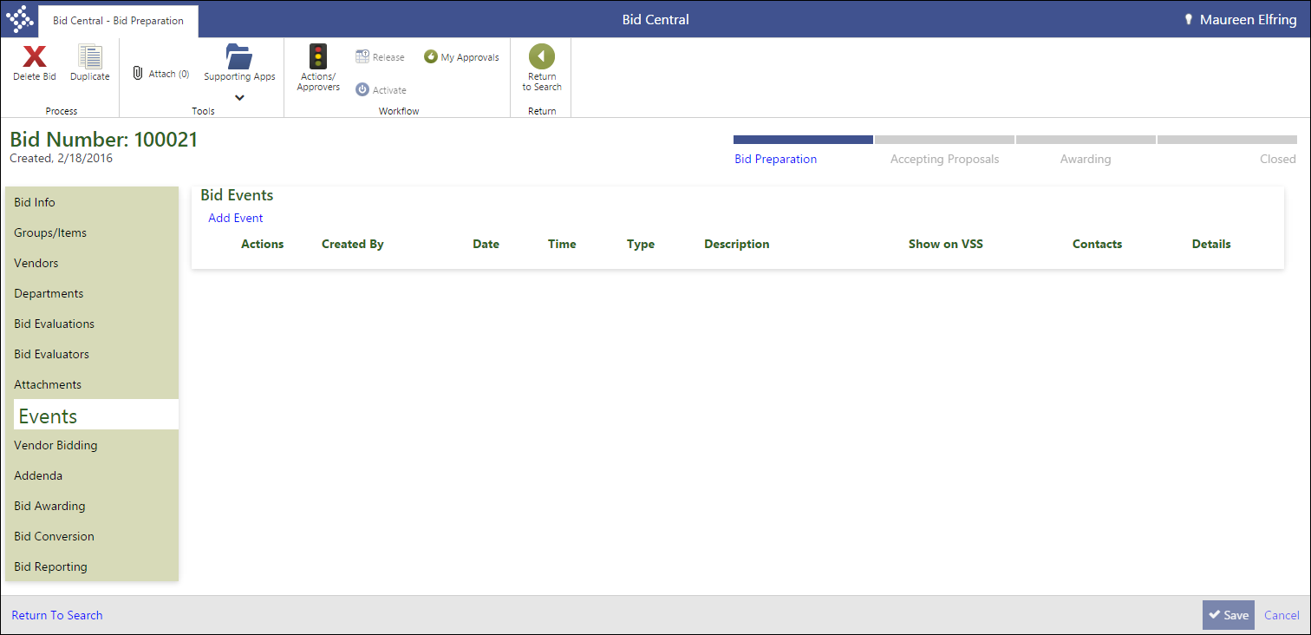
- Click Add Event.
The program displays the Bid Event dialog box.
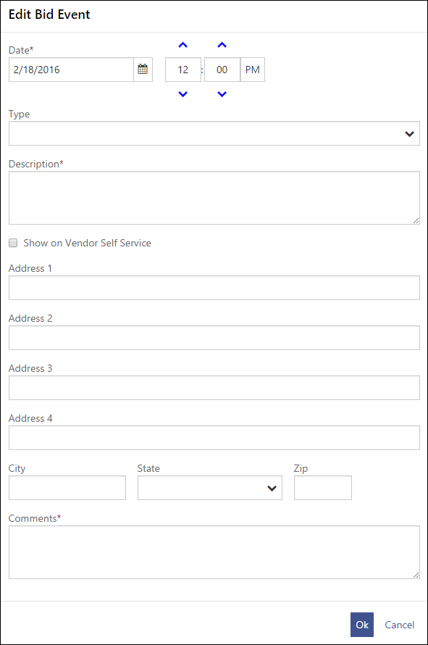
- Complete the fields in order to define the event, and then click OK.
The program closes the dialog box and adds the event to the Bid Events list.
- Continue to add events to the bid by repeating the Add Event process.
- When you have finished adding events, use the Edit Contacts option from the Actions menu for each event to assign contact persons for that event.
- Continue to add contacts for the events on the bid. When you have finished adding events and contacts, click Save.
The program saves your entries.

Results
You have created one or more attachments, events, and event contacts for the bid record.

What’s Next?
When the departments in your organization have finished the bid quantity request process, the bid is ready for release to vendors for proposal submissions. This process is completed in Bid Central.

Release a Bid for Proposals

Objective
This document provides instruction on the steps needed to preview and release a bid to vendors for proposals.

Overview
After the departments in your organization have completed the quantity request process, and all supporting information has been added to or defined for the bid, the bid record is eligible for release to vendors in order to receive bid proposals. The process is completed using the Bid Central program.

Prerequisites
Before you can successfully complete this process, you must ensure that roles granting the necessary permissions have been assigned to your user account. If the roles have not been established, contact the system administrator to have them updated or added into the Munis system.

Confirm the following:

- You have menu access to the Bid Central program.
- If the bid was created by another user, your user role has been assigned permission to view and maintain others’ bids in the Bid Management Roles program.

Procedure
To release a bid for proposals:
- Open the Bid Central program.
Financials > Purchasing > Bid Management > Bid Central
- From the Bid Number column, click the bid for which to add groups and items.
- On the Bid Preparation page, click Vendor Bidding.
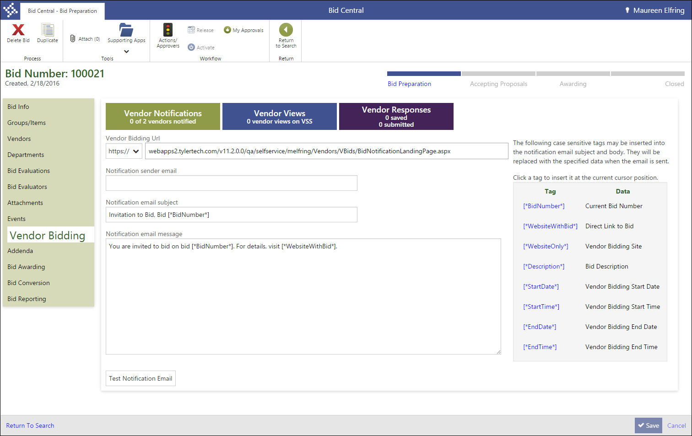
The Vendor Bidding tab displays the vendor statistics for the bid, and provides the fields used to define the notification email sent to vendors regarding the bid’s availability.
- Complete the fields in order to define the notification email that will be sent to vendors.
- After you complete the fields, click the Test Notification Email button.
The program validates the information in the fields, and sends a test email to your email address. If the test email is sent successfully, the program displays a confirmation message. If an error is encountered, the program alerts you to the error condition.
- Repair any errors and continue to generate test emails until one has been sent successfully.
- After the email test is successful, click the Bid Preparation option of the bid progress bar.
The program performs a validation check to ensure the bid record is complete, and displays the Bid Preparation Checklist dialog box, which lists the data conditions required to change phases and any errors encountered.
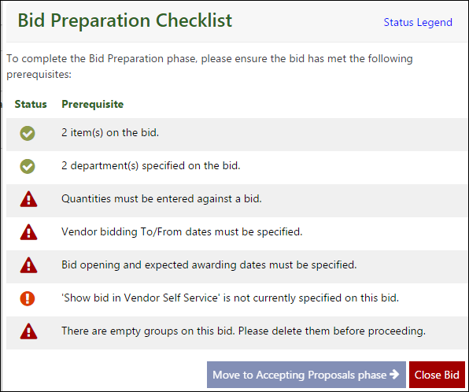
- If the program discovered errors, close the dialog box and repair each error condition.
- After resolving the errors, click Bid Preparation again to view display the Bid Preparation Checklist again.
- With all errors corrected, the Move to Accepting Proposals Phase option is active.
- Select this option, and then click OK for the confirmation.
The program updates the bid process status and includes the Notify Vendors button on the Vendor Bidding tab.
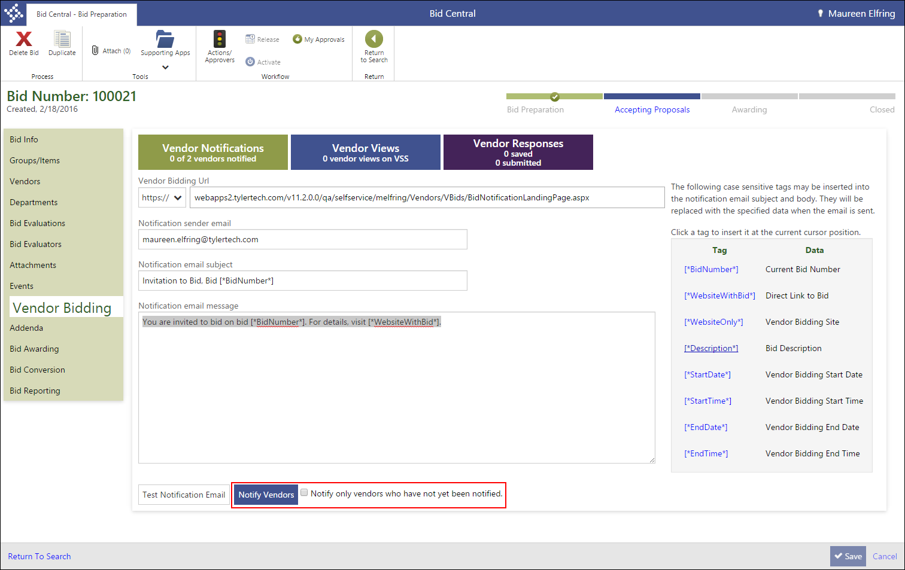
- Select or clear the Notify Only Vendors Who Have Not Yet Been Notified check box to determine which vendors will be notified.
- Click Notify Vendors.
The program displays a confirmation message.
- Click OK to send the notification emails.
The program generates the emails and updates the Vendor Notification box on the Vendor Bidding tab with the number of vendors to which email was successfully sent.
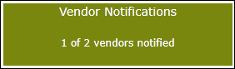

Results
You have notified vendors of the bid’s availability for proposals and advanced the bid process status to Accepting Proposals.

What’s Next?
Vendors access the bid using the link provided in the notification email. The link opens in Vendor Self Service, where the vendor can view the bid details, and then prepare and submit their proposal. The bid proposal process is described in the Vendor Self Service User Guide.

Create Bid Addenda

Objective
This document provides a description of the steps taken to create addenda for a bid record.

Overview
When changes are made to a bid after it has been released for proposals, you may be required to generate a bid addendum that records the changes made and notifies bidding vendors of the updated information. Use the Bid Central program to create the addendum record and notify vendors.

Prerequisites
Before you can successfully complete this process, you must ensure that roles granting the necessary permissions have been assigned to your user account. If the roles have not been established, contact the system administrator to have them updated or added into the Munis system.

Confirm the following:

- You have menu access to the Bid Central program.
- If the bid was created by another user, your user role has been assigned permission to view and maintain others’ bids in the Bid Management Roles program.

Procedure
To create a bid addendum:

- Open the Bid Central program.
Financials > Purchasing > Bid Management > Bid Central
- From the Bid Number column, click the bid for which to add groups and items.
- On the Bid Preparation page, click Addenda.
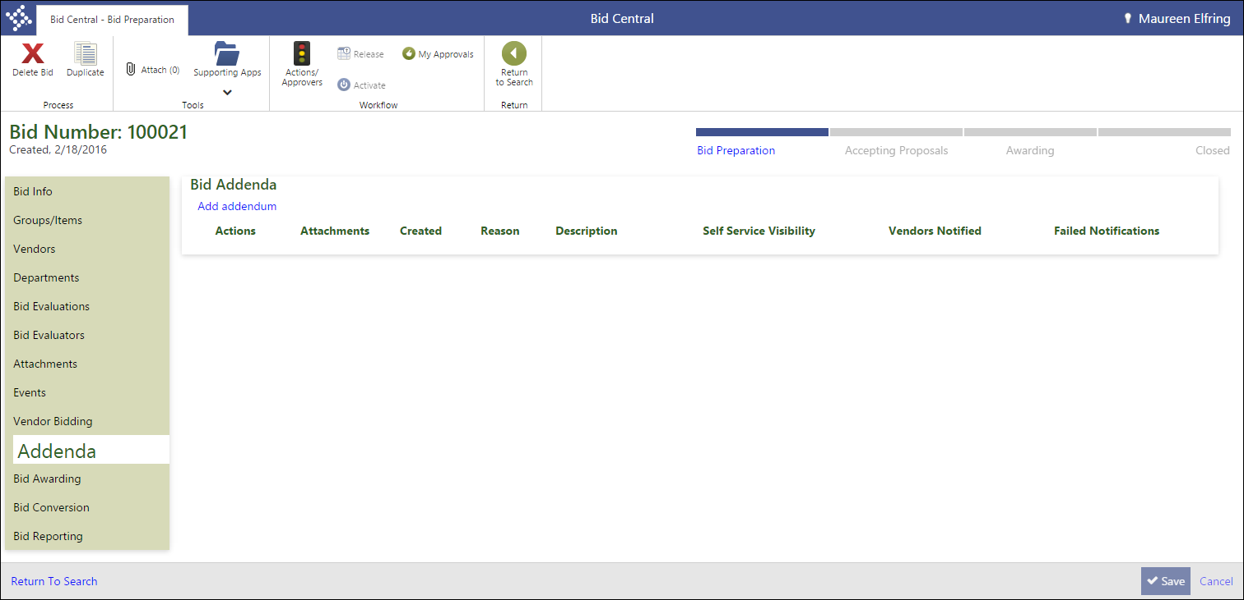

- Click Add Addendum.
The program displays the Add/Edit Bid Addendum dialog box.
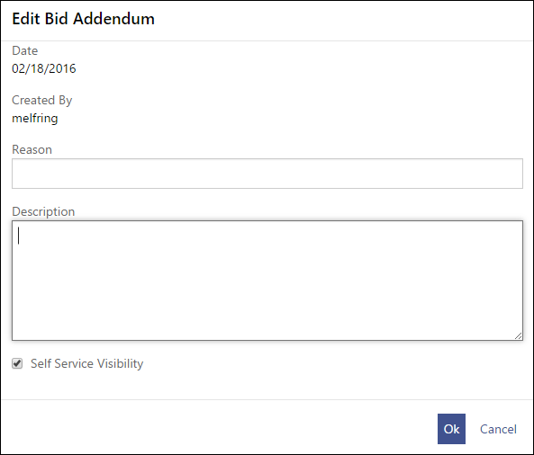
- Enter a reason for the addendum and a general description of the changes.
- If the addendum information should be visible to vendors in Vendor Self Service, select the Self Service Visibility check box.
- Click OK.
The program closes the dialog box and adds the addendum to the Bid Addenda tab.
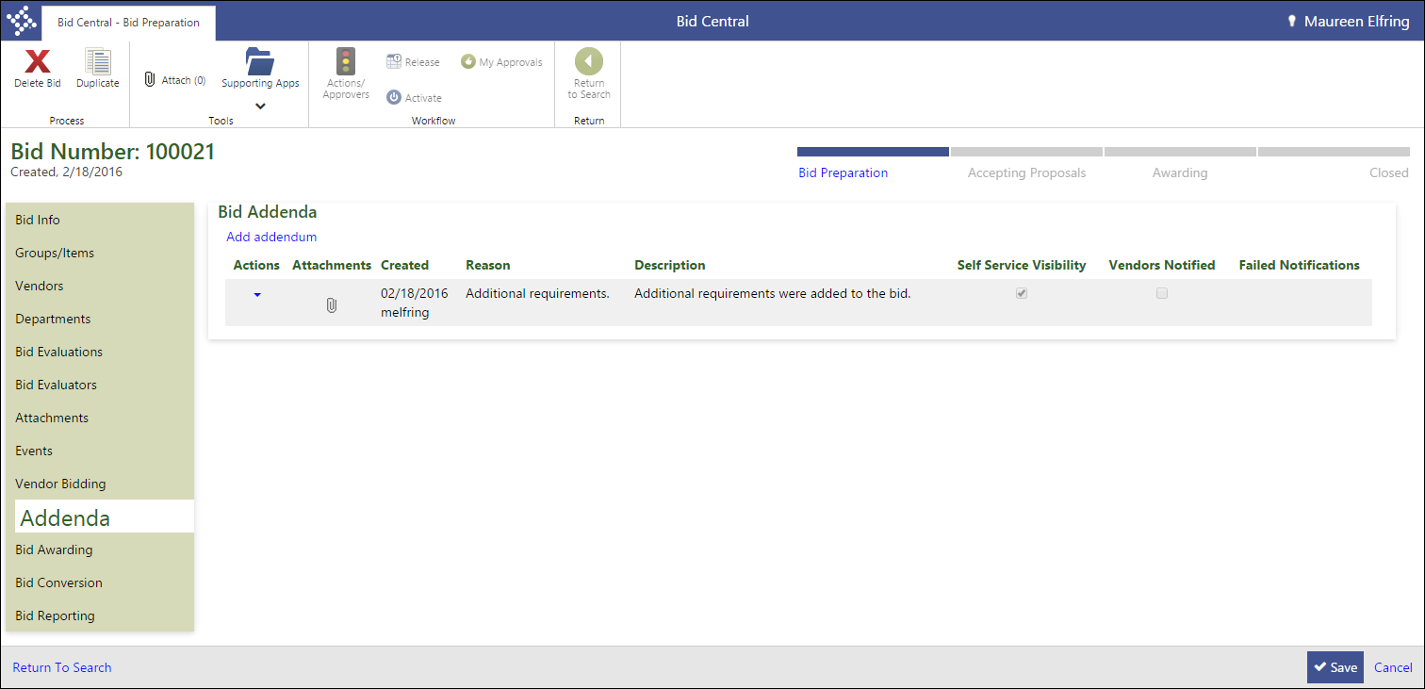
- Click the Attachments button to attach files to the addendum. The process varies based on the content management system used by your organization. Refer to your organization’s standard business practices for instruction on how to attach files.
- When you have finished attaching files, click Notify from the Actions menu for the addenda item.
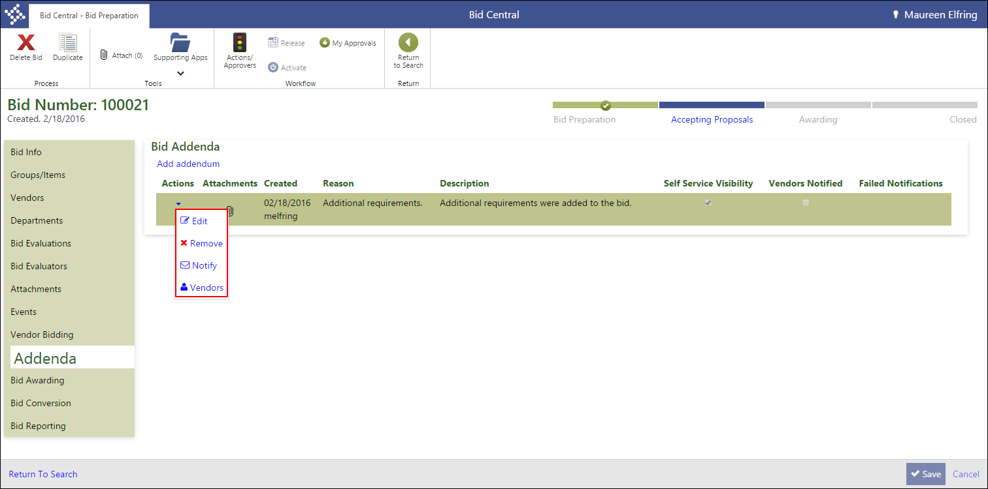
The program displays the Bid Addendum Notifications dialog box.
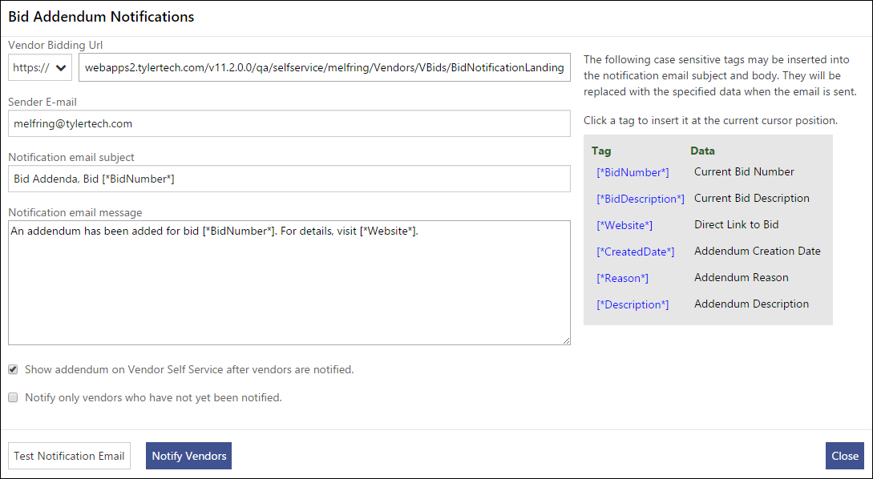
- Complete the fields to define the content of the notification email.
- After defining the email content, click Test Notification Email.
The program generates a test email that is sent to your email address for review.
- If the email is accurate, click Notify Vendors.
The program displays a confirmation message.
- Click OK to generate the emails, and then click Close to return to the Bid Addenda tab.

Results
You have created a bid addendum and notified vendors of the changes made to the bid.

What’s Next?
Vendors are provided the option to update their bid proposals as a result of the addendum. They can view the addendum information in VSS. No further action is necessary by your organization until the bidding has closed.

Award Bids

Objective
This document describes the steps taken to transition bids to the awarding phase, and then award the bid items to vendors.

Overview
Bids are awarded to vendors based on your organization’s criteria. This can be price only, or involve any number of factors.
You can award single bid items, item groups, or an entire bid to one or more vendors.

Prerequisites
Before you can successfully complete this process, you must ensure that roles granting the necessary permissions have been assigned to your user account. If the roles have not been established, contact the system administrator to have them updated or added into the Munis system.

Confirm the following:
- You have menu access to the Bid Central program.
- If the bid was created by another user, your user role has been assigned permission to view and maintain others’ bids in the Bid Management Roles program.

Procedure
To award proposals:
- Open the Bid Central program.
Financials > Purchasing > Bid Management > Bid Central
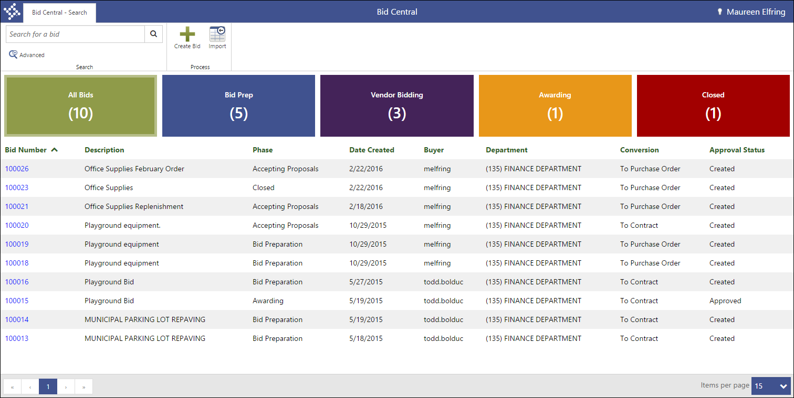
- From the Bid Number column, click the bid for which to add groups and items.
- On the Bid Preparation page, click Bid Awarding.
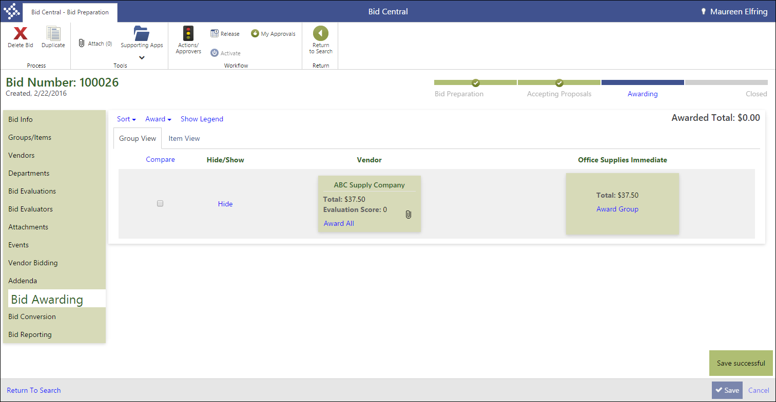
- On the Bid Awarding page, use the Sort menu to reset how the proposals display.
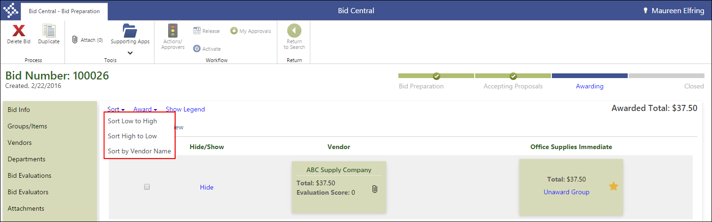
- To compare proposals, select one or more vendors and click Compare.
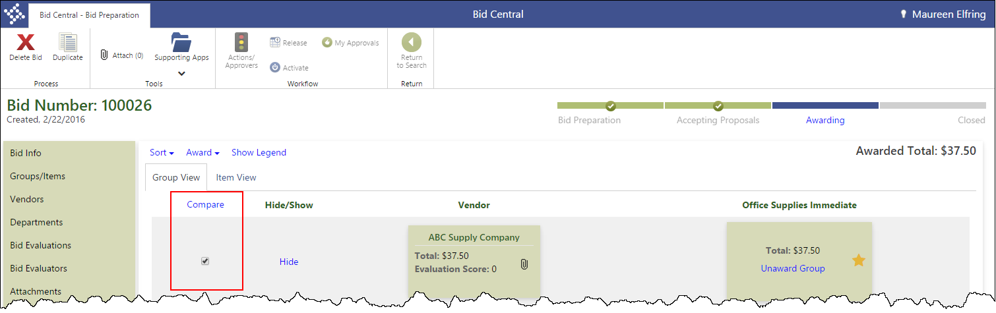
- On the Bid Awarding page, use the Award list to determine how to award the bid.
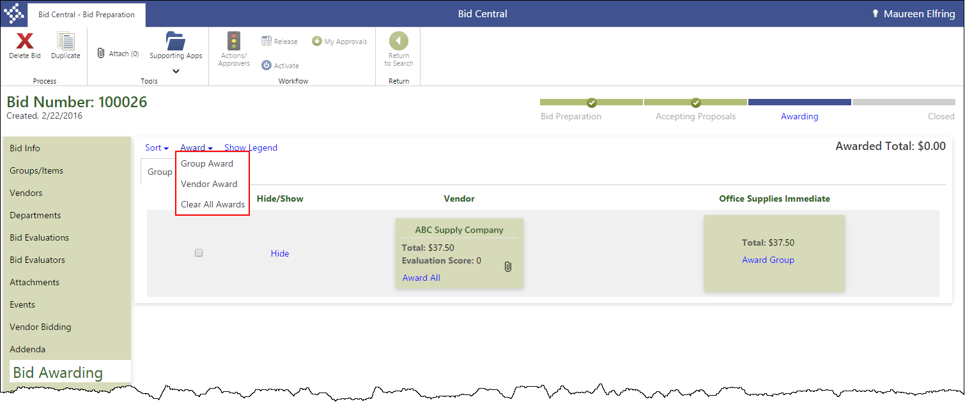
- If you select Group Award, the program displays the following confirmation message.
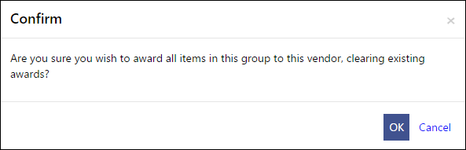
- Click OK.
The program updates the group list with the award information.
- If you select Vendor Aware, the program displays the following confirmation message.
- Click OK to update the bid with the award information.
Once you confirm the award, the program refreshes the page to indicate the award is complete.
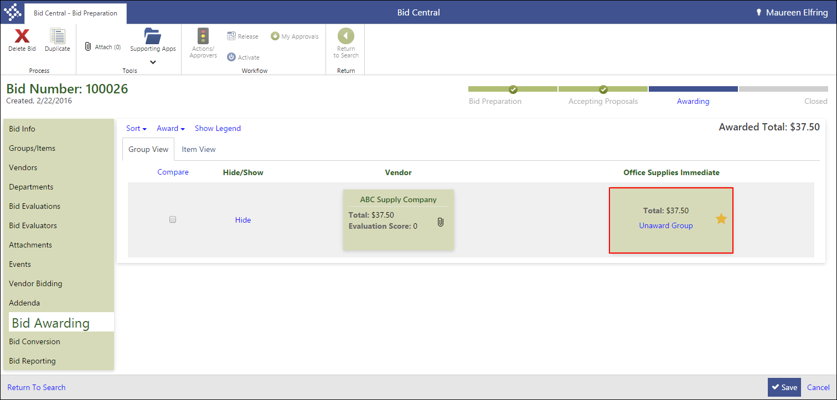
- Click Save.
The program saves your awards.

Results
You have awarded the bid, bid groups, or bid items to one or more vendors.

What’s Next?
The bid must be released for approval using the BMA–Bid Management Approval workflow business rule. Once the bid award is approved, the bid can be converted to a requisition, purchase order, or contract based on the bid attributes.

Convert a Bid

Objective
This document provides instructions for converting approved, awarded bids to a requisition, purchase order, or contract.

Overview
Fully awarded bids are converted to requisitions, purchase orders, or contracts based on the value of the Conversion list on the Bid Info tab of Bid Central. This document uses a conversion to a requisition as an example. The procedure is the same for purchase orders and contracts, though the fields displayed on the Bid Conversion tab differ based on the record type to create.

Prerequisites
Before you can successfully complete this process, you must ensure that roles granting the necessary permissions have been assigned to your user account. If the roles have not been established, contact the system administrator to have them updated or added into the Munis system.

Confirm the following:
- You have menu access to the Bid Central and program.
- If the bid was created by another user, your user role has been assigned permission to view and maintain others’ bids in the Bid Management Roles program.
- The bid award has been approved by a workflow approver using the BMA – Bid Management Approval workflow business rule.

Procedure
To convert a bid:
- Open the Bid Central program.
Financials > Purchasing > Bid Management > Bid Central
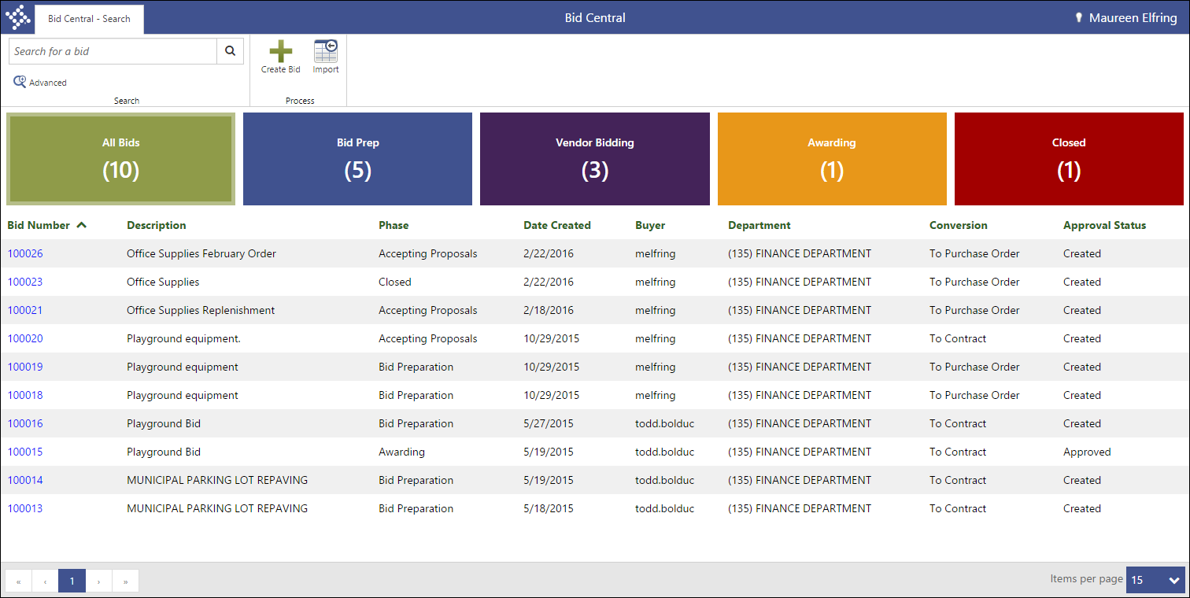
- From the Bid Number column, click the bid for which to add groups and items.
- On the Bid Preparation page, click Bid Conversion.

- Click the Bid Conversion tab.
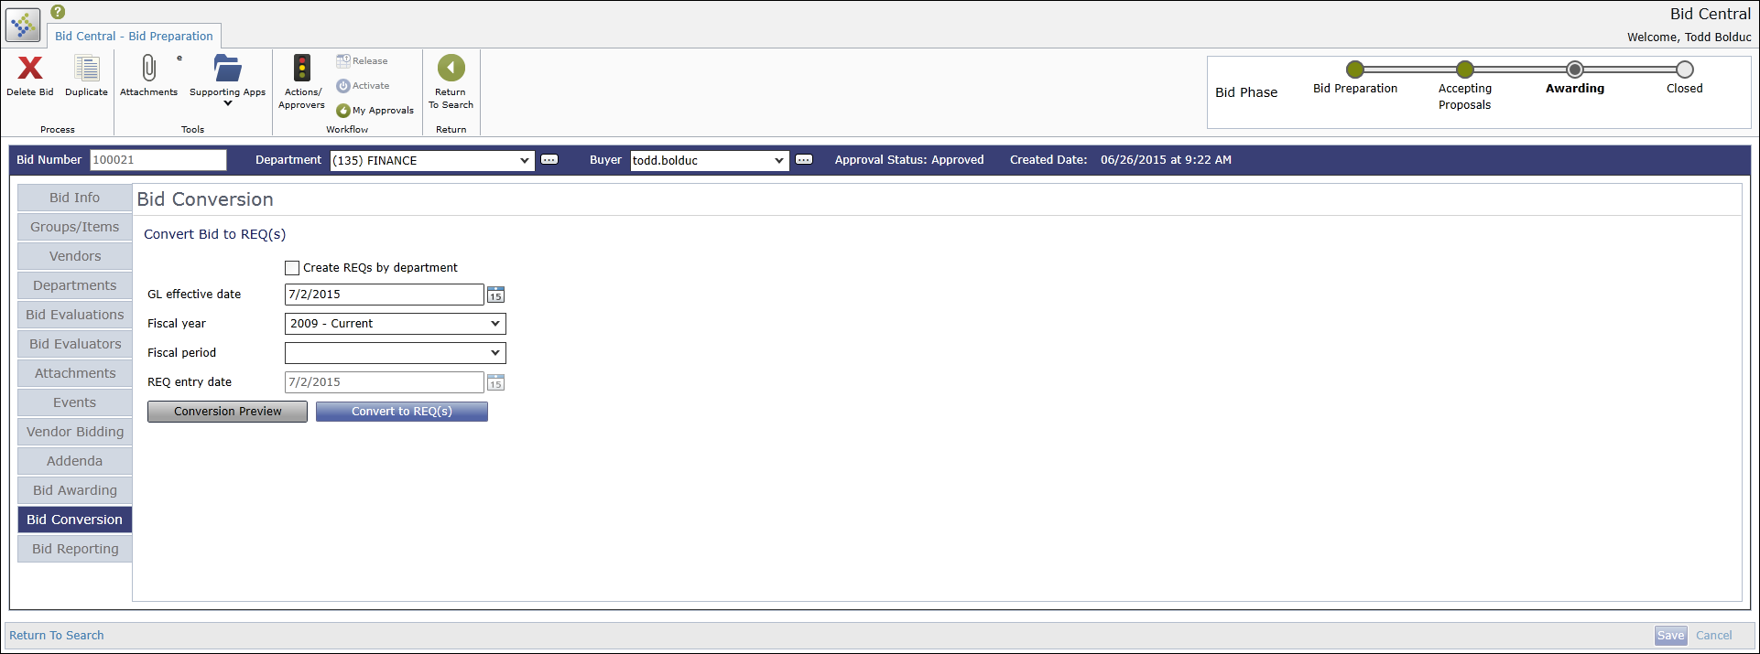
- Complete the fields on the tab to define the record to create from the bid.
- Click Conversion Preview.
The program displays a list of the records that will be created from the bid based on the values entered in the fields.
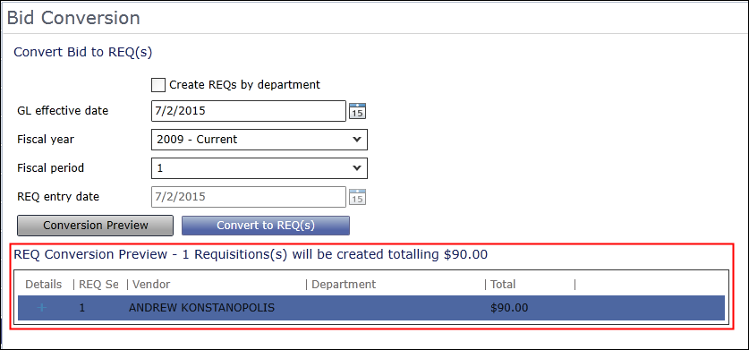
- Update the fields as necessary to produce the correct records, and then repeat the preview.
- If the preview is accurate, click the Convert To button.
The program displays a confirmation message.
- Click Ok.
The program creates the records and refreshed the Bid Conversion tab to display a list of the records created.
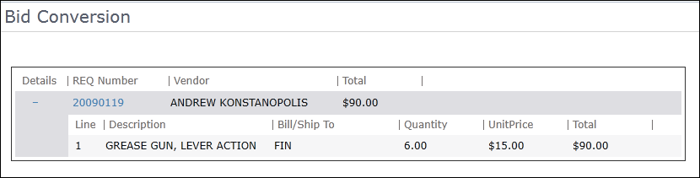

Results
You have converted the bid into one or more requisitions, purchase orders, or contracts.

What’s Next?
The created records are available for immediate processing. You can create reports for the bid information by clicking the Bid Reporting tab in Bid Central and selecting a report type to create.
